ENGINEER IN RESIDENCE

About Cheltenham College

The College consists of two inter-dependent fee-paying schools within a single executive structure. The Senior School (pupils from 13 – 18), founded in 1841, is the oldest of the Victorian public schools and is predominantly a boarding school of some 680 pupils, and with the purchase of a new house, is aiming to become 720 pupils within the next few years. College includes a Sixth Form of approximately 300 pupils.

The Prep School is situated on the same campus as Cheltenham College in a beautiful setting with its own sports fields, lake and stunning views of Leckhampton Hill. Originally situated on the main College campus, it moved to its current site in 1908. The Prep is fully co-educational, day and boarding, and takes pupils from 3 to 13, with the majority preparing for Scholarships and Common Entrance for the College. There are approximately 400 pupils.

Both schools are fully co-educational. They have fine academic records and a considerable reputation for sport, drama and music.

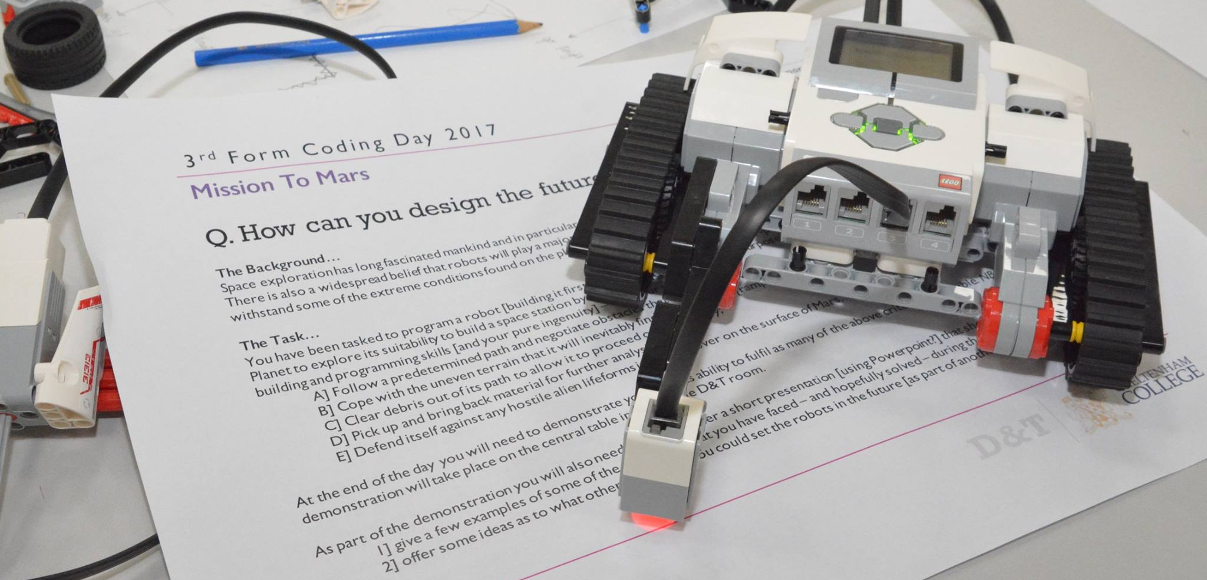
The role
Sciences at Cheltenham College are flourishing and, during the 2018-2019 academic year, over half of all our Sixth-Form students will study Science at A Level. In 2017 86% of Science A Levels were graded A*-B. As well as possessing the ability to inspire and motivate pupils, the successful candidate will be passionate about Science and will be able to share an infectious love of the subject with colleagues and pupils alike. The post holder will teach a reduced timetable in one or more of the Physics, Maths, Chemistry and/or Computer Science departments along with contributing to the running, organisation, and creation of engaging STEM projects beyond the confines of the curriculum.

Person Specification
Potential candidates may or may not have teaching experience, and are likely to:

- have or be aiming for II.i or higher honours degree in a scientific discipline
- have A Levels (or equivalent) in Physics and at least one of Biology, Chemistry, Computer Science or Maths
- be energetic, enthusiastic, dynamic, creative and motivated
- be able to work in a team, and to take initiative individually
- be willing to share their passion for Science with young people, and to inspire them to pursue a wide range of science-related degrees and careers
- have a positive attitude towards their own professional development and learning
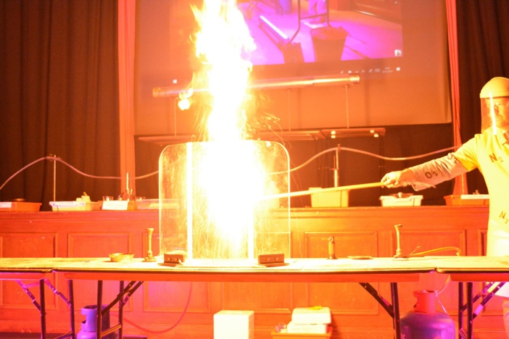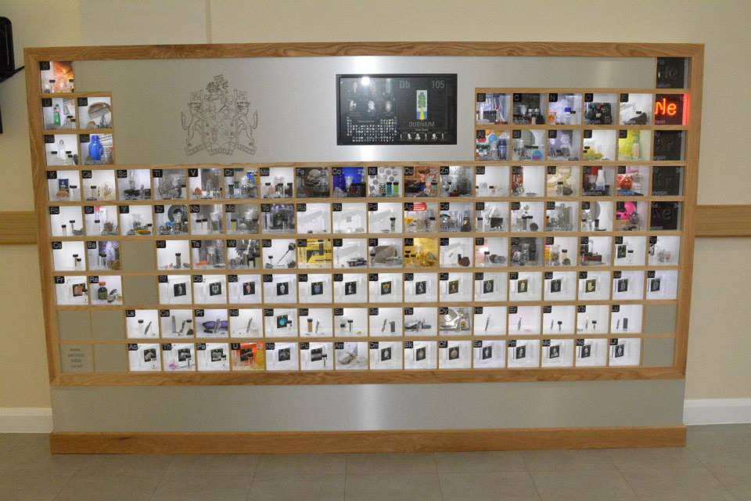
The Engineer in Residence will have much scope to craft the role according to his or her strengths, though the framework for the position will comprise:

- Teaching a reduced timetable of Physics and one or more of Maths, Chemistry, Computer Science, depending upon the candidate's experience
- Setting and marking work, and providing regular written and verbal feedback to pupils in line with the College and Departmental policies
- Liaising with the appropriate department technical staff to ensure the correct planning and delivery of practical work
- Making a positive contribution to the efficient running of the various departments noted above
- Contributing to the running, organisation, and creation of STEM projects beyond the confines of the curriculum. Examples may include:
  - Helping to lead a STEM club
  - Aiding in the organisation, and preparation of a STEM Careers fair
  - Involving our pupils in national STEM initiatives
  - Helping to coordinate events in across scientific disciplines to engage College and its pupils in British Science Week
  - Helping to coordinate cross-curricular initiatives encompassing a variety of interdisciplinary STEM-related areas
  - Helping to develop links with schools in the local area, and organising joint events with other schools
  - Helping to develop outreach links with local universities and organising visits
  - Organising and running a computer programming and coding activity

The successful candidate will be offered accommodation on site and will wish to contribute whole-heartedly to other aspects of College life by drawing upon their own interests and enthusiasms. The richness of the offering at College benefits from the experience of colleagues who coach sport, direct plays, take pupils on educational visits, and support and organise society meetings.

Terms and Conditions
- A full-time teacher has approximately 27 lessons per week of forty minutes, however this post is offered with a reduced timetable
- All colleagues are expected to undertake duties and to play an appropriate part in the co-curricular life of the College.
- The College has its own salary scale.
- Service with the College is pensionable in accordance with the Teachers’ Pension Scheme and permanent members of staff are entitled to a substantial reduction in fees for their children.
- Members of staff may use the College sports facilities (at staff allocated times).
- Subsidised health scheme membership (Benenden).
- Discounts and offers for College staff from local businesses and retailers.

March 2018

