Longridge Towers School
Berwick-upon-Tweed
Northumberland
TD15 2XQ
United Kingdom
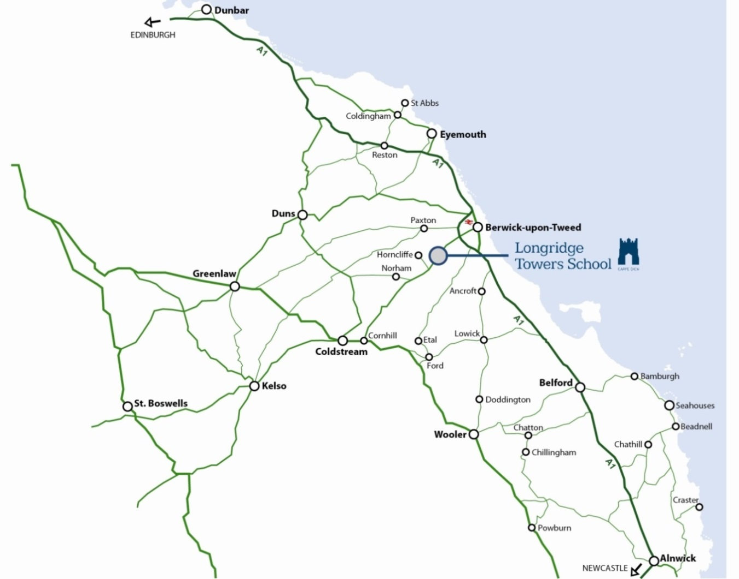
By Road:
The School is situated on the A698 Berwick to Coldstream Road about 1.5 miles from the A1 and has a signpost at the bottom of the drive. Turn left at the top of the drive and take the road around to the front of the main building where parking is available. Note: if using a Satnav do not turn into Eagle Drive which is the junction before the school and which has a small gatehouse at the entrance. The school drive is very clearly marked by two large signs at the entrance to the drive.

By Rail:
Berwick-upon-Tweed railway station is a five minute drive from the school - there is a fast East Coast service, taking less than four hours from London Kings Cross. Virgin Trains operate routes linking Berwick to the North and South.

By Air:
Numerous flights operate from our two nearest airports; Newcastle-upon-Tyne and Edinburgh.

