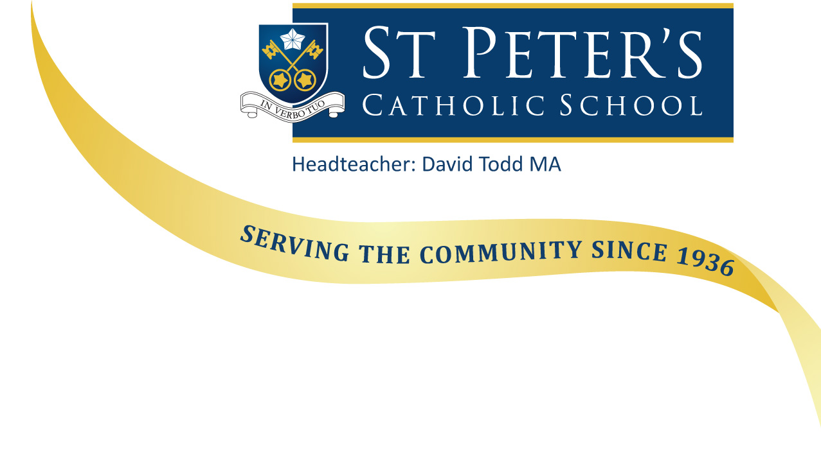

January 2018

Dear Applicant

Re: - Teacher of Design and Technology (1.0 FTE/ 0.8 FTE), with the possibility of a responsibility for Key Stage 3 for an exceptional candidate - required from 1st September 2018

Thank you for your request for information regarding this recently advertised post. I hope you find the information on our website useful. If you have any queries, please do not hesitate to contact the school.

St Peters is a Catholic school with a strong Christian ethos which underpins all we do. We are also an Academy jointly sponsored by the Catholic Diocese of Portsmouth and the De La Salle Order – an international organisation which has been running schools for over 300 years.

The school consists of two sites, with Primary accommodated at Iford and Years 7 to 13 at Southbourne. It is a school with a tradition of success, oversubscribed every year and benefitting from a deservedly positive reputation in the local community. Relationships with families are affirming and constructive, with parents and carers keen to support the school and the children’s learning.

We are not a complacent community; all staff are keen to learn and improve, developing pedagogy through research, shared practice and innovation.

We therefore seek individuals who are committed to comprehensive and inclusive education, to developing their practice through collaboration with colleagues and to delivering high standards and success through high expectations. We seek to appoint staff who are comfortable with the Catholic ethos of the school and able to support our core values. We are looking for teachers who have a clear pastoral commitment, able to get to know their students quickly and tailor the teaching to meet their needs.

If this describes you, please read through the documentation and should you wish to apply please complete the application forms and email to applications@st-peters.bournemouth.sch.uk . The closing date for applications is by midday on Monday 22nd January 2018. I am anticipating that interviews will be held on Thursday 25th January 2018. If you are invited to attend for interview, there will be an expectation that all candidates will teach a lesson. Provided candidates reach the necessary standard in this part of the selection process, they will be invited for the final interview in the afternoon.

If, you do not receive a telephone call from us inviting you for an interview, please assume that on this occasion your application was not successful. However, I would like to thank you for your interest in St Peter’s School.

I look forward to receiving your application.

Yours sincerely
Mr D J Todd
Headteacher

