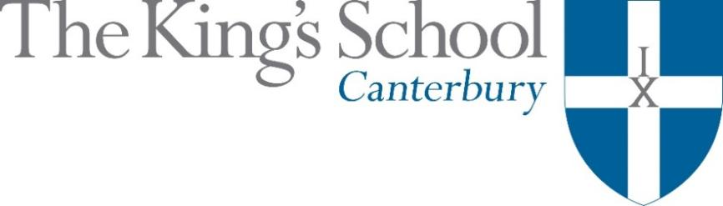

Appointment of a Teacher of
History of Art 0.6 with a further subject
to make up a full timetable
September 2018

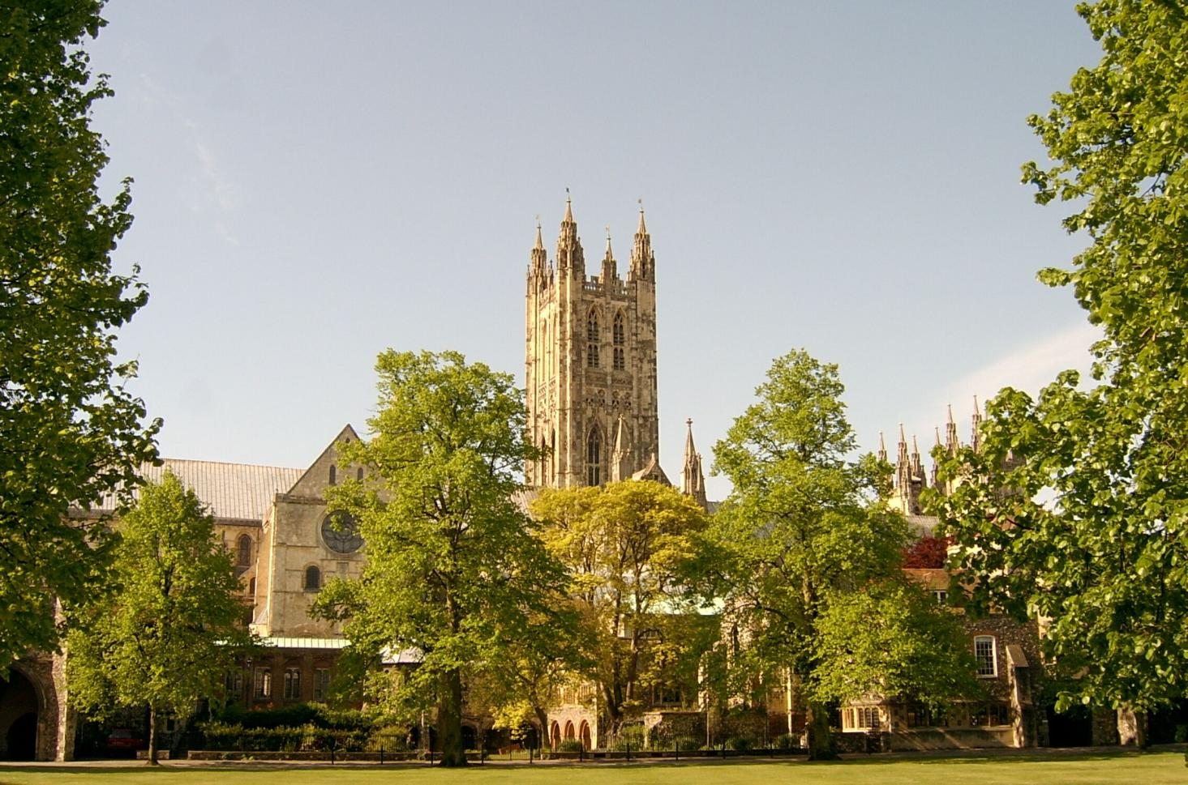

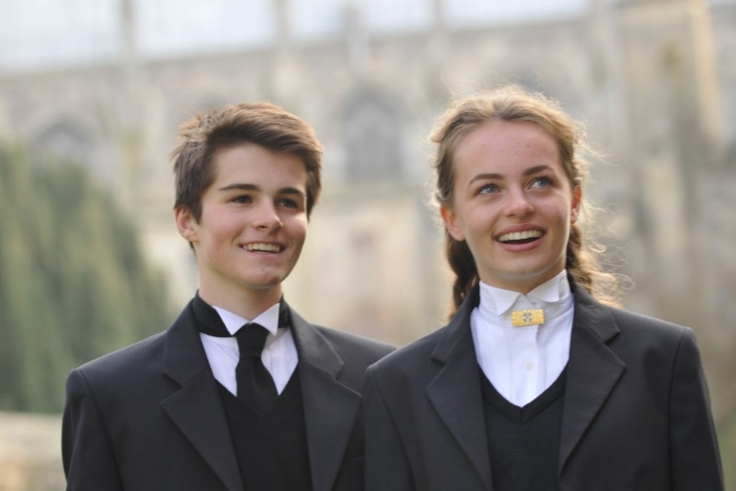
THE KING’S SCHOOL is a leading independent co-educational boarding school, situated in the heart of the historic cathedral city of Canterbury in Kent.

The precincts of Canterbury Cathedral are part of a world heritage site, a centre of pilgrimage and study, and host to over 1 million visitors each year from many different cultures. This international dimension deeply influences the life of the city and the school.

The origins of King’s date back to the arrival of St Augustine in 597 AD and the school’s Christian tradition remains at its heart although pupils and staff subscribe to many different faiths and beliefs and none. Embracing this diversity, there is a desire to foster fairness, tolerance, courage, perseverance, mutual respect and understanding. The Benedictine tradition of developing mind, body and spirit within a community given to hospitality still influences the life of the Cathedral and the school lives out its life in that context. Thus, academic excellence and scholarship take their place alongside the school’s commitment to physical and cultural endeavour. Sport is strong, with a number of boys’ and girls’ teams at national level. Music and drama are outstanding, both having the finest traditions and producing performances of the highest standards. King’s Week, the school’s own Festival of Creative and Performing Arts, attracts thousands of visitors each summer.

The curriculum at King’s is based upon strong academic roots. It emphasises and relies upon what is best in traditional school education: scholarly excellence supported by a caring pastoral and tutorial system, and a wide-ranging co-curricular programme. The curriculum is continually adapting and reacting to the changing demands of modern education: new subjects are added, new teaching techniques adopted, and there is an increasing awareness of the need to provide programmes of study that match individual needs and skills. The school does not gauge its success by exam results alone but by broader measures of educational attainment and personal development, helping pupils to achieve their potential and equipping them to play an active and responsible role in society as young adults.

Our family of schools comprises The King’s School, Canterbury (KSC), The Junior King’s School and, from September 2018, the International College. At KSC there are currently 826 pupils at the school – 452 boys and 374 girls – of whom about 80% are boarders. There are six boys’ boarding houses, seven girls’ boarding houses and three mixed day houses. Junior King’s occupies a fine rural site on the banks of the River Stour, in Sturry, two miles from Canterbury. There are over 375 pupils at Junior King’s of whom around 20% are boarders.

The King’s School occupies various sites around the Cathedral and its precincts. Many teaching departments and the majority of houses are in the beautiful ancient buildings around Green Court on the north side of the Cathedral. To the east of the Cathedral the St Augustine’s site is home to five boarding houses, a medieval refectory, and the magnificent neo-Gothic school library (shown in the picture below). There are two major sites for sport: Birley’s, and the Recreation Centre, both within walking distance of the school, with rowing at Westbere Lakes in Sturry. The International College opens in September 2018 as the third school in the King’s family and a fourth school is planned in Shenzhen, China.

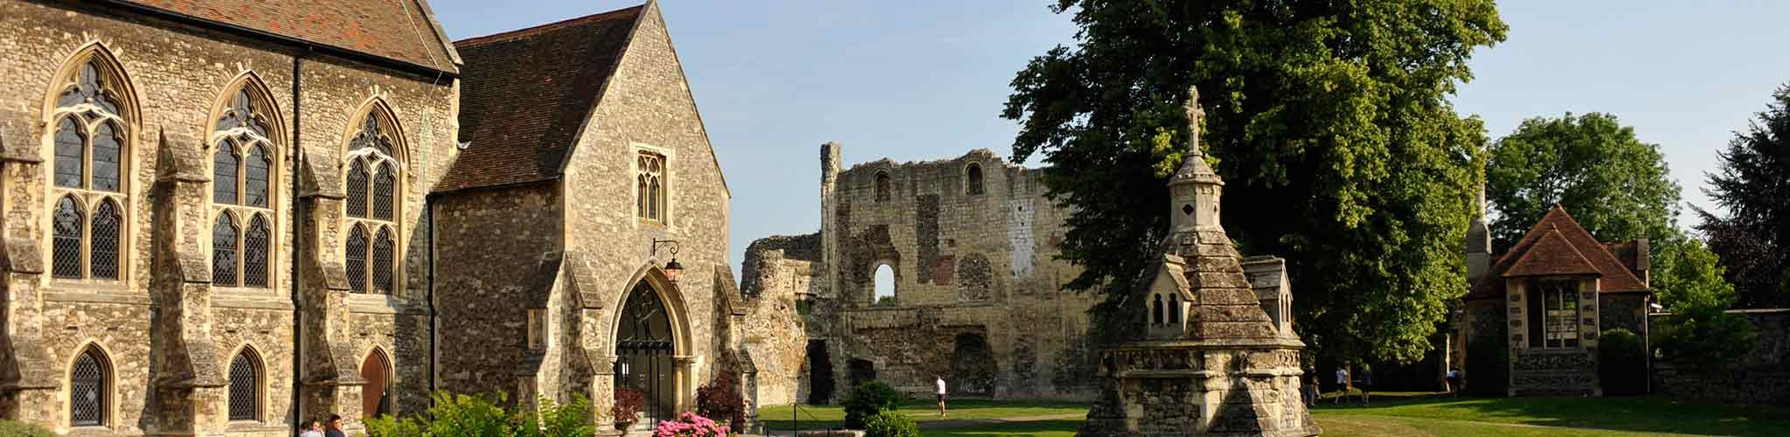

The King’s School Library at St Augustine’s

The Role

The History of Art is a highly successful Department which teaches the University of Cambridge Pre-U course for Sixth Formers. The course encompasses the study of artists and art movements across history. The opportunity is there to study both individual artists and the wider themes of which their creativity formed part. The course includes the study of paintings, sculptures, buildings and installations. There are regular trips to Exhibitions in London, as well as study tours to Italian cities and Paris. Pupils are expected to write essays, undertake research and conduct their own reading, keeping individual notebooks of works of art they have observed. The Turner Contemporary Gallery in Margate and Pugin’s house in Ramsgate offer local visits, but the co-location of Canterbury Cathedral with the school and the Medieval and Victorian buildings in the School itself are objects of great interest on our doorstep.
Pupils are prepared for Essay prize competitions and to enter the Kent Articulate competition for presentations about cultural history.
The teacher will support the Head of Department, hold tutorials as well as teach lessons, as well as pursue their own scholarly interests in History of Art. The Department is highly successful in gaining valued added for pupils at Pre-U, as well as encouraging applications to read History of Art and allied subjects at university
A PGCE or equivalent is desirable but not essential, and no teaching experience is necessary: we welcome applications from experienced teachers as well as recent graduates and those making a change of career.

In addition to academic excellence, the school seeks to promote excellence in all of its varied co-curricular pursuits. All teachers at King’s are expected to be fully involved in some capacity in this programme. They are also required to contribute fully to the pastoral care of the pupils through taking on a tutor group and duties in one of the boarding houses.

APPLICATIONS
Applications should be submitted online through the King’s School website (www.kings-school.co.uk – Staff Vacancies), and should include a letter of application to the Headmaster, Peter Roberts, and a CV by 5pm on Friday 2 March. Shortlist interviews are likely to take place on Friday 9th March. If you have any difficulties accessing the internet please contact the School Office: reception@kings-school.co.uk; 01227 595501.
Those considering applying but requiring more information, can contact the Head of History of Art
Holly Barton for an informal discussion: hb@kings-school.co.uk.

February 2018

