Job description
POST: Early Years Class Teacher
GRADE: Main Pay Scale / UPS
RESPONSIBILITY TO: Head teacher
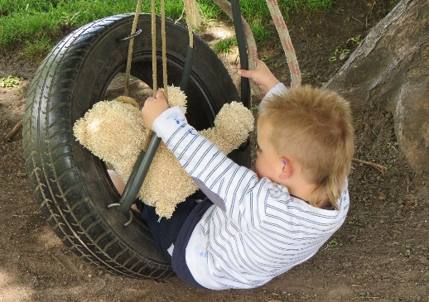
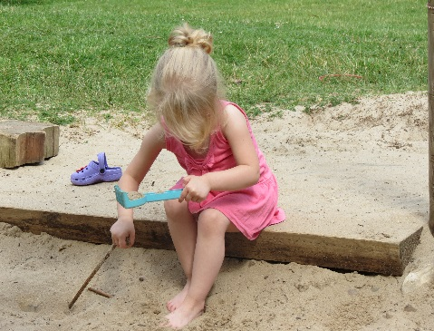

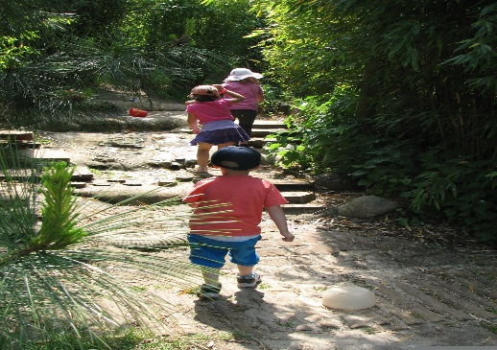

CLOSING DATE FOR APPLICATIONS:
Friday 15th June 2018
Interviews: Wednesday 20th June 2018

MAIN ACTIVITIES AND RESPONSIBILITIES
The duties and responsibilities of this post are to be carried out in accordance with the provision of the current School Teachers’ Pay and Conditions Document.

- Teaching and Learning
- To have a thorough knowledge and understanding of the EYFS Statutory Guidance, Early Years Outcomes and child development
- To plan and lead learning opportunities, in the indoor and outdoor classroom, which challenge all pupils and ensure high levels of engagement and promote pupil voice in curriculum planning
- To identify clear objectives and expected outcomes for children’s learning, building upon their prior attainment, and adopt a range of strategies to meet their different learning styles
- To promote challenging standards of pupil achievement and set high expectations for behaviour, establishing positive relationships and a stimulating learning environment
- To use data effectively to identify pupils who are underachieving and, where necessary, create and implement effective plans of action to support those pupils and accelerate their progress
- To plan and prepare work using appropriate resources to make learning accessible to all pupils, including those with Special Educational Needs and children speaking English as an Additional Language
- To identify pupils who have special educational needs and work within the school SEND policy in order to give positive and targeted support and implement Individual Play Plans
- To select and make good use of learning resources, including ICT, which enable objectives to be met
- To provide a learning environment which fosters children’s emotional wellbeing and promotes independence for all children

- Assessment and Evaluation
- To assess, record and report the development, progress and attainment of pupils in accordance with the schools’ assessment and evaluation procedures
- To evaluate how well learning objectives have been achieved and use this evaluation to inform future planning and teaching
- To maintain the assessment records for each pupil in the class as required by school policy
- To provide regular opportunities to share children’s learning and progress with parents and carers
- To speak to and liaise with other staff and outside agencies as necessary to best support each child

- Relationships with Parents
- To communicate effectively with parents and carers, both formally and informally, thereby encouraging active participation in the education of their children
- To prepare and present informative written reports to parents annually
- To liaise with agencies responsible for pupils’ welfare and attend meetings when necessary

- Managing own Performance and Development
- To understand the need to take responsibility for personal professional development and keep up to date with research and developments in pedagogy and in the subjects taught
- To participate in further training, professional development and research as appropriate
- To participate and contribute to staff training and meetings
- To participate in arrangements within the agreed framework for appraisal
- To reflect upon feedback from colleagues, self-evaluate own teaching and participate in the school’s aims to share good practice and improve the quality of practice

- Managing and Developing Staff and Adults
- To plan the work of Early Years Educators for whom they have responsibility, ensure colleagues are briefed effectively and ensure that activities undertaken promote achievement of pupils
- Support school aims to share good and outstanding practice and coach/mentor colleagues as well as accepting support where required

- Professional Conduct

- To fully support the aims and ethos of the school
- To set an excellent example to children, staff and parents in terms of presentation and personal conduct
- To relate positively to colleagues, establishing effective and professional working relationships
- To implement all current school policies and procedures
- To safeguard the health and safety of pupils at all times
- To carry out any other such duties which may be required from time to time to meet the needs of the school

G Safeguarding Children
- To be fully aware of and understand the duties and responsibilities arising from the Children’s Act 2004 and Working Together in relation to child protection and safeguarding children and young people in relation to this post and the wider organisation.
- To also be fully aware of the principles of safeguarding as they apply to vulnerable adults in relation to this post and the wider organisation.
- To follow the schools Child Protection and Safeguarding policies and procedures.

Person Specification – Early Years Teacher
Personal Qualities
- Positive and creative thinker who sees challenges as opportunities and who is able to enthuse others
- Highly motivated and passionate about early years teaching and enabling children of all abilities
and backgrounds to achieve
- Ability to communicate clearly and effectively in speech and in writing to a variety of audiences
- Reflective practitioner committed to personal development
- Ability to contribute to, lead and work within a highly motivated team
- Good interpersonal skills and ability to inspire and support colleagues

Knowledge and understanding:
- Thorough knowledge of the requirements of the EYFS Framework and child development
- Thorough subject knowledge and awareness of current issues and recent educational developments in early years education
- Understanding of the key features of good and outstanding early years teaching and learning
- Understanding of effective planning and assessment procedures
- Excellent understanding of how children learn effectively, including different learning styles
- Knowledge of and commitment to equal opportunities
- Knowledge of effective strategies to include and meet the needs of all children including those who speak English as an additional language and those with SEND
Skills and attributes:
- Excellent classroom practitioner who can inspire children and utilise a range of strategies to enable children to achieve outstanding progress
- Ability to develop and maintain positive relationships with pupils, colleagues, governors and the wider community
- Ability to create an inspiring learning environment which enables children of all needs and abilities to achieve success
- A commitment to developing a curriculum which embeds outdoor learning opportunities
- Confident in using a range of resources, including ICT, to make learning accessible to all children
- Good record of attendance and punctuality
- Excellent behaviour management skills together with an understanding of the value of effective and consistent routines in creating a positive learning environment
Education, training and qualifications
- Qualified Teacher Status
- A willingness to undertake personal and professional development with a relevant focus

