

# Equal Opportunities Monitoring Form

Cardinal Newman College is committed to equality and diversity and welcomes colleagues into our community regardless of their religion or belief, ethnicity, gender, gender identity, disability, sexual orientation, marital or pregnancy status. To help us measure how effective we are in encouraging applications from a diverse range of candidates, and to ensure that no job applicant or employee receives less favourable treatment on any grounds, please complete thesections below.

THIS INFORMATION WILL BE TREATED AS STRICTLY CONFIDENTIAL AND WILL ONLY BE USED FOR MONITORING PURPOSES. THE INFORMATION PROVIDED WILL BE KEPT SEPARATELY FORM THE INFORMATION USED IN RECRUITMENT DECISIONS AND WILL NOT INFLUENCE SUCH DECISIONS.

|  |  |
| --- | --- |
| **POST APPLIED FOR:** |  |
| **NAME:** |  |
| **DATE OF BIRTH:** | **PREFER NOT TO SAY** |
| **GENDER:** | **MALE:  FEMALE:**  **PREFER NOT TO SAY** |
| **MARITAL STATUS:** | **SINGLE:  MARRIED:**  **PREFER NOT TO SAY** |
| **RELIGION:** | **PREFER NOT TO SAY** |
| **RECRUITMENT SOURCE:** |  |



## WHAT IS YOUR ETHNIC GROUP?

***DISABILITY***

***Do you have a physical or mental impairment that has a substantial and long term negative effect on your ability to do normal daily activities?***

I would describe my ethnic origin as

Please tick the relevant box

**Prefer not to say**

**White**

British

Irish

Gypsy or Irish Traveller

Any other White background,

### Mixed/Multiple Ethnic Group

White and Black Caribbean

White and Black African

White and Asian

Any other mixed/multiple ethnic background

### Asian/Asian British

Indian

Pakistani

Bangladeshi

Chinese

Any other Asian background

### Black/African/Caribbean/Black British

Caribbean

African

Any other Black background

### Other Ethnic Group

Arab

Any other

**Any other Ethnic Group**

________________________________________

**Signed:……………………………………………………………**



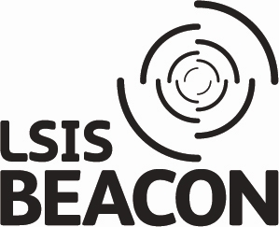

No Known Disability

Yes

Prefer not to say