St Michael’s Church of England High School
A Church of England Academy

Growing in Body, Mind and Spirit

Teaching Assistant Level 1
Candidate Information
Therefore, choose
Thank you for your interest in the position of Teaching Assistant Level 1 currently being advertised at St Michael’s CE High School, a Church of England Academy.
Letter from the Headteacher

St Michael’s is a special place to learn and work with a strong Christian identity. Our mission statement is:
As a vibrant learning community
we choose to serve God
pursue excellence
and
celebrate the uniqueness of each individual
We aim to achieve this mission through a Christian learning experience which focuses on opportunities for growth in body, mind and spirit:-
Where the safety, happiness and wellbeing of pupils are paramount. Where every child matters and more crucially, know that they matter.
Body

High expectations and aspirations in all areas of school life create a disciplined and ordered learning environment where creativity, passion and enthusiasm help to engender a life-long love of learning and secure excellent pupil outcomes.

Mind

Where pupils are supported to find for themselves the person that God wants them to be and really experience the joy and hope of ‘life in all its fullness’.
Spirit

As a thriving, oversubscribed Church of England Academy within the Diocese of Blackburn, our values are rooted in the Christian faith. Serving God, pursuing excellence and celebrating the uniqueness of each individual are at the heart of our distinctive ethos as we strive to ‘be the best that we can be’. We create and sustain our caring Christian community by encouraging positive supporting relationships based on Christian values and striking a genuine balance between the highest academic standards and opportunities for personal growth.
Worship is at the centre of our school life and is usually led by various staff, the Christian Youth Worker and/or pupils, with occasional support from local clergy or visitors. The school Chapel Choir (Hughes Tutorial) and the school Worship Band are regularly involved in worship helping to create a contemporary vibrant experience. Each day begins with a year group worship, assemblies and school prayers. In addition we hold Eucharist services in the school chapel throughout the year both at the start of the day and at lunchtimes. These services are led by various members of the local clergy who are always willing to support the school.
The chapel in the magnificent Armstrong Centre is also used for staff prayers and reflections which take place at the start of each working week. We hope that the school’s distinctive Christian ethos shines through in all aspects of our life and work here. We have numerous student leadership roles within school and an active charities committee. Each year group within school is linked to a particular charity.

All staff take responsibility for behaviour and wellbeing around school on a day to day basis and model the qualities and Christian values we believe are important for self- worth, respect, responsibility and stewardship.
St Michael’s has been in the top 10% of non - selective schools nationally for attainment for the last four years. In 2017 89% of pupils achieved 5+A* - C/ 9 - 4 grades including English and mathematics. However, we are not complacent and are ambitious for further success because of the real life chances these results bring for our pupils.
We want all at St Michael’s to ‘be the best that they can be’. We are confident that our pupils are provided with a rigorous and productive learning environment where they are both challenged and supported. We have talented, dedicated, caring and dynamic staff who are willing to develop innovative approaches to learning and teaching for our young people, provide outstanding care and guidance and support our distinctive Christian ethos.

I hope the information provided on our website gives you a clear flavour of our ethos, of what to expect at St Michael’s and also helps you to prepare for the application process.
I look forward to receiving your application.
Yours sincerely
Jayne Jenks
Mrs Jayne Jenks
Headteacher

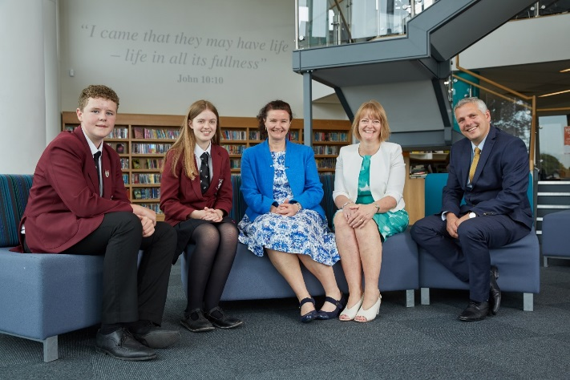
Information about the RE Department Department

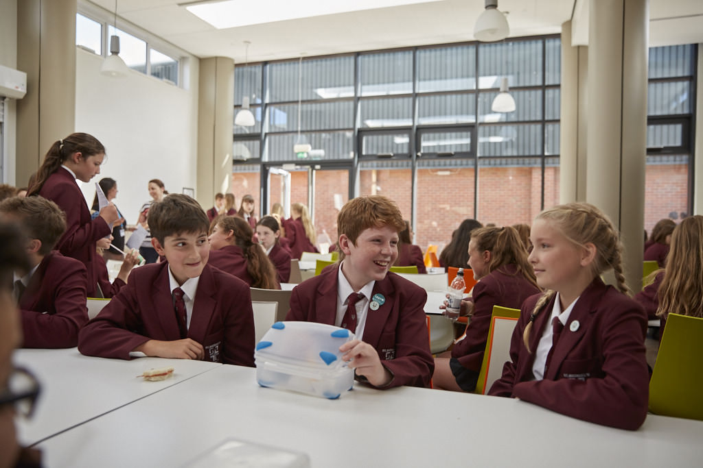
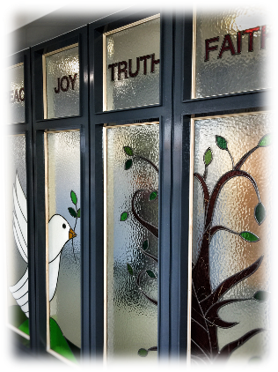
Letter from the Governors

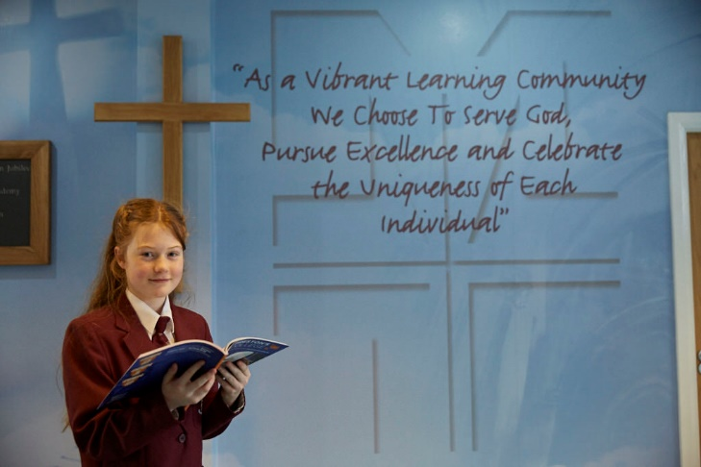

Thank you for requesting details for the post of Teaching Assistant Level 1 at St Michael’s Church of England High School.

Most of the information you will need is displayed on the school website. However, the governors are proud to emphasise the ‘outstanding’ Ofsted inspection in 2009 and ‘outstanding’ SIAMS inspection in 2014. This was achieved by a whole school community approach of teachers, support staff, pupils and governors working together.

The strong academic, sport, and performing arts record is supported by the active Christian ethos apparent throughout the school; providing the opportunity for pupils to grow in body, mind and spirit. Staff focus on continually raising attainment, encouraged by inspiring, forward thinking leadership and management.

The governors will expect the successful applicant to become a full and active member of ‘Team St Michael’s’ and to support our distinctive Christian ethos.

Thank you for your interest and I look forward to hearing from you.

Yours sincerely

Mr C M Metcalfe
Chair of Governors
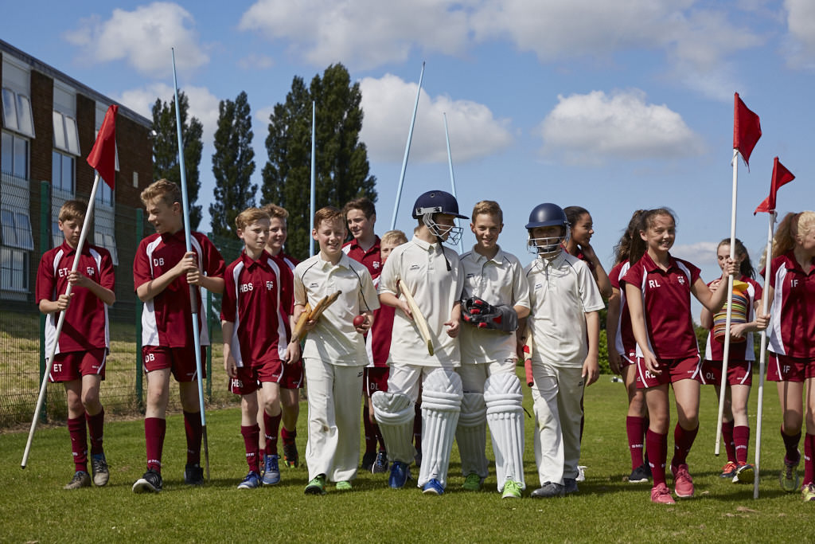
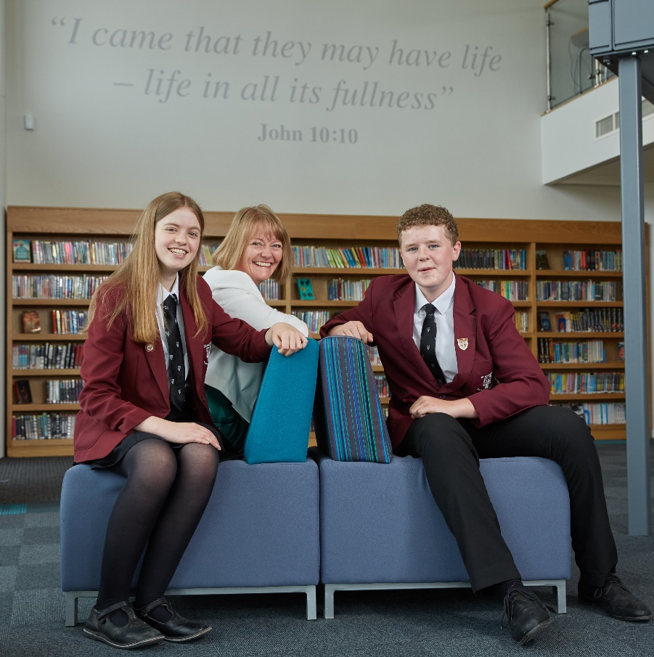
Head Girl and Head Boy Letter of Welcome
We appreciate your interest in the role of Teaching Assistant Level 1 at St Michael’s Church of England High School. St Michael’s is an outstanding school with exceptionally high standards, allowing pupils to develop both academically, physically, spiritually and socially.
‘Team St Michael’s’ is a significant phrase used within our school life. The ‘team’ encompasses parents, pupils, staff and governors, who all work closely together allowing pupils to, “be the best that they can be”. This ‘team’ helps create a strong pupil teacher relationship which is necessary to create mutual respect and a sense of community. Exceptional examination results already demonstrate that this is in place.
Christianity is at the heart of all that happens at St Michael’s. ‘Excellence within a Christian context’ is the school’s philosophy and this can be seen throughout school. At St Michael’s, pupils’ faith in Christianity is developed and encouraged. Each year group has a weekly worship, tutorial worship and prayers every morning and Christian values are embedded within lessons, helping to produce a compassionate environment.

St Michael’s Church of England High School really is a fantastic place to learn. Pupils experience engaging and productive lessons, which challenge and support us.
‘Celebrating the uniqueness of each individual’ is another key focus, which is already well integrated into school life. We hope the member of staff appointed will be passionate and enthusiastic and willing to go the extra mile to support us in all that we do.

Yours sincerely
Emily and Lewis
(Head Boy and Head Girl 2017- 2018)

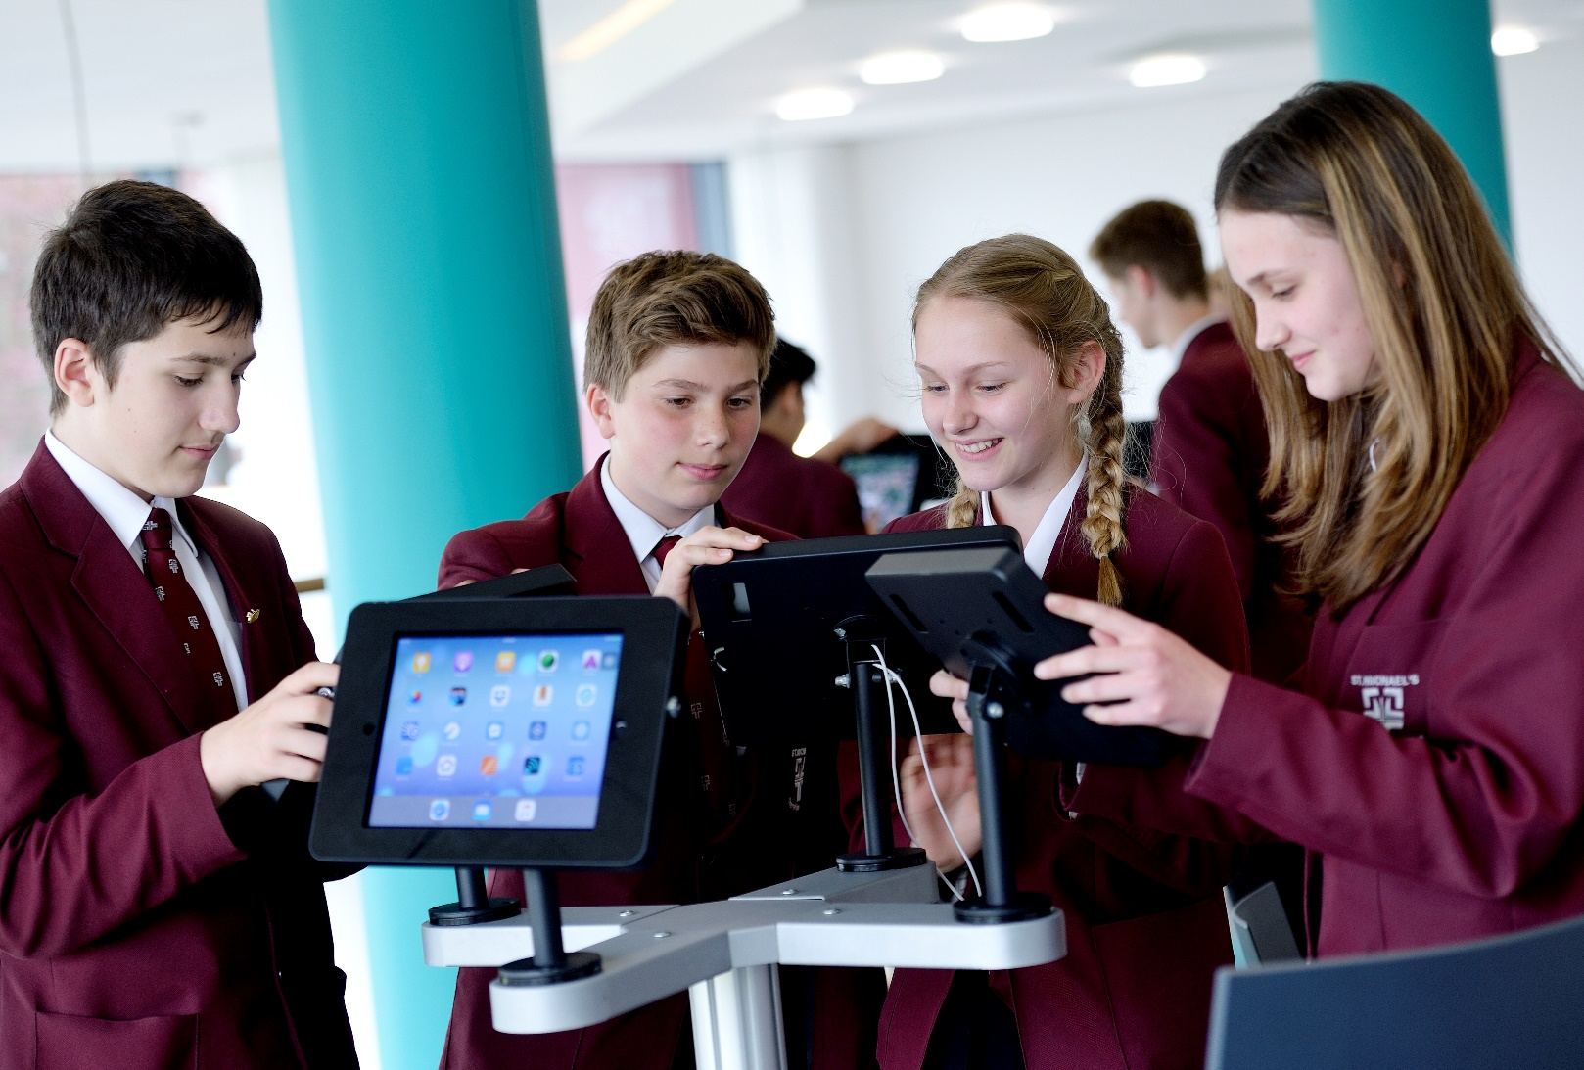
Application: Supplementary Information
Teaching Assistant Level 1
Required for September 2018
Temporary 1 year contract in the first instance
Full time, term time plus INSET
(Grade 3 Scale 11- 13 pro rata)
(Salary £17,007 - £17,391 pro rata)
(Actual salary £14,693 - £15,025)

Applicants are asked to provide a fully completed application form and a supporting letter (no longer than 2 sides of A4 in length in Arial point 12) that clearly sets out how your
experience to date prepares you for the advertised post (with reference to the enclosed
person specification).

Closing date for the receipt of completed applications: Wednesday 20 June at 09.00

Interviews: Wednesday 27 June 2018

Applications should be returned by email to: vacancies@saint-michaels.lancs.sch.uk

Applicants will be asked to produce original certificates for all education qualifications stated in the application form prior to the appointment being confirmed. All appropriate safeguarding and attendance at work checks will be requested.

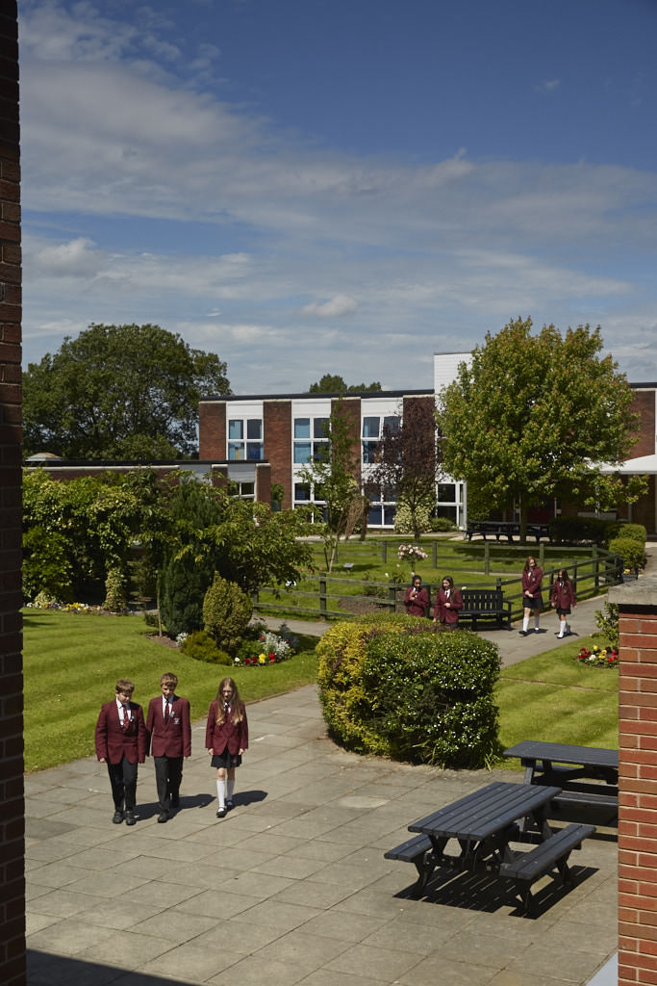
The applicant will be required to safeguard and promote
Teaching Assistant Level 1
Person Specification/Selection Criteria
the welfare of children and young people and be faithful to the trust deed.

Note: Candidates failing to meet any of the essential criteria will automatically be excluded
Section A Qualifications, Experience and Professional Development
Training and Qualifications
5 GCSEs at C or above or equivalent, including Maths and English | E | A
Educated to GCE A level or equivalent | D | A
Educated to Degree level or equivalent | D | A
Relevant child care qualification | D | A
Professional Development and Experience
Experience of working with children/young people with special educational needs | D | A/I
Experience of working with children aged 11-16 | D | A/I
Section B Professional Knowledge, Skills and Understanding
Ability to work independently and as part of a team | E | A/I
Excellent listening and interpersonal skills with an ability to communicate/engage with a range of stakeholders | E | A/I
Ability to relate well to children | E | A/I
Ability to organise classroom resources | E | A/I
Good communication skills (oral and written) | E | A/I
Knowledge of classroom roles and responsibilities | E | A/I
Ability to work flexibly and under pressure | E | A/I
Resilience and ability to manage and prioritise workload | E | A/I
Basic knowledge of First Aid | D | A/I
Excellent organisation and time management skills | E | A/I
Ability to use relevant technology | E | A/I
Meticulous and methodical in approach | E | A/I
Commitment to undertake in-service development | E | A/I
Ability to demonstrate a commitment to the Equal Opportunities policies in practical terms in the context of service delivery, employment issues and commitment to customer care practices | E | I
Section C Personal Skills and Attributes
Fully supportive of the Christian ethos of the school | E | A/I
Commitment to equality and diversity | E | I
Commitment to health and safety | E | I
Enhanced DBS Disclosure will be required | E | A/I
Ability to maintain confidentiality and discretion at all times. | E | A/I
Driving licence and car | D | A
Smart appearance in accordance with the school dress code | E | I

Section D: Confidential References and Reports

Positive and supportive faith reference from the priest/minister where the applicant regularly worships | D
Positive recommendation from all referees, including current employer | E

KEY
E = Essential
D = Desirable
A = Application
L = Lesson Observation
I = Interview
R = References

The successful candidate will be joining a highly dedicated, committed and effective team in providing excellent learning support to pupils. This support can help us continue to raise standards, achievement and enhance wellbeing. The ability to deal with sensitive and confidential issues and to relate well to young people, parents and carers, staff together with excellent interpersonal skills are essential for this role.

The role and responsibilities may evolve over time in accordance with the grade of the post. As a vibrant and successful school there are many demands on time, so flexibility and the ability to work under pressure are essential skills for this post; although you will benefit from working alongside supportive colleagues in a well-established associate staff team.

This is a full time, term time only, one year temporary post, in the first instance. The hours of work will be 30 per week with a break for lunch. The post will also involve occasional evening work in support of school events/meetings such as Parent Consultation Evenings, Open Evening, School Improvement meetings, Pupil Manager meetings, Governors’ meetings.

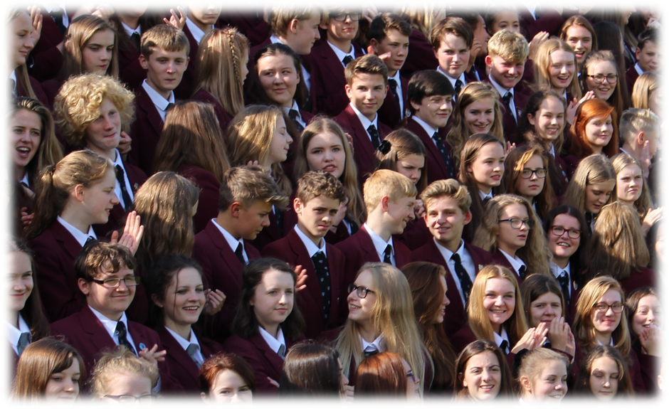

Responsible to: SENDCo
Job Description for Teaching Assistant Level 1

Our mission statement:
As a vibrant learning community we choose to
Serve God
Pursue Excellence
and
Celebrate the uniqueness of each individual

Responsibilities for this post:

Support for Pupils
- To meet the needs of pupil(s) in relation to welfare, hygiene, toileting, intimate care, dressing, feeding, mobility and learning.
- To assist in the movement around the school environment and during school activities.
- To assist in the development of independent social skills.
- To assist in the proper use of specialist aids and equipment.
- To assist in the specific medical/care needs of pupils when specific training has been undertaken.
- To accompany pupils on trips/visits.

Support for Teachers
- To assist in the accurate monitoring/recording of pupils’ progress and identification of areas to be addressed.
- To assist in the supervision of set tasks for an individual/small group of pupils.
- To assist in the preparation of the classroom and resources for learning.
- To feedback and liaise with the teacher to support the learning needs of each pupil.

Support for School
- To work within school policies and procedures.
- To contribute to the provision of an effective environment for learning and to assist pupil progress and attainment.
- To support the promotion of positive relationships with pupils, parents, staff and outside agencies
- To attend skill training and participate in personal/performance development as required
- To take care for their own and other people’s health and safety
- To attend staff training/meetings as appropriate.
- To be aware of the confidential nature of issues related to home / pupil / teacher / school work.
- To support the distinctive Christian ethos of the school

Note: In addition, other duties at the same responsibility level may be interchanged with/added to this list at any time by the Headteacher within the grade range of the post

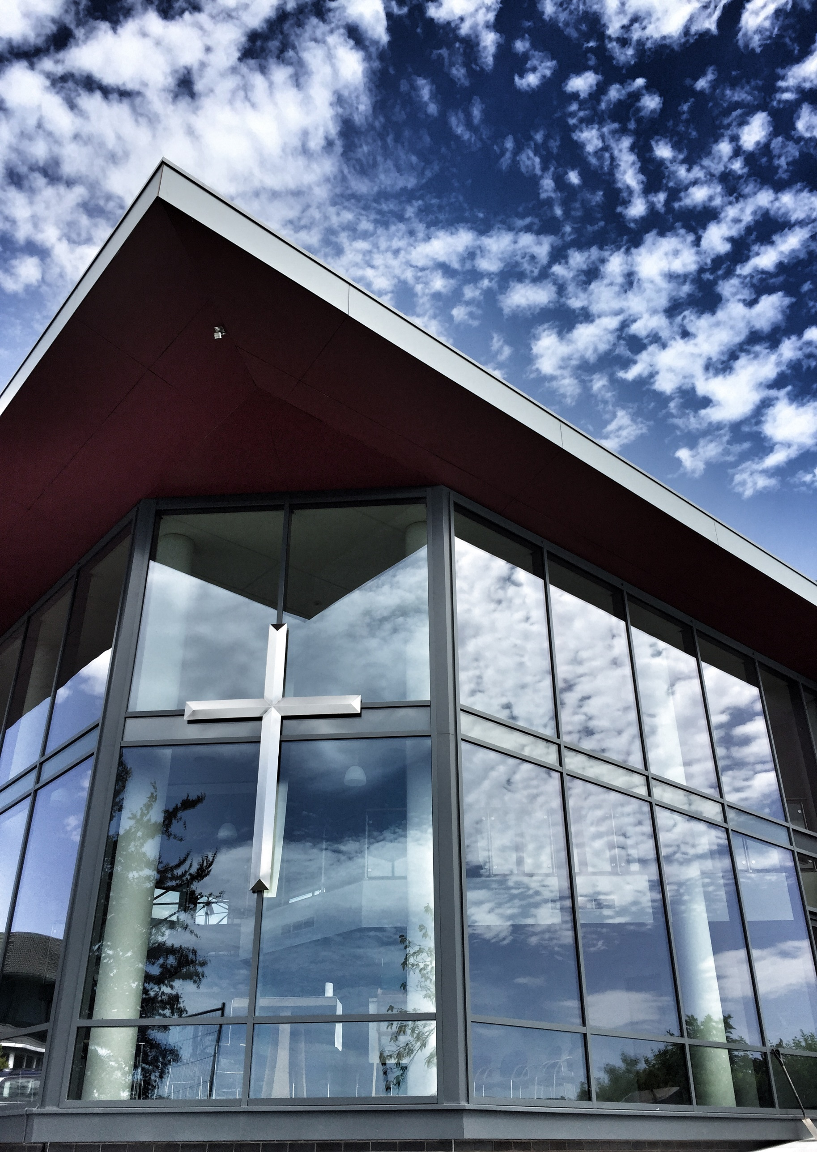

Therefore, choose
St Michael’s C.E. High School
A Church of England Academy
Astley Road
Chorley
Lancashire
PR7 1RS
Tel. 01257 264740
www.saint-michaels.com

