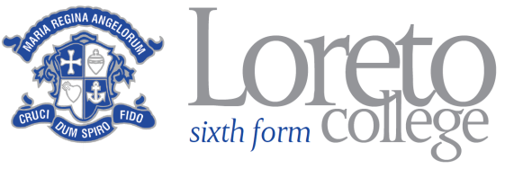

MEDIA

DEPARTMENT INFORMATION

There is a large Media Studies / Film Studies Department at Loreto College with approximately 300 students enrolments following the Eduqas Media Studies and Film Studies specifications. The Department is placed within the wider Faculty of Languages and Arts.

It is a hardworking and enthusiastic Department presently staffed by three full time members and two part time members of staff with extensive experience across the curriculum area. In addition we have a Media Studies technical officer who supports students and staff in the production of practical work. Currently production work in Media Studies focuses on music video and related print work, although in the future other practical areas are likely to be explored. In Film Studies, creative coursework comprises of screenwriting for short film and a related digital photography exercise, although moving image production work is an area we are interested in developing.

It is a Department which encourages staff to play to their strengths and push forward innovative approaches to the teaching and learning of both subjects while maintaining an excellent record of student achievement. The Head of Department very much believes in a collaborative approach to the delivery of the curriculum with all staff contributing in a direct manner to the overall success of the area. The successful candidate will bring new ideas and experience to the Department and with this in mind we welcome applications from both experienced teachers and those new to the profession.

