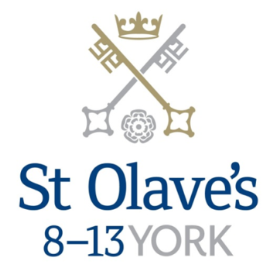

**Information for Applicants**

**Teacher of History (Maternity Cover)**

**May 2018**

From: The Master A I Falconer, MBA, BA (Hons)

Tel: (01904) 527391

E-mail: a.falconer@stolavesyork.org.uk



Dear Sir/Madam,

This exciting post arises as a result of a current maternity cover being extended for a further term. The ideal candidate will have experience of teaching history in Years 6-8. The ability to help coach hockey would be an advantage, but not essential.

St Olave’s is one of the leading Prep schools in the country. We do not believe in resting on our laurels and so are looking for someone with the enthusiasm and ideas to help us to continue to move forward. We believe passionately in continuous improvement and trying to achieve quality and excellence in all we do.

As part of a foundation of three schools, our curriculum dovetails with that of Clifton School & Nursery and St Peter’s. We do not follow the Common Entrance syllabus nor do we do KS2 tests, and so are free to go down interesting and topical tangents if that is what a teacher feels is best for their class. We are academically selective, but not highly so (our average standardised score is 115). Great teaching is what gets great value-added results by the time the pupil sits GCSEs and A-levels at St Peter’s. The vast majority of the 80+ pupils in Year 8 move on to St Peter’s – it is a real privilege to follow their progress through the senior school and to see them in concerts/plays/fixtures or just around campus. The principles of growth mindset are firmly embedded in all that we do, both as teachers and pupils.

York is a fabulous city to live and work in. We are just a ten minute walk from the centre of York and a similar distance from the railway station. London is just two hours away by train. York is much more accessible than most people realize. The local education authority is one of the best in the country and we continue to look at ways of building links with the City of York – the Independent State School Partnership (ISSP) continues to develop and we run Master Classes for local primary schools in Maths and Science.

We are a team, and a very strong one at that. You will be strongly supported as well as challenged. We expect you to speak your mind but to also display tact and diplomacy. We all get things wrong from time to time and that’s OK providing you hold up your hands and learn from the mistake. I am looking for glass half full, solutions orientated people who realise that working in a Prep school is not an easy life but that it is a vastly fulfilling one.

So, are you still interested? If so, I look forward to receiving your completed application form and covering letter in due course. With best wishes,



Andy Falconer

Master

|  |  |
| --- | --- |
|  | **N:\Master Copies\Crests\St Olave's New logo November 2012.jpg** |

**JOB DESCRIPTION**

**Post Title: Teacher of History**

**Grade: St Peter’s Salary Scale**

**Responsible for: Teaching History in Years 6-8**

**Responsible to: Director of Teaching and Learning**

**Overall Purpose of the Post:**

To contribute to the mission and the strategic objectives of the School through the effective and appropriate delivery of high quality teaching, learning and support to pupils.

These responsibilities are to be delivered within the context of the aims, objectives and schemes of work of the school, within the context of the National Curriculum, the subject team and all relevant school policies and procedures.

To contribute to strategic and business planning at department and whole school level and to the management of the school through the efficient and effective deployment of resources.

**Key Responsibilities:**

**Teaching and Learning**

1 Planning and preparing courses, lessons and activities that ensure appropriate challenge and high expectation for all learners.

2 Teaching lessons according to the educational needs of the pupils and as required by the school timetable.

3 Setting, marking and recording work carried out by pupils in accordance with the school marking policy.

4 Liaising with other teachers, as necessary, to ensure consistency across the curriculum.

5 Periodically reviewing programmes of work and methods of teaching.

6 Maintaining good order and discipline among pupils and safeguard their health and safety at all times.

**Assessment and Reporting**

1 Assessing and reporting upon the progress of pupils in line with school policy including producing written reports as required and those on request e.g. for school transfers.

2 Maintaining and updating appropriate and accurate records of pupils’ marks and progress.

3 Attending and contributing to parents’ evenings to discuss pupils’ progress with parents.

**Pastoral Duties**

1 Taking responsibility for the academic and pastoral oversight of pupils as a Mentor within a day house and full involvement in the life of the House and unique House system.

**Other Professional Duties**

1 Sharing in the overall responsibility for the academic progress, personal development, health and safety, discipline and well-being of all pupils.

2 Participating in meetings to discuss curriculum, pastoral and other issues including staff meetings, departmental and whole school meetings as required.

3 Attending school events and activities as necessary.

4 Making an appropriate contribution to the planning and management of the subject area and to share departmental responsibilities as required.

5 Providing supervision or cover for classes / absent colleagues as necessary.

6 Participate fully in the school Performance Review and Support process and engage in appropriate continuing professional development.

7 Comply with all relevant school policies and procedures including Health and Safety requirements.

8 Be part of the Staff Duty Team & offer a minimum of one co-curricular club a week.

*The School is committed to safeguarding and promoting the welfare of children and young people and expects all staff and volunteers to share this commitment. The successful applicant will be required to undergo checks with the Disclosure and Barring Service.*

*All staff at St Peter’s School are required to observe all relevant Health and Safety, Equality and Data Protection legislation and procedures.*

*Note: This job description is not a comprehensive definition of the post and the post holder will be expected t*o undertake any other tasks commensurate with the duties and responsibilities of the post. *The job description will be reviewed as part of the cycle of appraisal, and it may be subject to modification or amendment at any time after consultation with the post holder.*

**Person Specification**

|  |  |  |
| --- | --- | --- |
| **KEY CRITERIA** | **ESSENTIAL** | **DESIRABLE** |
| **Experience** | Relevant and effective classroom teaching experience.  Monitoring, assessment and reporting of pupil progress. | Experience of working in a boarding school environment and/or an understanding of the independent school sector.  Commitment to continuous professional development.  Contribution and commitment to extra-curricular activities.  Experience of teaching a second subject. |
| **Qualifications** | Qualified teacher status.  A degree or equivalent qualification in a relevant subject area. | Evidence of continuing professional development.  Driving licence endorsement, or other qualification, to allow driving of school minibuses. |
| **Specialist Knowledge** | A thorough up to date knowledge of a range of teaching, learning and behaviour management strategies and how to implement them effectively, whilst seeking continuous improvement.  A thorough understanding of the national curriculum and a range of assessment requirements and arrangement.  Statutory requirements of national legislation and knowledge and understanding of the implications of equal opportunities, multicultural education and inclusion, health and safety and the safeguarding of children.  Knowledge and understanding of digital technology and its ability and use to enhance classroom learning. | Up to date knowledge of relevant developments with regard to the subject area. |
| **KEY CRITERIA** | **ESSENTIAL** | **DESIRABLE** |
| **Skills and Abilities** | Work with the demands of life which relies as much upon good will as precise contractual guidelines for its well-being.  Effective teaching skills with the ability to prepare and plan effectively.  Organising the classroom creatively to encourage a positive learning environment.  Ability to prioritise and manage time effectively.  Excellent communication skills with the ability to develop and maintain good relationships with colleagues, pupils and parents.  Willingness to provide pupils with a range of co-curricular activities.  Commitment to school events and excursions. |  |
| **Personal Attributes / Competencies** | A commitment to safeguarding and protecting children and young people.  Passion for teaching with the ability to motivate and inspire and challenge pupils as well as acting as a role model and mentor.  A willingness to fully embrace the Christian ethos and values, and to engage fully with the life of the school.  Strong team working skills.  Work effectively under pressure.  Integrity and dependability and maintaining an appropriate level of discipline and personal and professional self-discipline at all times and in all contexts. |  |

**How to Apply**

To apply for this post, submit a school application form, completed in full, with a covering letter. Please do **not** send CVs, either in place of or as an attachment to the application.

**Closing date for applications is Friday 25th May 2018 at 9.00am.**

**Interviews will be held on Monday 11th June 2018.**

Please return the completed application form and accompanying letter by post to:

Mrs Clare Murgatroyd

Master’s PA

St Olave’s School

York

YO30 7WA

Or by email to [c.murgatroyd@stolavesyork.org.uk](mailto:c.murgatroyd@stolavesyork.org.uk)

**About St Olave’s**

**Background**

St Olave’s is a very successful and flourishing co-educational IAPS and HMC Prep school, for day and boarding children in Years 4–8.  We are the middle part of the St Peter’s School family with Clifton School and Nursery covering 3–8 year olds, and St Peter’s School covering 13–18 year olds. The vast majority of our 80+ pupils in Year 8 move on to St Peter’s. St Olave’s has 350 pupils, including around 15 full boarders and another 20 who flexi-board.

St Olave’s School was founded in 1876. The former Queen Anne Grammar School, located right next to the St Peter’s campus, was purchased in 2001 and this enabled the St Olave’s to move into much bigger premises and an additional 14 acres of grounds – all within 10 minutes walk of the centre of York.

From the very first moment a child enters St Olave’s they benefit from an excellent academic education supported by highly qualified and experienced specialist staff and a large range of musical, creative, sporting and artistic opportunities which are essential for children’s all-round education and development. The pastoral care and welfare of the children is of paramount importance and we make every effort to ensure that each child feels secure and happy. Our ethos is founded on praise and encouragement within a traditional framework, with growth mindset and our eight learning habits underpinning everything we do. We were shortlisted this year for the TES Prep/Pre-Prep of the Year award.

In Year 4 (J1) we have three Form entry (20 in a class), then in Year 6 (J3) another class is added, and in Year 7 (J4) we fill up the classes to a maximum of 22 in each class.  Pupils in Years 4 and 5 are taught partly by their Form teachers but with increasing subject specialism, then in Year 6 they move to subject specialists and moving around the school with a timetable for all their subjects. We are fortunate to be over-subscribed in most year groups.

The House system is a particular strength of the school. There are 5 Day Houses (Ainsty, Alcuin, Elmet, Fairfax, York).  The House Tutors are in charge of the pastoral care of the 70 or so children in their House and are the primary point of contact for parents with concerns. Teaching staff are attached to the different Houses and fulfil a Mentoring role with a group of 12 pupils. Registration in the morning and afternoon is done in Houses not classes, and lunch is eaten in Houses not year groups. There is a House Assembly every Wednesday.

St Olave’s benefits from wonderful facilities which are shared with Clifton and St Peter’s, including 4 lawn tennis courts, 9 hard tennis and netball courts, an impressive 6 lane indoor swimming pool, a full size synthetic pitch for hockey/tennis, 2 large sports halls with indoor cricket nets, and a fully equipped gym hall. Sport at St Olave’s has a national reputation – regularly playing in regional and national competitions. Many pupils play representative sport both at very high levels. However, the school combines playing at the highest levels with a sport for all approach. The aim is to make sure that every child has the opportunity to represent the school at the appropriate level each term, on multiple occasions.

Classroom provision is very generous, especially considering the small class sizes which are usually 20–22 pupils. Much money has been spent on upgrading the IT infrastructure. There are two IT suites, each containing 28 computers, plus laptops are also available.

We have two fully equipped science laboratories. General Science is taught in Years 4–6 and then in Years 7 and 8 Biology, Chemistry and Physics are taught as discrete subjects.

A programme of language awareness is taught in Years 4 and 5 consisting of French, Spanish and German.  Classics is added from Year 6. In Year 7 pupils choose which two of the three MFL languages to continue with through to St Peter’s, plus also moving from Classics to Latin. The Library is a large, light welcoming space including 10 computers for research purposes, 10,000 books and a full-time librarian.

The Arts are very well provided for with a large performance hall and stage for productions and a separate Music School, which includes a large rehearsal space along with other classrooms and individual teaching rooms. The Shepherd Hall is air-conditioned and has retractable tiered seating, ideal for concerts and plays. Music is a huge part of life at St Olave’s. The school has an orchestra, wind band, brass band, jazz band, rock band, chapel choir, school choir, cello group, as well as smaller ensembles. There are around 24 peripatetic music staff who deliver over 215 individual lessons each week. End of term concerts, along with many more informal concerts, allow for opportunities to perform in front of audiences. Each class has a drama lesson each week and we offer LAMDA classes after school. Years 4 and 6 do a big, whole year group production and in Year 8 pupils take part in the Shakespeare Schools’ Festival.

Art and Design Technology have their own large building. The art department has an art studio as well as a ceramic workshop with a kiln, whilst the D.T. area has one room for designing and planning work and then a large, fully equipped workshop.

St Olave’s is a school that is proud of its traditions yet is forward looking, continually striving to improve the quality of learning for the children. The needs of the children come first, which mean staff must be prepared to go the extra mile – there can be no half measures. We achieved ‘outstanding’ in our I.S.I. inspection in May 2017 through hard work and a dedicated approach. Staff at all levels take professional development and visit other schools to pick up new ideas. We have an annual Review and Development system, appraisal under another name, which all staff take part in. St Olave’s follows the St Peter’s pay scale, which is above the main teaching pay scale M1-M6.

Our boarding community who live in Wentworth House, are a central part of the school. Academic staff can offer to do a Sunday activity for the boarders if they wish. There may also be the possibility of being a residential tutor within Wentworth.

There are over 50 clubs and activities run by staff during lunch breaks and after school. The school day starts at 8.15am for pupils with lessons finishing at 4.00pm. Between 4.00pm and 5.20pm there are clubs, activities and Prep Club. All pupils will usually have gone home by 5.30pm.  On Saturdays there are five lessons starting at 8.15am and finishing at 12 noon. School finishes at this point, so that our pupils can continue to be involved in local teams outside of school and also have a rest. We also have five Exeat weekends a year, which means no Saturday school.

The Dress Code for staff is consistent with our professional standing: normally we require a jacket, collar and tie for men and smart, professional attire for women.

Smoking is not permitted on campus at any time nor off campus when on school trips.

**Our other schools**



**Clifton School and Nursery**

Clifton School and Nursery, for day girls and boys aged rising 3 to 8 years, has its own building with use of extensive play areas, sports hall and swimming pool. Under the leadership of the Head, teachers use the attractive buildings and play areas to maximum advantage, teaching a broad and balanced curriculum which gives a wide variety of experiences, and emphasises the importance of basic skills. The curriculum is based on the National Curriculum and Primary Strategy, but goes far beyond this, both within the school day and during the wide range of co-curricular activities and visits outside of School.

Clifton enjoys separateness, a clear identity and its own House system. It allows smooth academic progression and provides tailor-made approaches and facilities for each age group.

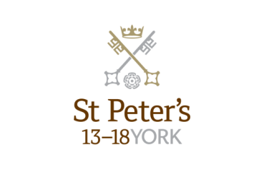

**St Peter’s School**

St Peter’s School, for children aged 13 to 18 years, is underpinned by academic rigour and challenge. Through outstanding teaching, first rate facilities, high expectations and sheer determination on the part of its pupils, St Peter’s achieves considerable success across a broad curriculum.

The four vibrant and successful boarding houses for boys and girls lend vitality to the pastoral life of the School. Inspiration from living in close proximity to a cultured and historic city adds further richness to the pupils’ lives. The Ofsted inspection of Boarding in December 2010 found the School’s provision to be Outstanding.

The School Chapel stands at the centre of the campus and regular services (three mornings a week) give pupils and staff the opportunity to reflect together on the spiritual values of the community and on the meaning and significance of what is happening locally, nationally and globally.

Music, Art and Drama are central to the cultural and academic depth of the School. The Sports programme is extensive, providing a wide range of choice for both girls and boys. Results are excellent, and St Peter’s pupils’ co-curricular achievements are considerable. The excellence of the teaching and facilities allows pupils to thrive.

The school’s website can be visited at [www.stpetersyork.org.uk](http://www.stpetersyork.org.uk). The most recent inspection report is available on the [ISI website](http://www.isi.net/schools/7039/).

**About York**

St Peter’s School is situated five minutes’ walk away from York’s compact city centre. York is one of the oldest and most beautiful cities in Europe, famous for its gothic Minster and winding medieval streets. York has won a number of tourist awards and further details are available on [the Visit York website.](http://www.visityork.org/members/about/awards.aspx) York is regularly voted as one of the best places to live in the UK. Such is the size and layout of York, walking and cycling are ideal ways to get around, including taking in the famous sights of this historic city; an ancient Roman and Viking capital.

York is a central rail hub between Edinburgh, London and Manchester. The main railway station is only a 15 minute walk from the School. In addition it has a large variety of restaurants, pubs, theatres, cinemas, parks, museums and galleries, and life in York is always interesting, by day or by night.

Finding somewhere to live is also comparatively easy. York’s rental sector is in good health, though demand remains high. If you are trying to buy you will find York prices are around the national average.

York is a family friendly city. Attractions such as the Jorvik Viking Centre, the Barley Hall, the York Dungeons, the National Railway Museum and the York Chocolate Story are immensely popular with people of all ages.

The city lies in the Vale of York, a valley that runs north to south between the heathery North Yorkshire Moors to the east and the famous Yorkshire Dales to the west. Both areas offer an excellent escape for walkers, cyclists, climbers – indeed anyone with a love of fresh air and rolling countryside.

A guide to the City of York can be found at <http://www.visityork.org/>

**Employee benefits**

Our vision is to be a happy, thriving 3-18 co-educational day and boarding school community that combines a classical, high quality, all-round education with a forward-looking and exciting approach to learning.

Our staff are the key to our success. It is their expertise, enthusiasm and commitment that is reflected in our high standards and continued success. In return, we offer all our colleagues a competitive total reward package from day one of their employment with us.

**Annual Leave**

Teachers will normally be entitled to take as annual leave all school holidays except for such time as may be reasonably required to carry out additional duties during the school holidays. This includes staff INSET training. Public holidays occurring when the School is in session are working days.

**Childcare Vouchers**

Eligible employees can join our Childcare Voucher Scheme that allows tax and National Insurance savings through a salary sacrifice arrangement. This scheme is available for employees with children up to fifteen years old (or sixteen years old for disabled children).

A salary sacrifice arrangement is an agreement between an employer and an employee to change the terms of the employment contract to reduce the employee’s entitlement to cash pay. This sacrifice of cash entitlement is in return for some form of non-cash benefit. Salary sacrifice is financially beneficial for the employee as tax and national insurance contributions are not paid on the non-cash benefit.

**Cycle to Work Scheme**

Eligible employees can join our Cycle to Work Scheme (also a salary sacrifice arrangement) that allows tax and National Insurance savings on the purchase of a bicycle (and related equipment).

**Discounted school fees**

A discount on school fees is offered to eligible staff for a maximum of two children at a time, if a place is available and entry requirements are met. The discount is offered for children at St Peter’s and St Olave’s Schools only.

For part-time staff the discount would be pro-rata based on the employee’s working hours.

**Enhanced Maternity Pay**

After one year’s continuous service with the School by the 11th week before the EWC, you will be entitled to receive enhanced maternity benefits as well as Statutory Maternity Pay (SMP).

You will receive the following benefits for a fixed period of 39 weeks:

First four weeks of absence Full pay

Following two weeks 90% of average weekly earnings

Following 12 weeks Half pay, plus Statutory Maternity Pay (SMP)

Following 21 weeks Statutory Maternity Pay (SMP)

**Free School Lunches**

Staff can enjoy a free meal during the lunch period in the School Dining Room. Lunch is provided on normal working days during term time. A selection of hot and cold food, beverages and sandwiches are available.

**Parking**

There is extensive free parking available to staff on the school site.

**Pension**

A teacher’s employment with the School is pensionable under the Teacher's Pension Scheme. Teachers are automatically enrolled when required by law. Both the teacher and the School will make the appropriate contributions based upon the teacher’s pensionable salary.

**School Chapel**

School Chapel is available to former pupils, staff and people connected the school for weddings, christenings and other appropriate events. Extensive grounds and gentle green lawns provide an excellent location for a marquee or champagne reception. The School is licensed for regulated entertainment and the Memorial Hall is ideal for evening functions.

**Sick Pay**

Where employees are unable to attend work due to sickness, there is a provision for sick pay. The amount of sick pay increases according to the employee’s length of service and current contract.

**Sports Facilities**

All staff can use the school sports facilities free of charge when they are not in use by the pupils. This includes a modern gym and swimming pool.

**Training and Development**

Our employees are encouraged to continually develop their skills and knowledge. Training and development opportunities may include gaining a professional qualification and other learning opportunities.

**How to find us**

You can find St Peter’s School, York, at YO30 6AB.

The School is less than fifteen minutes on foot from York Railway Station.

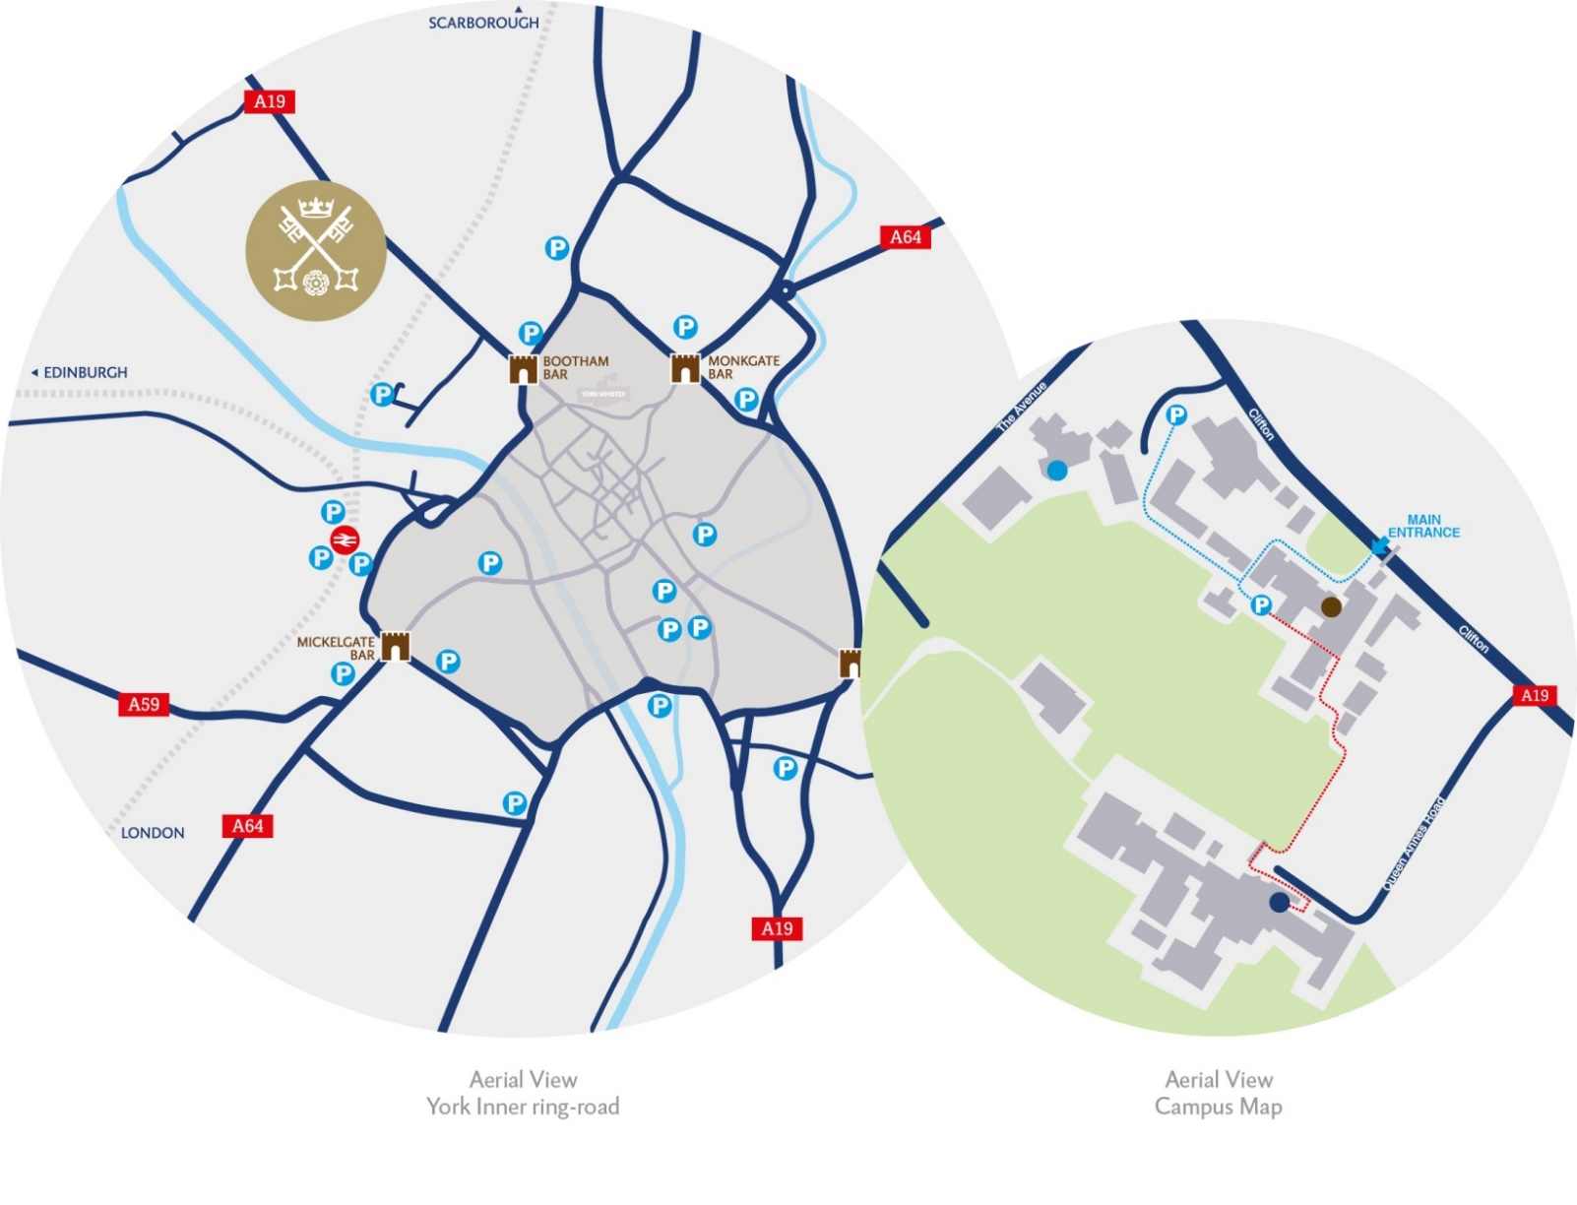

**By car:**

**From York City Centre**: Take the Thirsk Road **(A19)** at the Bootham Bar traffic lights. The school is 700m on the left, immediately after the footbridge.

**From the A64**: Take the Northern Ring Road **(A1237)**. At the **A19 roundabout** turn towards the city centre. The school is two miles on the right, 300m after Clifton Green. Turn right into the school immediately before the footbridge that crosses the road.

Parking is available on site.