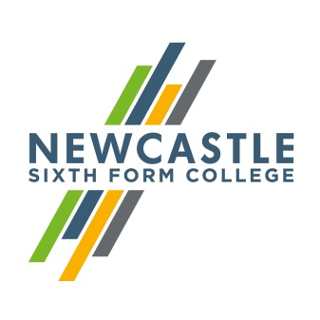
Gerard Garvey
Principal

Dear applicant,
Digital Marketing Officer
Thank you for showing an interest in our College. I hope you find the information about this post exciting and that it encourages you to apply.
We are absolutely committed to our vision, and determined to create an outstanding College through all members of our College community working hard to achieve it. With an ethos based on aspiration and achievement, Newcastle Sixth Form College will provide the first choice for academic sixth form education in the region. Through high quality teaching and learning in an exciting, dynamic and supportive environment, we will enable our students to realise their potential. If you share this vision, and believe that you share our commitment to making this College a great place to work and learn, I look forward to receiving your application.
This is an exciting time to join the Sixth Form; 2016 saw the best ever results at the college. Students thrive in a culture of mutual respect, increased freedom, and high expectations. More students progress to university from NSFC than from any provider in the region, with over 450 students gaining places each year. The college is based in a purpose built Sixth Form College offering a university style learning environment. NSFC is the only dedicated Sixth Form College in Newcastle, and is the most popular choice for A-levels in the city. Across the region, young people travel from as far as Berwick and Teesside to study at the college. They choose to do so not just because of the world class facilities and wide range of subject choices, but most importantly because of the inspirational teaching, guidance and support.
I hope that you will visit our website to find out more about the College, and if you wish to visit us to look around informally we would welcome that. If you would like to arrange a visit, please contact my PA, Sandi Davison, on 0191 226 6225.
Yours faithfully,

Gerard Garvey
Principal
Newcastle Sixth Form College, Westmorland Road, Newcastle upon Tyne, NE4 7SA
T: 0191 272 1001 E: enquiries@newcastlesixthformcollege.ac.uk
www.newcastlesixthformcollege.ac.uk

 | Newcastle Sixth Form College  Information for Applicants | 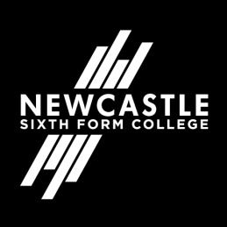

Newcastle Sixth Form College
Newcastle Sixth Form College is a dedicated academic college focusing on the needs of 16 to 18 year olds in a purpose built multi-million pound Sixth Form College. Our breadth of A Level subjects is second to none in the region and our students are nurtured to achieve the best possible results for them to move on to higher education at universities and colleges or into the workplace.
Our culture is based on support and challenge for both students and staff. We provide the highest standards of teaching and learning and a wide range of exciting opportunities for our students to develop their skills, talents and interests while they are with us. We aim to help our students develop a responsible and positive attitude in an all-inclusive environment where different cultures and diversity are embraced. We expect that all students and staff will share in these values.

Newcastle upon Tyne
Newcastle upon Tyne is the regional capital of the north east and renowned as one of the best student cities in the UK. A vibrant student population and a warm and friendly atmosphere make it a popular destination for students from far and wide.
World-class culture, vibrant nightlife, fantastic shopping, award-winning dining, inspiring heritage and acclaimed architecture are just some of the things you can expect from this exciting city. Newcastle has a population consisting of nationalities from all over the world and offers something for everyone.
Newcastle benefits from a low cost, quick transport link – the Metro, so you can see everything the local area has to offer. Newcastle also has its own international airport and major train station both with excellent links. With so much to do and fantastic transport links to get you there, Newcastle really is a city you’ve got to experience for yourself.

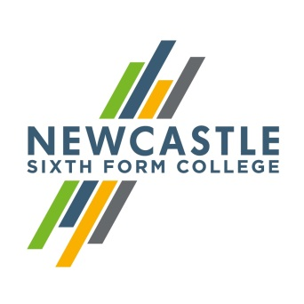

Job Description

Job Title: Digital Marketing Officer
Department: Admissions, Marketing and Outreach Team
Reports to: Admissions Coordinator
Level / Grade: H
Direct Reports: None

Summary of main purpose of Role
To take a lead role for student recruitment through the effective use of social media and digital marketing, working across a variety of channels and organising campaigns throughout the year, including an extensive programme of open days and outreach events.

Key Responsibilities:

- Contribute to the achievement of Admissions, Marketing and Outreach team targets, providing an appropriate and responsive service to managers, their staff and students.

- To plan, oversee and budget manage various marketing projects throughout the year, including student recruitment campaigns, summer enrolment, parent engagement, advice and enrolment evenings and open day campaigns.

- Identify new opportunities to raise the profile of the college as a provider of 16-18 further education and to build successful relationships locally, regionally and nationally including local and national print publications.

- To manage an exciting, engaging social media and digital marketing strategy to maximise engagement and support NSFC priorities.

- To undertake the writing, editing and proofing of marketing and event materials, including prospectuses, flyers, emails, invitations, banner stands and to manage the relevant production processes through the design.

- To work within the Admissions, Marketing and Outreach Team to provide a high quality marketing service to internal and external customers.

- Represent the college at open days, events and presentations facilitated by feeder schools and colleges when necessary; transporting and setting up the college exhibition stands.

- Recruit and coordinate a team of student ambassadors to support the development of engaging activities at internal and external events.

- To work closely with the Admissions Coordinator regarding recruitment targets and marketing plans and campaigns, including engaging parents.

- Be a brand custodian helping ensure all staff are on message with effective communication within the college including organising a staff newsletter.

- Develop and maintain a variety of databases of enquiries, contacts, courses and information collected from/for marketing and other events.

- Deal confidently and effectively with a variety of telephone and personal enquiries (internal and external) and communicate accordingly with all members of the team to ensure an effective and customer focused approach.

- Prepare documents using a variety of different sources and presentation methods e.g. word processing, spreadsheets, databases, PowerPoint, Photoshop, web design and project planning.

- Use demographic and socio-economic data to produce reports and make recommendations to inform planning and evaluation of widening participation activities

Standard responsibilities for all positions in NCG:

- Participate in any staff review/performance management processes involving the identifying and meeting of training needs for self and others.
- Take appropriate responsibility to ensure the health and safety of self and others.
- Pursue the achievement and integration of equal opportunities throughout all activities.
- Undertake any other tasks and responsibilities appropriate to the level of this post.
- Comply with all NCG policies and procedures
- NCG is committed to safeguarding and promoting the welfare of children, young people and vulnerable adults and expects all staff to share this commitment.

Person Specification

 | Essential | Desirable | Method of assessment
Qualifications / Training
2:1 degree or equivalent or better |  |  | Application Form
Experience of studying at a Russell Group University |  |  | Application Form
Experience
Experience of successfully working with young people to achieve a significant goal, this could be as a leader or participant |  |  | Application Form /Interview
Experience of digital marketing, in either a voluntary or paid role |  |  | Application Form /Interview
Experience of successfully organising events individually or as part of a team |  |  | Application Form/Interview
Experience of using digital creation software e.g. Photoshop, Final Cut |  |  | Application Form /Interview
Experience of multi-tasking and prioritising to achieve multiple demanding targets with differing deadlines |  |  | Application Form /Interview
Skills and Knowledge
A brilliant writer |  |  | Application Form
Exceptional attention to detail with the confidence to edit and proofread the work of others |  |  | Application Form
Razor-sharp ability to analyse large data sets including confidence with Excel |  |  | Application Form /Interview
Excellent communicator able to engage and enthuse a wide variety of people including students, parents, teachers and headteachers |  |  | Application Form /Interview
A willingness to develop your digital marketing skills, and knowledge of education policy, news and trends through research and collaboration |  |  | Interview
Knowledge of SQL and basic web design |  |  | Application Form
Attributes / Other Requirements
Committed to safeguarding and promoting the welfare of children, young people and vulnerable adults. We expect all staff to share this commitment  Staff will always strive to achieve 1 or 2 during lesson observation to demonstrate excellence in Teaching and Learning |  |  | Interview
Reliable and conscientious approach to work with a commitment to professional development |  |  | Interview
Able to obtain a satisfactory DBS clearance |  |  | DBS form
Eligible to work in the UK |  |  | Application Form
Passionate about the importance of education |  |  | Application Form/Interview
Self-starter who is able to manage their own work and priorities |  |  | Application Form/Interview
Full UK driving licence and access to a vehicle for business purposes or access to equivalent mobility |  |  | Application Form

