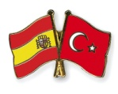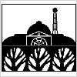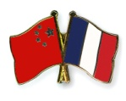
Alexandra Park School
LANGAUAGES DEPARTMENT
The Languages Department at Alexandra Park School is an exciting and forward-looking department with a truly international feel. Alongside the more traditional academic disciplines of French and Spanish which form the mainstay of the department, we teach Turkish as a timetabled course at both KS4 and KS5 and offer Mandarin across all key stages. In KS3 all students study either French or Spanish together with Mandarin. We are a Confucius Classroom and one of fourteen founder schools delivering the Mandarin Excellence Programme. Excellent teaching and learning entailing the consistent and effective use of AFL, praise and reward, and a collaborative ethic that encourage confident and enthusiastic learners are hallmarks of the department.
Our ethos

As a department, we aim to promote a life-long love of languages by:
- taking a creative and dynamic approach to teaching which brings languages alive in all of our classrooms
- promoting international links and cultural understanding through foreign trips and curriculum ventures which encourage students to see themselves as citizens of the world
- having an engaging and enticing presence in the school through both lively and colourful classroom displays and high impact linguistic and cultural events
- emphasising high achievement by equipping students with a sound understanding of grammatical structures to enable them to manipulate language for themselves and become successful autonomous learners
- providing opportunities for extra-curricular learning through a range of stimulating clubs and activities.
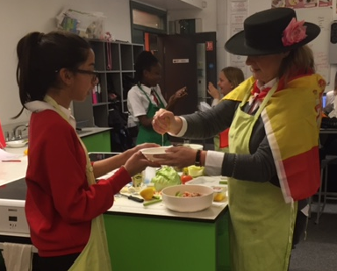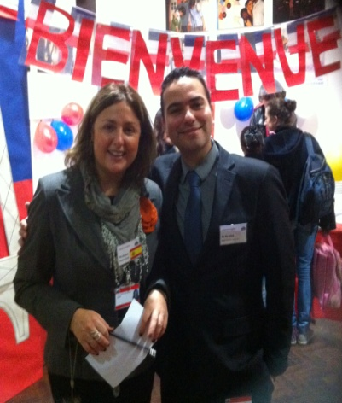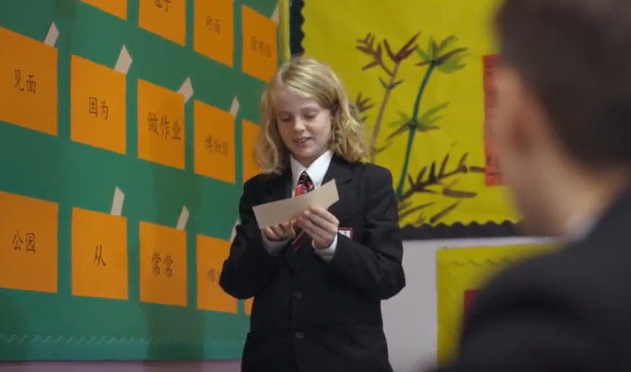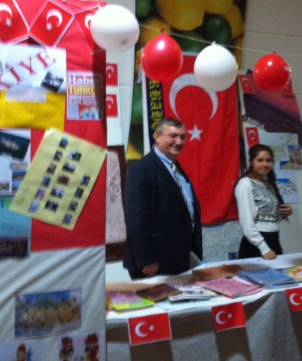

Our team
The Languages department harnesses the experience of a well-qualified and highly professional team of teachers who bring their linguistic expertise from all corners of the world. The department combines a desire for diversity with a shared vision of excellence in language teaching in which individuals pull together to share resources and approaches which can drive progress forward in this already highly successful department of our school. The Languages team currently comprises 14 language teachers including the Curriculum Team Leader, the KS3, KS4 and KS5 French/Spanish co-ordinators and 3 visiting Mandarin teachers from China. Every year we host trainee teachers. We also work closely with the SEN Department and its team of teaching assistants.

Our international links
The department undertakes cross-curricular, linguistic and cultural student exchanges with Lycée Jean Moulin in France, Cycle du Renard in Switzerland, Instituto Clara Campo Amor in Spain and Beijing No.57 School in China. Our Sixth Form students of Spanish and French have undergone periods of work experience in Santiago de Compostela and Valladolid, Spain and Monpellier, France respectively. Our Mandarin Sixth Form students enjoyed a work experience stint at Singapore’s prestigious Marine Life Centre. For the past ten years our students studying Mandarin have participated in Chinese linguistic and cultural immersion courses in various cities across China. As an international school we are always open to new ideas and are constantly reviewing our range of extra-curricular activities.
Our International Partner Schools:
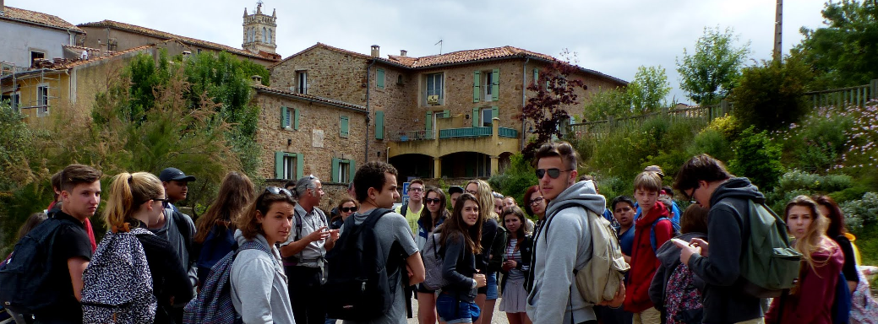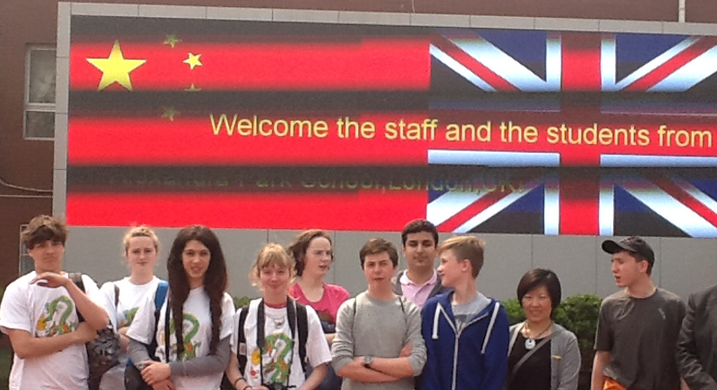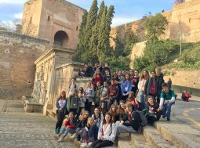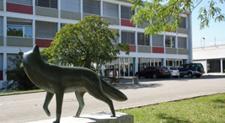
France: Lycée Jean Moulin China: Beijing No.57 Middle School Spain: I.E.Clara Campo Amor Switzerland: Cycle du Renard

Our resources
The Languages Department has a well-equipped suite of rooms with interactive whiteboards and access for all staff to a wealth of electronic and online resources as well as more conventional materials which support language learning. We use Jinbu 1 and 2 for Mandarin KS3. We follow the Edexcel GCSE Spanish, French, Turkish and Mandarin syllabi in KS4 and AQA in KS5. Our KS3 French and Spanish schemes of work are based on ‘Allez’ and ‘Zoom’. Our online resources include Kerboodle, Active Teach, GoChinese and The Chairman’s Bao.

Our results
The department consistently achieves excellent results in languages with over 90% of our GCSE students in all languages achieving A*-C over the past few years.
In addition to French, Spanish, Turkish and Mandarin, we offer students the opportunity to take GCSE and GCE examinations in home languages such as Arabic, Dutch, German, Greek, Italian, Persian, Polish, Portuguese, Russian and Japanese.
We aim to continue our development as a leading department at Alexandra Park School.

The Languages team look forward to hearing from you.
Jay Naidoo
Curriculum Team Leader

