CANDIDATE PACK

Dear Candidate,

Thank you for expressing an interest in becoming a teacher and a member of our dynamic and forward thinking team at Swanbourne House.

This presents an incredibly exciting opportunity to become part of something special. Swanbourne House provides a unique balance between tradition and the best of modern teaching practice, a beautiful setting in 55 acres of Buckinghamshire countryside and a passion for the delivery of excellence in education.

We give teachers the chance to be creative, collaborative, and by bringing teaching alive to develop the skills, passions and innate attributes of all the children.

Simon Hitchings,
Headmaster

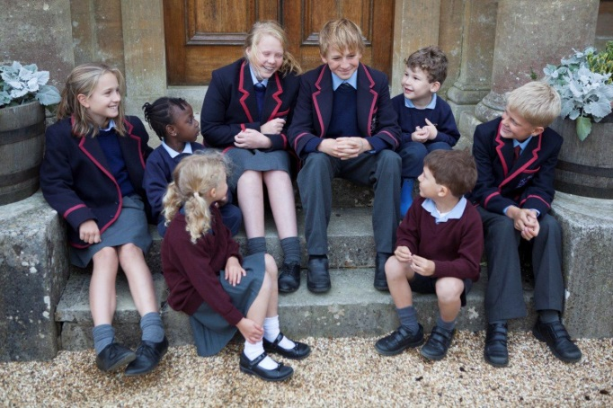
Contents – the aim of this pack is to give you sufficient background information to support your application.

1. Letter from the Headmaster

2. School History

3. Ours values and beliefs

4. School Organisation

5. Important Features of the
School

6. The local area

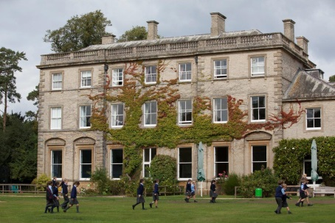
School History. The school started as a boys’ boarding school at St Andrew’s College, Bradfield in 1915 and moved with just 43 boys to Swanbourne House in 1920. Early on the School established a good reputation at cricket and football and many matches were played against other prep schools in the area. In the early years all the classes were held in the main house and all games, with the exception of tennis, took place on the lower fields. The water supply was pumped from a well in the yard and coal provided the energy for cooking and heating. The gardens and grounds were maintained by five gardeners and the large walled-garden was most productive making the School self-sufficient for fruit and vegetables. There was no secretary, no bursar, no housekeeper or administrative staff; all correspondence, accounts and housekeeping were the responsibility of the Head’s wife. There were hardly ever more than two cars on the premises and the boarders travelled to and from the School by train; their trunks and tuck boxes being brought up to the School from the station by horse-drawn carriage.

Coat of Arms. The heraldic tinctures provide the School livery colours still in use today. The swan’s heads are an allusion of the School’s name and a reference to the County of Buckinghamshire. The swan in the crest is shown holding a pomegranate, which, with its many seeds is an allusion to learning with the seeds representing the seeds of wisdom.

Motto. ‘Discendo Crescimus Vera Quaerentes’ which means ‘We grow by learning, seeking after the truth’

Swanbourne House has progressively expanded since the early days and now boasts a modern range of buildings housing a number of departments. The school has been co-educational since the 1970s. The Pre-Prep department was opened in 1980s and is situated in a late 16th century house, known as The Manor House; the Nursery was opened soon afterwards and is now housed in the Coach House extension built in 1997. The Prep school remains situated in and around the main house, which was built in 1860 as the residence of Lord Cottesloe. Three classroom blocks with dedicated Science Labs, DT Lab, and IT rooms supplement the classrooms built in the old stable block, known now as The Cloisters. Sporting facilities have been expanded with an indoor swimming pool built in 2001 and two large Astros, the latest added in 2010, and a golf course. The Bridget More Hall provides a spacious indoor sports facility as well as the venue for the frequent musical and dramatic performances which are a central part of education at Swanbourne House.

The school remains true to its boarding roots, and day pupils benefit from the ethos of a boarding school in which the range of activities and the wrap-around care extend into the evening. Flexi-boarding is strong and complements the life of the weekly and full boarders. A majority of pupils move on from Swanbourne House to board at senior schools.

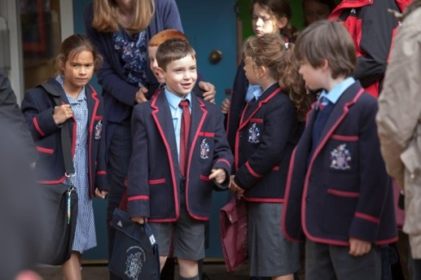
Our Values and Beliefs
Swanbourne House is a family-centred school which aims to provide a broad education. We recognise each child to be unique with individual needs and talents. We cater for pupils’ social, emotional, moral and spiritual well-being in a stimulating and creative academic environment. Day pupils and boarders are well prepared within the context of a Christian pastoral ethos for their next school and for their future lives in a fast moving and challenging globalised world.

School Organisation

Important Features of the School - We want all our teachers to teach excellent and innovative lessons consistently and be able to coach others to do the same. Successful candidates will be excited at working collaboratively across disciplines to deliver rich learning experiences and be keen to develop different pedagogies. We believe that the combined power of flexible teaching styles, adaptable learning spaces and different group sizes to meet different curriculum needs is a potent way to improve learning.

English Language is at the heart of everything we do, with pupils having the chance to develop their reading and writing skills every day. All teachers are expected to develop reading, writing and speaking skills in lessons.

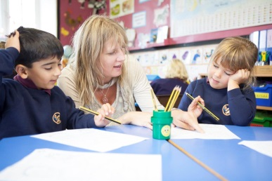
Mathematical Skills are emphasised from the Early Years upwards. A strong focus on learning number bonds and multiplication and division facts provides a strong foundation for pupils’ development. We aim to teach ahead of National Curriculum expectations and the focus on independent school exams takes our curriculum beyond national age expectations.

Integration of New Technology is becoming a central plank of the pupil’s learning experience. Whether iPads, laptops, IT suites, language laboratories or usage of the Swanbourne Digital Learning platform, pupils are constantly challenged and stretched to achieve their potential. All staff are expected, with training, to develop this practice further.

Throughout the school we take pride in a broad curriculum. French is introduced as the curriculum modern foreign language in Year 2 and Latin is added in Year 5. From Year 5 Science and the humanities are taught by specialist teachers. Preparation of children for Common Entrance or academic scholarship entry to a range of senior schools is the aim of our own schemes of work. A creative approach to teaching and learning which encompasses the development of skills and a passion for lifelong learning is encouraged.

Class Sizes are small and rarely 16 exceed pupils. Setting by small groups within classes and by creating separate classes is gradually increased as children move through the school to further stretch those who have been identified as academically capable and to support those who are progressing more slowly.

The Pre-Prep is fully integrated into the life of the school, but has its own classroom buildings, kitchen and play areas. The Pre-Prep runs from the Nursery (which takes children from the term they turn 3) to Year 2. Class teachers provide the bulk of the teaching across the curriculum. Our high academic standards mean that we accelerate most children beyond the requirements of the National Curriculum. We keep abreast of developments in the National Curriculum, but plan beyond it. Alongside the core skills of reading, writing and Maths, we seek to broaden the children’s horizons as they explore topics in Science and the humanities. Games, PE, swimming and ICT are taught in the facilities shared by the whole school. The curriculum is planned in order to provide a smooth transfer to the Prep and all pupils use the wider school facilities. Forest School is taught in Reception and Year 1 and dedicated areas of the woods by staff who are fully accredited to deliver this part of the curriculum.

The school owns a day nursery, Home Farm Day Nursery, which functions as a separate part of the business. The Head of Pre-Prep acts as line manager to the Manager at Home Farm Nursery.

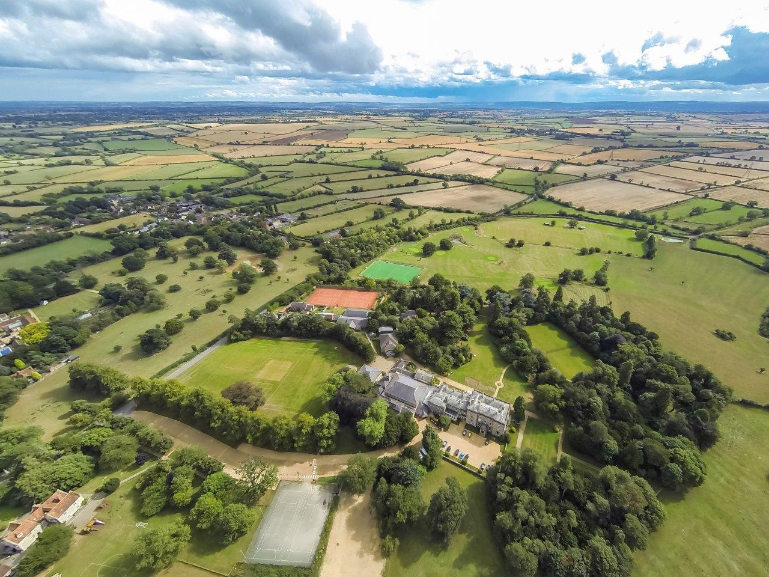
The Local Area
Swanbourne is a thriving community, nestled in the heart of the Buckinghamshire countryside, close to Milton Keynes, Buckingham, Aylesbury and Leighton Buzzard. The village boasts a general store, sub-post office and its own pub, the acclaimed Betsy Wynne, which is in easy walking distance of the School.

