Dear Applicant

Re: Post of Deputy Headteacher at Turton School

Thank you for your interest in the post of Deputy Headteacher at Turton. This is an exciting stage in the school’s development and we are looking for a dynamic colleague with determination and a clear understanding of how to sustain and develop high quality learning experiences for all our students.

Following the retirement of the current postholder, we have a vacancy for a Deputy Headteacher. We are a dedicated and hard-working leadership team, well supported by an enthusiastic and knowledgeable Governing Board. We have a clear shared vision of what we want to achieve at Turton and an open and caring community supported by a network of strong relationships which are at the heart of everything we do here.

This post provides an excellent opportunity to join a vibrant and visionary team, leading a pretty fabulous community school, where the right candidate will be supported in further developing their leadership, management and administrative skills.

The School website and Leadership Blog should give you some background information and the Job Description and Person Specification outline exactly what we are looking for. If you would like to come and meet the exciting challenges of the next few years with us at Turton, please submit your application for the post by 9.00 am on Tuesday, 17th April 2018.

We will be short-listing on Wednesday 18th April 2018, after which we will contact those candidates we would like to attend for the selection process, which will take place on Tuesday 24th and Wednesday 25th April 2018.

If you would like to visit the school before applying, please contact the Head’s P.A., Joanne Shaw. Tours will take place Tuesday 27th March and Wednesday 28th March 2018, at 10.15am.

Best wishes and good luck!

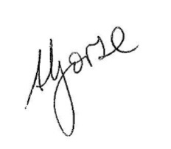
Sam Gorse Owen Hughes
HEADTEACHER CHAIR OF GOVERNORS

