

**French /German Language Assistant**

**September 2018**

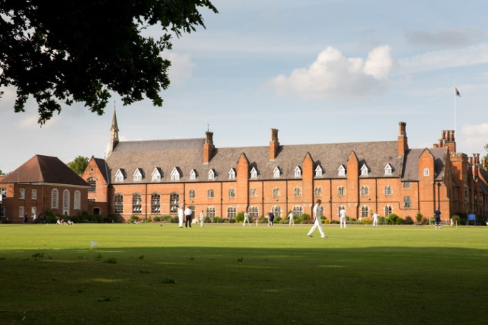Ratcliffe College is an independent, HMC, co-educational boarding and day school for children aged 3 - 18, with boarding available from age 9 to 18. The School is thriving - there are currently over 800 pupils of which over 100 are boarders, about half of these are international. Our aim at Ratcliffe is to create a learning community in which young people may grow to become confident, competent, articulate members of society.  The School was founded in 1847 by the Institute of Charity. Founder Antonio Rosmini was renowned as an educational innovator and that spirit has propelled the College forward ever since. The College ‘Victorian Gothic’ buildings were designed by Augustus Welby Pugin, who co-operated with Sir Charles Barry on the design of the Palace of Westminster. The school is set within 200 acres of beautiful grounds seven miles north of Leicester, in the Midlands and within easy reach of airports and motorways.  Whilst we are a Catholic school, children of other denominations and faiths, and none, are welcome.

**ISI Inspection 2015**

In the latest ISI inspection in March 2015, the School was judged to be “Excellent”, the top accolade, in all nine categories.

This role is for a native speaker of French/German to help with conversational French/German to students in Years 10 & 11 (GCSE) and Years 12 & 13 AS/A2 level. The person appointed will be required to work for 20 hours per week (term time only), as well as assisting within the boarding houses.

Within the Boarding Houses, you will be working with the Residential Housemaster/Housemistress, Assistant Housemasters/Housemistresses and other Boarding staff. You will be required to be on duty, assisting with activities, trips and supervision.

This is a residential appointment, accommodation is provided free of charge together with all meals during term time. Meals are taken in the School refectory.

The Languages department is housed in a refurbished suite of classrooms in its own block.  The facilities consist of three classrooms around a central area.  There is also a departmental office and a languages tutorial room which houses a number of networked computers; there are also two other large classrooms (French, Latin) in an adjacent building.

There is a plentiful supply of textbooks and digital resources.

The department consists of the Head of Department, two full time, four part-time members of staff and three language assistants (French, German and Spanish).  The Languages department is a very successful department within the school; it has outstanding leadership and achieves excellent examination results at GCSE and AS/A2 level.

The teaching resources include:

* Interactive whiteboards in each classroom
* Access to school networked computers.
* Ample textbooks and reading materials for use at each level.

The department organises regular visits to France, Germany and Spain; there are annual homestay visits to Nice/Montpellier and Salamanca/Granada at Easter an exchange visit with a Gymnasium in Koblenz.

Ratcliffe College is committed to safeguarding and promoting the welfare of children and applicants must be willing to undergo child protection screening appropriate to the post, including checks with past employers and Police checks.

For further information about Ratcliffe College please see our Website:

[www.ratcliffe-college.co.uk](http://www.ratcliffe-college.co.uk)

Application packs are available from the website <http://ratcliffe-college.co.uk/home/careers/>

**Closing date for receipt of applications is 4.30pm on Friday, 20 July 2018.**

**Application forms to be emailed to** [**HR@ratcliffe.leics.sch.uk**](mailto:HR@ratcliffe.leics.sch.uk)

Before Governors confirm a permanent appointment, a satisfactory report of general health will be required of the selected candidate. Ratcliffe College is committed to safeguarding and promoting the welfare of children and applicants must be willing to undergo child protection screening appropriate to the post, including checks with past employers and the Disclosure and Barring Service.



**THE ROLE OF THE LANGUAGE ASSISTANT**

The role of the Language Assistant is to develop the students’ oral fluency in French/German/Spanish and to help students prepare for speaking assessments in both public and school examinations. In addition, the Language Assistants will live in at the School and assist with boarding duties.

**Assistance in the Language Department:**

(Supervised by the Head of Languages)

The majority of the lessons will be with Years 10-13, but the younger years (Years 7-9) may also be taught. Students will be taught individually or in pairs, in a bright, purpose-built suite of language rooms. Full access to networked computers and other audio/visual equipment is available.

Topics will be discussed and agreed with the class Teacher and you will be given some resources to help you, but you will also be expected to develop your own materials to use with the students.

You will work 15 hours per week within the Languages Department.

In addition, you will be invited to assist with the marketing of French/German/Spanish through cultural evenings, Open Days, trips abroad and language clubs, as well as supporting language teachers in some administrative tasks.

**Assistance in Boarding:**

The Assistant Head has specific responsibility for the management of the Language Assistants who live in, though their languages work is supervised by the Head of Languages and their boarding duties are co-ordinated by the Senior Boys’ Housemaster or Senior Girls’ Housemistress, as appropriate.

To reside in the Boarding House during term time;

Working under the direction of the Senior or Assistant, Housemaster/Housemistress as part of the duty team, you will be required to be on duty, assisting with activities, trips and supervision for a maximum of:

* five weekday evenings per fortnight.
* every other weekend during term times.

There may be occasions when you are required to sleep overnight in a duty room.

**Salary:**

You will be paid a salary of £12,000 (split into 10 equal monthly payments) plus all accommodation and meals during term time. Your final salary payment will be at the end of June 2019.

**General:**

* You will be required to provide supervisory cover in the mornings, on a rota basis.
* You will carry out any other tasks that might reasonably be required by the school to promote the educational experience of the students.
* You will work according to the Rules, Policies and Procedures of Ratcliffe College.
* You will work according to Health and Safety Regulations being aware of your own safety as well as the safety of others.
* You will be employed on the terms and conditions for Support Staff.