Teacher of Physics
For September 2018

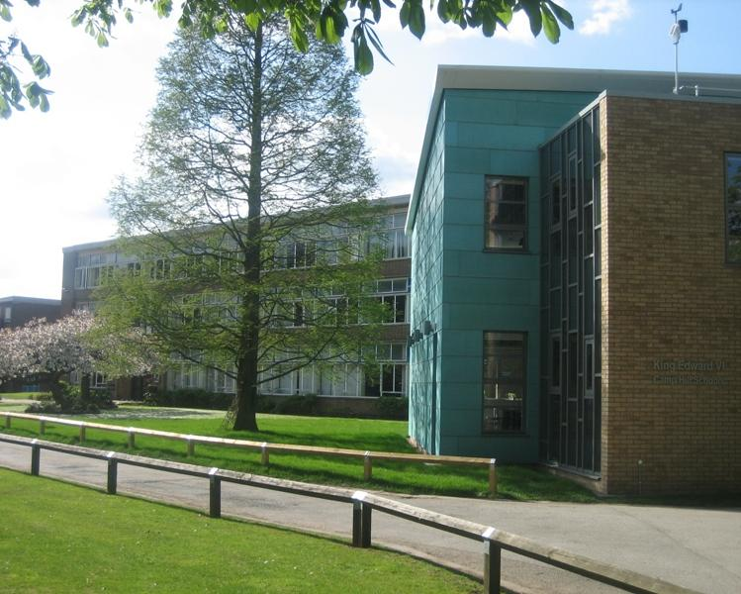

January 2018

Dear Applicant,

Thank you for requesting information about our Teacher of Physics post.

In the enclosed booklet you will find information about the department and the role.

Academic results at King Edward VI Camp Hill School for Girls are outstanding, and girls make excellent progress as they move through the different key stages.

Pupils tell us that they also find this a happy and caring place to be, with excellent relationships between the girls and with staff.

This is an exciting school, where pupils experience a high quality range of curricular and extra-curricular opportunities, and where they can develop a love of learning, respect for each other and the leadership skills needed for successful careers.

The School also provides a sustained professional development programme, and an opportunity to work with talented staff and congenial colleagues.

We look forward to hearing from you.

Best wishes

Linda Johnson
Head Teacher

The Physics Department

STAFFING:
Becky Nicholson – Subject Leader
Richard Dewes
Other members of the Science department currently teach some Physics up to GCSE level.
The department works closely with the other two sciences, Biology and Chemistry, sharing common goals and strategies to develop students with rigorous scientific skills and an enjoyment of the subject matter.

SUPPORT STAFF: There is technical and administrative support for the department. We are well supported across the Science department by two full time and one-part time technicians.

ACCOMMODATION AND RESOURCES:
Practical work is integral to the teaching of the subject and the department is well resourced with three dedicated physics laboratories equipped for A level work. Laptops are available to book for physics lessons.

CURRICULUM:
Students are taught physics as a separate compulsory subject from Year 7 – 11. Students in Year 7 and 8 currently follow the Science Works Scheme of work which encourages and develops the students understanding of Physics in preparation for the new GCSE specification. From Year 9 onwards, the girls work towards GCSE Physics following the AQA specification.
Physics has grown as an A level subject with two groups in Year 12 and two classes completing the existing specification in Year 13. Students in Year 11 and above are supported in their learning by lunchtime sessions and a weekly workshop open to all physics students.

ENRICHMENT ACTIVITIES:
The department is keen to promote the subject through a selection of extra-curricular events. In recent years the Physics department has organised and promoted a variety of trips including Lectures at Birmingham University, Science Live for A-level and a well-attended trip to CERN.

STUDENTS:
We are most fortunate in the skills, talents and qualities which our students possess. Their responsive nature and willingness to learn and succeed provide an exceptional teaching and learning environment. They offer an enthusiastic secondary teacher a fulfilling opportunity to truly enjoy the teaching of their subject at an intellectual level. There are currently just over 300 students in the Sixth Form, drawn from our Year 11 and from other local schools. Physics usually attracts 30+ at A Level.

REQUIREMENTS AND RESPONSIBILITIES IN THE POST:
We wish to appoint a well-qualified graduate who can contribute to the department and who can teach their subject up to A level and Chemistry or Biology up to GCSE Level. Recently qualified colleagues and NQTs with relevant experience are very welcome to apply and a part-time appointment may be possible. There is a clearly articulated and detailed programme for NQTs, as well as induction arrangements for all colleagues joining the school.

MAKING AN APPLICATION:
Applicants should complete the application form which includes the names, addresses, telephone numbers and e-mail addresses of two referees. A concise but comprehensive letter of application is expected. The details should reach the Headteacher no later than Friday 26 January 2018. Candidates who would like their applications acknowledged are asked to include a stamped, addressed envelope. Applicants will be able to tour the school on the day of interview. Please leave a message for Becky Nicholson if you have any specific questions or you can e-mail her on: r.nicholson@kechg.org.uk.

INTERVIEW ARRANGEMENTS:
On the day of interview, applicants have an opportunity to tour the School and speak to pupils. Interviews are likely to be held in the week 5 February 2018.

It is our regular practice to ask short-listed candidates to teach a short lesson of 20-25 minutes. The group to be taught will be determined to some extent by the background and experience of the candidate, and the school’s timetable on the day of interview. Candidates will find our students accepting and welcoming.

TRAVEL EXPENSES AND REIMBURSEMENTS:
Normal second-class travel is payable to all applicants who attend for interview, plus reasonable overnight expenses where this applies. Candidates from abroad receive travel expenses paid from the port of entry or airport.

We look forward to receiving your application.

Linda Johnson
Headteacher

January 2018

Job Description: Qualified Teacher:

Core purpose:
To provide a high quality educational experience for all students.

General duties and responsibilities:
To carry out the duties of a schoolteacher as set out in the “School Teacher Pay and Conditions” document.

To continue to meet the required National Standards for Qualified Teacher status.

Knowledge and understanding:
- Be familiar with the school’s current systems and structures as outlined in policy documents including Health and Safety and Child Protection Policies, Behaviour Policy and implement them.
- Have a secure knowledge and understanding of the concepts and skills in specialist subject(s) and a detailed knowledge and understanding of the National Curriculum programmes of study.
- Understand specialist subject(s) framework of 14-19 qualifications and the routes of progression through it.
- Select and make good use of ICT where appropriate within subject teaching.
- Understand and know how national, local comparative and school data including National Curriculum data can be used to set clear targets for student’s achievement.
- Understand how students’ learning in the subject is affected by their physical, intellectual, emotional and social development.
- Be familiar with subject-specific health and safety requirements, where relevant, and plan lessons to avoid potential hazards.

Planning, teaching and class management
- Plan and deliver in relation to the National Curriculum and with regard for the school’s aims and objectives, own policies and schemes of work, the teaching programme for all pupils within the class.
- Provide clear structures for lessons and for sequence of lessons, which maintain pace, motivation and challenge.
- Make effective use of assessment information on students’ attainment and progress and in planning future lessons.
- Ensure effective teaching of whole classes, groups and individuals, establishing high expectations of behaviour and attainment, so that teaching objectives are met.
- Ensure coverage of the relevant examination syllabuses and School Programmes of
Study.
- Exploit opportunities to improve students’ basis skills in literacy, numeracy and ICT.
- Monitor and intervene when teaching to ensure sound learning and discipline and maintain a safe environment in which students feel confident, both in the classroom and around school.
- Use a variety of teaching and learning styles to keep all students engaged.
- Be familiar with Codes of Practice and identification, assessment and support of students with special educational needs.
- Evaluate own teaching critically to improve effectiveness.

Monitoring, Assessment, Recording, Reporting and Accountability
- Assess and record each student’s progress systematically with reference to the school’s current Assessment Policy and use the results to inform planning.
- Mark and monitor class work and homework, providing constructive feedback and setting targets for future progress.
- Provide reports on individual progress to the Headteacher and parents as required.

Other Professional Requirements
- Establish and maintain effective working relationships with professional colleague and parents.
- Participate effectively and appropriately in meetings with professional colleagues and parents in respect of the duties and responsibilities of the post.
- Be aware of the need to take responsibility for your own professional development.

This job description may be amended at any time, following consultation between the Headteacher and member of staff and will be reviewed annually.

King Edward VI Camp Hill Girls’ School is committed to safeguarding and promoting the welfare of children and young people and expects all staff and volunteers to share this commitment. The successful applicant will be required to undergo an enhanced Disclosure and Barring Service check.

Person Specification: Qualified Teacher

 | Essential | Desirable
Qualifications | - Appropriate subject degree.  - Qualified teacher status/PGCE. | - Good honours degree.
Experience | - Experience of teaching in the secondary phase. | - Some Pastoral experience.  - Some Sixth form teaching experience.
Classroom teaching skill | - Record of successful teaching.  - Meeting national standards. | - Innovative and creative approaches to teaching and evidence of strong performance.  - Confident use of ICT.
Knowledge and understanding | - A clear philosophy about the teaching of the subject.  - Knowledge of appropriate teaching methods for delivering the subject.  - Subject knowledge sufficient to challenge able students and achieve high outcomes. | - Ability to take responsibility for own professional development.  - Awareness of strategies for improving well-being, learning and achievement for high ability students.
Curriculum | - Familiarity with the nature and purpose of assessment/ reporting particularly re enabling pupils to improve.  - Familiarity with key concepts of values. | - Familiarity with current initiatives.
Personal attributes | - Ability to work under pressure and meet deadlines.  - Good personal organisation.  - Good interpersonal skills.  - Ability to work independently and cooperatively as a member of the team.  - Reliability and integrity.  - Applicant required to demonstrate their suitability to work with children – this will include motivation, ability to maintain appropriate relationships with children, emotional resilience to challenging behaviour and attitudes to the use of authority and maintenance of discipline. | - Range of interests and willingness to participate in extra-curricular activities.  - Pragmatism, humour and optimism when dealing with emerging adults.

Last updated: February 2016

