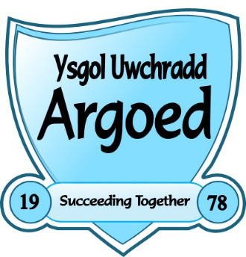

ARGOED HIGH SCHOOL
Bryn Road, Bryn-y-Baal, Mold, CH7 6RY

Tel: 01352 756414 Fax: 01352 750798
e-mail: contact@argoedhs.co.uk

11-16 Mixed Comprehensive
NoR: 564
Headteacher: Mrs Dawn Spence

Progress Leader (3 Posts)
Full Time and Permanent from 1 September 2017.
Salary: Main Pay Scale + TLR 2c (£6,511)

The Argoed High School has a proven record of delivering high quality outcomes for our learners. It is a highly successful, 11-16 comprehensive with an excellent reputation in the community.

This is an exciting opportunity to become one of three new Progress Leaders who will make a positive and measurable impact on progress, behaviour and attendance, taking responsibility for either Year 7/transition, Years 8 & 9 or Years 10 & 11.

The successful candidate will:

- have a full understanding of what makes an outstanding and successful learning experience;
- have experience of devising, monitoring and reporting on the impact of academic and pastoral interventions;
- be an excellent teacher;
- have a proven track record in providing success for students;
- have the ability to teach a KS3 and KS4 core subject (desirable);
- have the drive and intent to secure improvement and raise aspirations for our students;
- have proven leadership ability and work successfully as part of a team.

If you have a passion for teaching and learning and are keen to contribute to our unstoppable improvement journey, we would love to hear from you.

Argoed High School is fully committed to the safeguarding of its pupils; the successful candidate will be required to have full, enhanced DBS clearance.

Please return applications, with covering letter, to the Headteacher, Mrs D Spence, via e-mail to: contact@argoedhs.co.uk, or by post to the address above.

Closing date for applications: 12.00 Noon, Friday, 23 June 2017
Interviews will be held: 27 June 2017.

