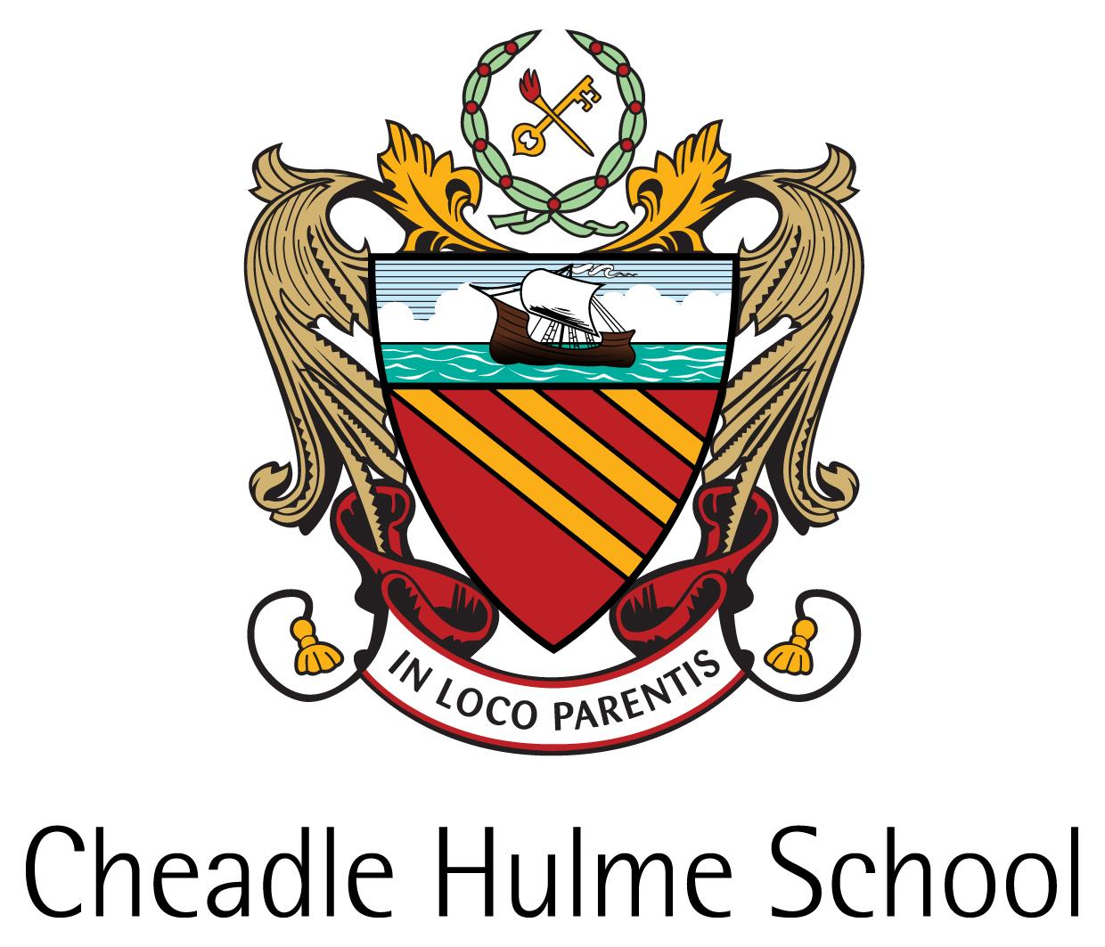
Donor Relations & Database Manager
Required for February 2018

The School - A Background

Founded in 1855 by a small group of Victorian philanthropists in Manchester, Cheadle Hulme School began its life educating the “orphans and necessitous children” of warehousemen and clerks during the Industrial Revolution.

Over the years since its inception, the School has grown in ways far beyond the imaginings of its Founders: the introduction of fee-paying day pupils was the first step towards the School becoming, as it is now, a very successful, independent, co-educational HMC day school, providing high quality education to boys and girls, aged 4 to 18, from all over the North West.
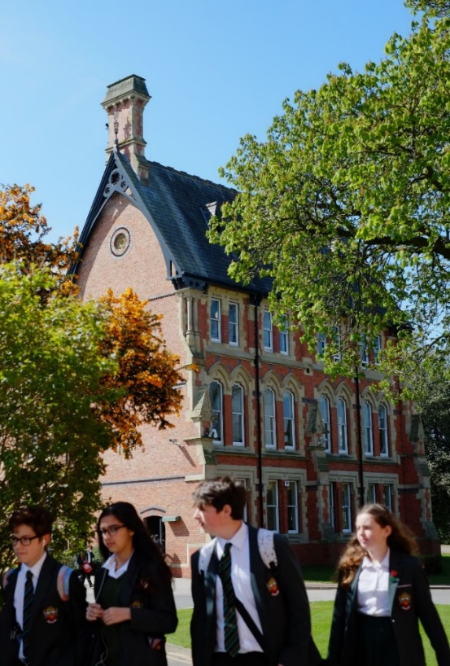
The School currently has 1414 students and is truly co-educational: there are 648 girls (46%) on the school roll and
766 boys (54%).

The School is committed to honouring the original intentions of the Founders by providing bursaries for students
whose financial background would otherwise preclude them from a CHS education.

The School has a Ten Year Strategic Plan (2011-2021) which informs its future aspirations and priorities.
Cheadle Hulme’s vision and aims
What it is like to work in Cheadle Hulme School.

The School’s Aims
- That each student experiences a challenging, dynamic and relevant education which enables them to reach
their full academic potential and flourish in a rapidly changing world;
- That each student develops a love of learning that extends beyond the confines of examination courses,
and is able to work effectively in a variety of settings;
- That each student develops a strong set of personal values and learns to value themselves and others,
appreciating difference and individuality and supporting those in need or less fortunate than themselves;
- That each student discovers and develops a broad and relevant set of skills and aptitudes, which enable them
to undertake useful and effective roles in their communities.
Curriculum
Cheadle Hulme School is an academically selective school that prides itself on providing a challenging academic curriculum, aiming to stretch and develop the intellectual capacities of each student.
The School offers a broad curriculum, which begins in the Junior School, where from Reception, children are gradually introduced to the study of particular subjects, with the emphasis on literacy and numeracy. From Year 3, students follow a subject-based curriculum which includes ten subjects.
In the Senior School the curriculum is broader. In the first two years (Years 7 & 8), all students gain experience in: English, Mathematics, General Science, French or Spanish, German (Year 8), Classical Civilization, History, Geography, Religious Studies, Latin, Computing, Design Technology, Art & Design, Music, Food Preparation & Nutrition, Drama, P.E., Swimming and Games. In Year 9 General Science is replaced by Physics, Chemistry and Biology.
All students take nine subjects at GCSE/IGCSE which include English Language, English Literature, Mathematics and a Modern Foreign Language. Students can take either separate sciences or Dual Award Science. They choose their other courses from a wide range of options. IGCSE is currently taken in Biology, Chemistry, Drama, English Language, English Literature, French, German, History, Mathematics, Science (Dual Award) and Spanish. In the last two years, both GCSE PE and Computer Science have been included in the range of subjects available, whilst Further Maths and Greek are available as additional subjects. Alongside the academic curriculum, students have lessons in Well Being, Physical Education and Games from Year 7 through to Year 11.
At post-16, CHS offers Advanced Level and Cambridge Pre-U examination courses. Students in the Lower Sixth will most commonly take four subjects; reducing to three in the Upper Sixth. An increasing number of students complete an Extended Project Qualification in addition to their A Level and Pre-U courses.
At Advanced Level, the School offers: Art & Design, Biology, Chemistry, Classical Civilisation, Design & Technology, Drama & Theatre, English Language, English Literature, Further Mathematics, Music, History, Latin, Mathematics, Politics, Physical Education, Physics and Psychology.
Pre-U courses are followed in Business & Management, Economics, French, Geography, German, Philosophy & Theology and Spanish. Alongside the academic curriculum, students take part in Sixth Form Enrichment and Games Programmes. In the Upper Sixth, students take a weekly Extension Class in the subject area for which they will be applying at university.

Pastoral Care
Cheadle Hulme School has a reputation for outstanding pastoral care; the School’s motto ‘in loco parentis’ is as relevant today as it has ever been and the welfare of every student remains a priority.
Whilst the Head has ultimate responsibility for all aspects of the School’s running, the Deputy Head (Pupil Progress and Welfare) leads and manages the delivery of the School’s pastoral vision and through the pastoral team, monitors the progress made by every student in the areas of academia, co-curricular and personal development to ensure that the School ensures the attainment of its Aims for every child.
The Senior School is divided into three smaller Schools; The Lower School – Years 7 and 8, The Upper School – Years 9, 10 and 11 and The Sixth Form – Lower 6 and Upper 6, to allow students to feel part of a smaller community and to ensure that every student is known and feels valued.
An enhanced tutor system, which places the Form Tutor as a mentor at the centre of the student’s school life, provides students with the guidance that they need to build on their skills and further develop their academic profile over the course of their education. The Form Tutor is a fundamental person in the life of each student and is the first point of contact for parents.
Overseeing each team of Form Tutors is a Head of Year, who is responsible for leading and managing that Year group to enable each student to work positively towards achieving their potential in academic, pastoral and co-curricular fields. Heads of Year are supported by the relevant Assistant Head who is responsible not only for the strategic development of their School, but also for the tracking of student progress and monitoring and reviewing the pastoral care within their area. The three Assistant Heads work closely together to ensure consistency across schools and to facilitate a smooth transition between Schools.
The School has dedicated Safeguarding Officers, a Head of Learning Support, a Head of Well-Being, and a medical team comprising of highly trained First Aiders, a School Nurse and a School Counsellor where students can be referred or self-refer where appropriate. Senior students also take an important role within the pastoral support system of CHS, acting as Peer Mentors to younger students and mentoring individuals. The School has a proactive Careers Department who provide guidance and advice to students throughout the different stages of their education.
Pastoral Care is central to everything at CHS and is promoted in many different ways; through the positive School environment and ethos, through a coordinated pastoral programme involving assemblies and tutor time activities, the numerous opportunities to be involved in charity events, the delivery of discrete Well-Being lessons, student mentoring and leadership and the extensive co-curricular programme to name but a few.

Co-Curricular Activities

Great emphasis is placed on co-curricular activities; we believe in the value that the students derive from learning beyond the classroom, of developing their talents and improving their social skills through diverse activities.

A House system has been recently re-introduced and there are numerous House activities encouraging participation in sport, music, drama, charitable events and academic competitions. The House structure also provides many opportunities for leadership.

All students participate in the Games programme as part of their curriculum, through which they sample all the major sports. Beyond this, pupils are able to engage with a wide range of further sporting opportunities through social and team practices.

The School has a justified reputation for the quality of its Music. Young musicians have a chance to play or sing in a range of choirs, the Big Band, the Concert Band, the Orchestra and numerous other ensembles.

We have a long and proud tradition of dramatic productions: two major productions are staged each year as well as there being GCSE and Advanced Level showcase evenings. There is a flourishing Musical Theatre Club pupils and an annual Sixth Form self-directed production.

Lunchtime and after-school clubs and societies exist to give every student the opportunity to broaden themselves and their education. A wide range of educational trips are also offered with some day trips taking place during curriculum time and many longer residential visits undertaken in the holidays. Comprehensive details of these can be found in the ‘CHS Life’ section of the School’s website.
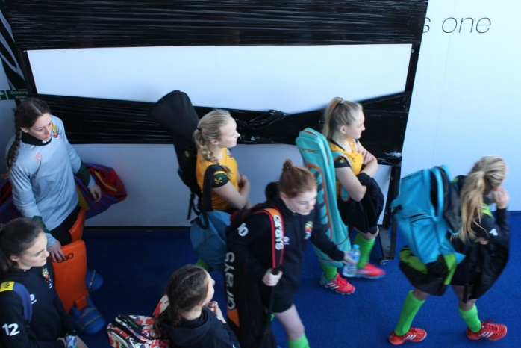
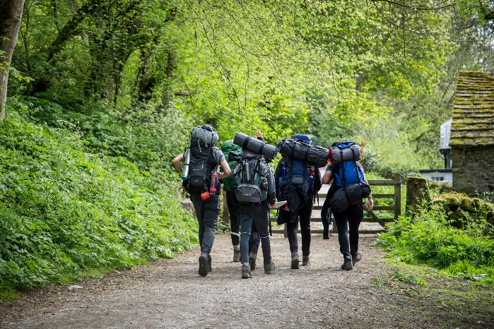
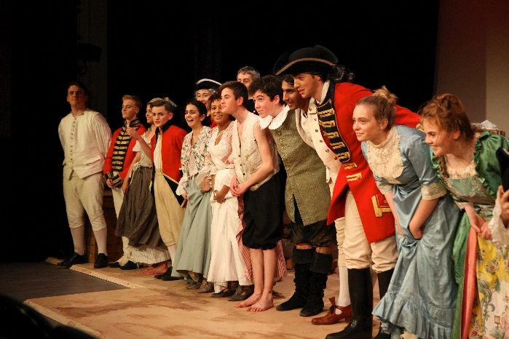
The External Relations Department

External Relations is a crucial team within the School. It aims to understand and positively influence the School’s place within the external environment and manage relationships with stakeholders to inspire positive action in support of the Ten Year Plan. The Department encompasses communications, branding, parent relations, alumni relations, fundraising and local community relations.
The principal aims of the External Relations Department are:

- To widely articulate and promote the ethos of Cheadle Hulme School (CHS) and generate awareness of the School’s short, medium and long term aspirations.
- To build and protect the reputation of Cheadle Hulme School.
- To develop strong relationships with all members of the CHS community.
- To create, manage and sustain a long-term fundraising programme in order to build a continuous culture of giving and, in so doing generate the necessary additional income to fund the School’s development plans.
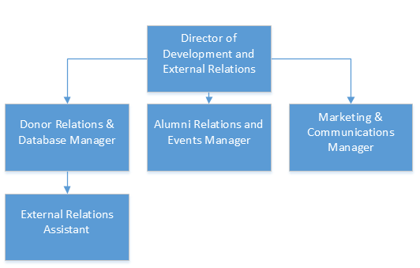

The Appointment

The School seeks to appoint a Donor Relations & Database Manager on a full-time basis, all year round. Reporting to the Director of Development & External Relations, the individual will be responsible for continuing to develop relationships with and expand the existing programme of events for our alumni and parents, working within our highly successful External Relations Department. Excellent working knowledge of Raiser’s Edge is essential, as are strong communication and team working skills. Competitive remuneration package, subject to qualifications and experience.

Please refer to the Job Description and Person Specification for further information.

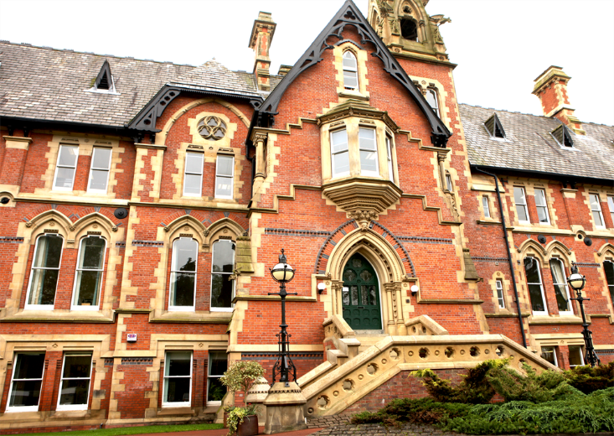

Remuneration package  The successful candidate will be offered an attractive salary, dependant on experience. A Defined Contribution Pension Scheme is offered as part of that package. The Governors subscribe to a private health scheme on behalf of permanent staff. Children of permanent staff who attend the Senior School also receive a staff discount.  Application procedure  A completed Application Form is to be submitted by 9am on 03/01/2018, to the Human Resources Department:  Phone Number: 0161 488 3330  Email: humanresources@chschool.co.uk  Postal Address: Cheadle Hulme School, Claremont Road, Cheadle Hulme, Cheshire, SK8 6EF  Interviews will take place on 10/01/2018. Unfortunately if you have not heard from the School in response to your application by 05/01/2018, you will not have been short-listed for interview.  (Cheadle Hulme School is committed to safeguarding and promoting the welfare of young people and expects all staff and volunteers to share this commitment. All appointments at Cheadle Hulme School are subject to clearance by the Disclosure & Barring Service and to identity and qualification checks).  Cheadle Hulme School is an equal opportunities employer and values a diverse workforce; we welcome applications from all sections of the community.  Registered Charity Number 1077017 for the education of children. | 