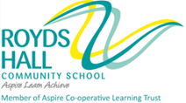

March/April 2018

Dear Colleague

Thank you for your interest in the position of Head of Community at Royds Hall Community School. I enclose an application form together with details of the school and the post for which you are applying. I hope you find the information to be both interesting and useful.

Royds Hall Community School is a successful and over-subscribed through school providing first-class education for 1200 children from age 3 to 16 across three sites, with 11-16 students based in the Wilson Building, 4-11 at Luck Lane Primary and 3-11, including nursery, at Beech Primary. The Primary Phase has 323 pupils on roll and will reach 544 pupils by September 2020.

We are the Kirklees Specialist Provision Hub for students with Speech, Language and Communication Need. Our school is enriched by its diversity. Approximately 40 per cent of students are from various ethnic minorities and, with more than 26 languages and 30 countries represented in school; we take great pride in our role at the heart of the local community.

We are an active member of the Aspire Cooperative Learning Trust and work closely with local primary schools in the Aspire Trust to develop and share best practice. Our entire community benefits through opportunities provided through our trust partner organisations the University of Huddersfield, Huddersfield New College, Huddersfield Town Football Club and the Holmfirth Fair Traders Association.
At Royds Hall we are delighted to have;
- Happy, confident and aspirational students who express a real pride in their school
- Expert staff in all areas with a passion for learning and a determination to ensure all students maximise their potential
- Calm and purposeful learning environments
- Excellent partnerships between students, parents, staff, governors and community
- A forward-thinking and innovative approach to teaching and learning throughout the school

Clearly, I am looking for someone who shares my enthusiasm for the school and is prepared to make a major commitment to its future as a Head of Community.

In addition to the Kirklees application form, please describe how your experience to date fits you for the post. (No more than 2 sides of A4)

Applications should be returned to school by 12 noon on Monday 23rd April 2018

As we are unable to write to all unsuccessful applicants, if you do not hear from me again, may I thank you again for your interest and wish you every success with any other applications you may make. Due to time constraints we are only able to provide feedback to applicants who reach the interview stage.

The school is committed to safeguarding and promoting the welfare of children and young people and expects all staff and volunteers to share this commitment.

I look forward to receiving your application.

Yours sincerely
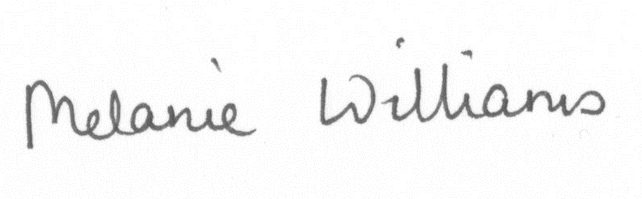
Melanie Williams
Executive Headteacher

