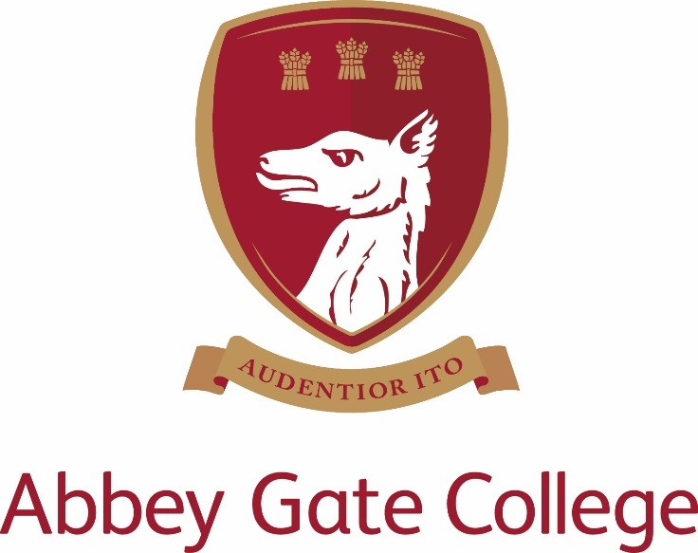
Temporary (maternity cover)
Head of Modern Foreign Languages

Required by 10 April 2018

Abbey Gate College – Head of MFL (Temporary Maternity Cover)

The College
Abbey Gate College is the longest-running coeducational independent school in the Chester area, catering for circa 485 pupils aged 4-18 years. Set in the idyllic rural villages of Saighton and Aldford on the outskirts of Chester.
Our pupils are at the heart of everything we do. We believe education is about building self-esteem, a love of learning and igniting a desire in all our students, to ensure they fulfil their academic and personal potential. We strive to guarantee our children leave Abbey Gate College as confident, articulate, respectful and happy young high achievers.
From the youngest in Foundation to our Sixth Formers, we aim to develop skills for life; core values such as respect and compassion within the framework of an excellent education. Developing talents and skills in a wide range of areas are encouraged, success is celebrated and endeavour is recognised.
The Post

We are seeking a temporary (maternity cover) Head of MFL who is dynamic and highly motivated. The role is full time and we are looking for an experienced MFL teacher (Teacher of Spanish and French) to join our innovative department as Head of Modern Foreign Languages to start by 10 April 2018. The successful candidate will teach Spanish and French across the year groups in the Senior School, with some lessons to include Year 5 and 6 Spanish lessons with the Junior School pupils. A willingness to participate in extra-curricular activities, including trips abroad within the MFL framework or beyond is desirable.

The Head of MFL is responsible for the overall control of MFL at the College. The Department achieves excellent examination results and comprises of one full time HOD, one full time and two part time members of staff. The MFL Department team work together to share outstanding practice and resources, and to develop the curriculum and schemes of work, particularly in light of recent changes to examinations. Valuing our pupils is a top priority and we offer a variety of opportunities and responses in order to tailor our teaching to the individual.

Curriculum

- Year 7 experience an introduction to three languages in carousel format; French, German and Spanish
- Year 8 pupils select two of these languages and continue with one or two languages into Year 9.
- All pupils are expected to study one language at GCSE but we offer the opportunity to study two if desired.
- At present we offer all three languages (French, German and Spanish) to A Level dependent on choices.
- The successful candidate will teach a timetable of lessons including Spanish and French. Involvement in departmental planning and supporting extra-curricular activities is involved.
Key Responsibilities

- To manage and deliver the teaching of MFL as an examination subject at GCSE and Sixth Form.
- To monitor the progress of individual students, including recording and reporting.
- To manage the teaching of MFL as a curriculum subject throughout the College.
- To promote MFL throughout the College.
- To manage the departmental budgets.
- To manage MFL resources, including Health and Safety issues.
- To manage any staff involved with teaching the subject
- To coordinate extra-curricular MFL events.
- To give positive and sustained leadership to the MFL Department thereby ensuring that it operates as effectively as possible.
- To report and update the Headmistress on matters relating to MFL and update the Departmental Development Plan.
- To report directly to the Deputy Head (Academic) on all matters relating to the MFL curriculum.
- To organise and plan the MFL teaching lessons for timetabling purposes.
- To ensure that all staff involved in the delivery of MFL are effectively deployed and that responsibilities are fairly distributed across the department.
- To manage the performance of MFL teachers so that the department fits in with the College plans in terms of effective learning and progress and to ensure that specification requirements are met for public examinations. Offering help, advice and curriculum leadership to MFL staff and supporting their professional development and training.

In addition to these duties as Head of MFL, all staff at the College are expected to help with the pastoral development of pupils, which will include acting as a form tutor and the duties associated with this role. Other contributions to the extra-curricular life of the College will also be welcomed.

The post-holder’s responsibility for promoting and safeguarding the welfare of children and young persons for whom s/he is responsible, or with whom s/he comes into contact will be to adhere to and ensure compliance with the College’s Child Protection Policy Statement at all times.

Key Qualities and Person Specification:-

The person appointed should demonstrate the following skills and qualities:-
- Have outstanding professional and personal qualities
- Have the ability to lead learning in MFL and act as a model of good professional practice
- Inspirational teacher
- Show good planning skills
- Well organised
- Calm under pressure
- Be enthusiastic, innovative and willing to share creativity and positivity in both the classroom and the department
- Be committed to raising standards and monitoring pupil progress
- Be caring, supportive and willing to adapt their teaching to suit the needs of the pupils
- Be proficient with the use of ICT in the classroom
- Be willing to assist with school trips in the UK and abroad

Salary
The salary for this position will depend upon the qualifications and relevant experience of the successful candidate.

Child Protection
Abbey Gate College regards as paramount the welfare and safety of children. Whilst criminal convictions are not necessarily a bar, this safety consideration will be key to all decisions regarding the employment of staff, approval of volunteers and standards of external contractors.

Equal Opportunities
We are committed to treating all employees with dignity and respect regardless of race, ethnic background, nationality, colour, gender, transgender status, pregnancy, age, sexual orientation, religion or belief. We therefore welcome applications from all segments of the community.

Applications
Candidates should complete an Abbey Gate College Application Form and submit this together with a letter explaining their interest in and suitability for the post addressed to Mrs Tracy Pollard, Headmistress, outlining their suitability for the post.

The closing date for applications is 4pm on Monday 27 November 2017; interviews scheduled for the week commencing 4 December 2017.

The interview process will include; the candidates will meet the Headmistress, Deputy Heads and Head of Modern Foreign Languages and have a tour of the College. Candidates will be asked to prepare and deliver a language lesson (details confirmed before interview).

References will be taken up prior to interview, please inform your referees.

Please mark the envelope:

Rebecca Upton
Human Resources
Abbey Gate College
Saighton Grange
Saighton
Chester CH3 6EN

Alternatively you can send your application electronically by email to: - rebecca.upton@abbeygatecollege.co.uk

