.
Parklands High School

Teacher of
Food & Nutrition

Application Pack

Learn, Respect,
Aspire, Achieve

-

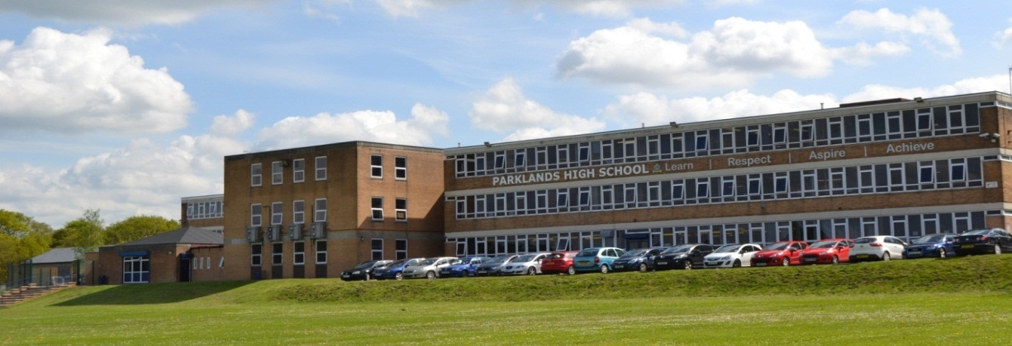

‘The good achievement of different groups of students shows the school’s dedication to ensuring that all students have an equal chance to achieve well’
(Ofsted November 2014)

November 2017

Dear candidate,

May I take this opportunity to introduce you to Parklands High School, an over-subscribed, successful, supportive and high achieving academy with 1071 pupils on roll. The school plays an active role in teacher training and in collaborating with other schools and it is also one of only 8 schools in the country to have been awarded the SSAT Leading Edge Framework For Exceptional Education in recognition of its innovative work in transforming learning behaviours.

I believe our school is a magnificent place to teach and help develop the next generation. Our school is a lovely, warm and effervescent community; our students are an absolute delight, and we receive constant praise from members of the community and visitors to our school about their mindfulness, manners, generosity and mature approach to their experiences in school. We are not an exams-factory; although our students achieve extremely well, we believe that a holistic education is paramount, and we encourage like-minded teachers to join us and contribute to our ongoing success. In return, teachers at Parklands can expect to teach due to outstanding student behaviour. Teachers enjoy a calm, purposeful and orderly school community where mutual respect is the norm. New staff to Parklands join a vibrant workforce, where there is lots going on, from school musicals and drama productions, to a multitude of sporting activities and social activities organised by staff for staff. We continually look to invest in our school and our working environment; we have a fantastic all-weather pitch, a magnificent TV studio, a state-of-the-art music recording studio, brand-new cooking facilities for students of Food Technology, a large dance studio, brand-new science laboratories, a brand-new Modern Languages block and a new dining area. For our students, our school is a wonderful place to learn, and for our staff it’s a wonderful place to make a difference!

At Parklands we aim to deliver an outstanding and exceptional educational experience to our student community. We are proud of our reputation as a forward thinking school which invests in the latest teaching and learning technologies and resources. Combined with an extensive network of pastoral support, we foster leadership skills and develop the attributes, personal qualities and social skills that will be essential to our students as they become adults in an ever changing world. Indeed, in 2014, Ofsted commented ‘The opportunities students have to enhance their spiritual, moral, social and cultural development are exemplary’.

The core values of Learn, Respect, Aspire and Achieve underpin the Parklands’ ethos and we believe that everyone, both students and staff, should strive to be the best that they can be. No matter what changes are ahead in terms of national policy, we maintain focus on offering a curriculum that stretches and challenges our students, preparing them for future careers and adult working life.

Parklands High School is a ‘Good’ school and was graded at its last inspection as Outstanding for behaviour and safety of pupils. The best schools are underpinned by strong foundations of basic discipline and respect and we have high expectations. “Students attitudes to learning in all key stages are positive…they make good progress across all subjects in all year groups” (Ofsted November 2014).

The Food department consists of two full-time teachers (one of which is the Curriculum Leader), who work closely together and support one another, constantly reflecting on their own practice. They are forward thinking, creative, innovative and supportive of change and new approaches. Due to one colleague taking a sabbatical for a year, we are looking ideally for an experienced teacher who is able to deliver the GCSE Food & Nutrition GCSE from year 7 through to year 11.

Please take time to look at our website, www.parklandsacademy.co.uk and this application summary. They can only give you a glimpse into life at our school, but I hope it will inspire you to apply for this excellent career opportunity in a school community where you can make a significant impact and where we will welcome you warmly and support you professionally.

Yours faithfully,

Mr Steve Mitchell
Headteacher

The Post

Salary Main/Upper Pay Scale (subject to experience)
TLR N/A
Contract type and term Full time, one year only
Start date 19th February 2018 (after our half-term break)

We are seeking an experienced colleague with excellent qualifications and a good track record of teaching Food & Nutrition to GCSE, although applications from NQTs/RQTs are also welcomed. The successful applicant will work collaboratively with the team, should be receptive to innovative practices and be an inspirational and motivational practitioner. You will also be expected to take an active role in all aspects of the work of the Food department and the school which is at an exciting stage in its improvement journey.

The ethos of the Food department is one of engagement, enjoyment, excellent teacher/pupil relationships and expectations of high standards for all pupils. We seek someone who will impart a love of food and nutrition to pupils. Ideas and new initiatives are warmly welcomed. A sense of humour and the ability to be a team player are vital.

The successful candidate will:

- be an excellent teacher

- be a strategic and innovative thinker

- be committed to raising achievement and levels of progress for all learners

- be focused on improving teaching and learning

- be able to inspire and motivate students and colleagues

- be a team player with excellent interpersonal and communication skills
- have excellent subject knowledge

GCSE Results: FOOD & NUTRITION

 | 2016 (20 students) | 2017 (12 students)
A* - C | 65% | 75%
A* - A | 10% | 33%
A* - G | 100% | 100%

Information for Candidates
The Food Department

The Food department consists of two full-time members of staff, one of which is the Curriculum Leader. We are in a fortunate position of all colleagues being required to be Food & Nutrition specialists. Unlike in other schools, the department does not lie within the Design & Technology department, as it has its own Curriculum Leader and autonomy. The Food department benefited last year from a huge investment which resulted in brand new kitchen facilities, partly funded by a successful bid by the department to the Savoy Educational Trust.

We are a small yet cohesive and dynamic team who work collaboratively and support one another, making teamwork essential. We are committed to creating a curriculum which inspires our learners and enhances a love of food whilst providing future life skills. We aim to ensure that Food is taught in a lively and interesting way and that students enjoy the subject. The department also provides an extra-curricular Cooking Club which has benefitted from recent funding.

As a team we are constantly trying to improve teaching and learning and enhance the experience of the students and believe that raising the profile of Food as a subject and increasing pupil enjoyment will continue to lead to continued successful progress figures and option uptake.

Students currently follow the Eduqas GCSE Food Preparation & Nutrition specification or BTEC Hospitality. We are continuing to adapt our schemes of work and assessments to ensure students are prepared for the challenge and rigour of the new curriculum.

Most Food & Nutrition lessons take place in either the newly refurbished kitchen or dedicated Food classroom (with demonstration cooking facilities) both equipped with interactive whiteboards. We also have access to bookable computer rooms to support learning and assessments and class iPads which are used in a variety of ways to enhance learning. Google Classroom is used extensively to provide learning, homework and revision experiences and opportunities. Google Blogger is also used by the department to encourage self/peer assessment and evaluation of learning by pupils.

The Application Process

Closing date Friday 8th December 2017, 12.00 noon
Proposed interview date Week commencing Monday 11th December 2017

The application form can be downloaded from the website www.parklandsacademy.co.uk Please complete this and return it to the school. In addition, please submit an accompanying statement to outline how your experiences demonstrate that you meet the person specification. Please include here details of your experience and your suitability for the post. Maximum 3 sides of A4, size 12 Arial font.

Please return applications by email, marked ‘Teacher of Food & Nutrition application’ to admin@parklandsacademy.co.uk

For an informal discussion, please contact Mrs Sharon Brookes, Curriculum Leader, either by telephone or email to sbrookes@parklandsacademy.co.uk

Parklands High School is committed to safeguarding and the process of safer recruitment. As a result, this post is subject to an enhanced Disclosure and Barring Service check, and all shortlisted candidates will be expected to prove their identity at interview. The successful candidate will be expected to show original copies of qualifications and further proof of their identity.

Parklands High School
Teacher of
Food & Nutrition

Job Description & Person Specification

Learn, Respect,
Aspire, Achieve.

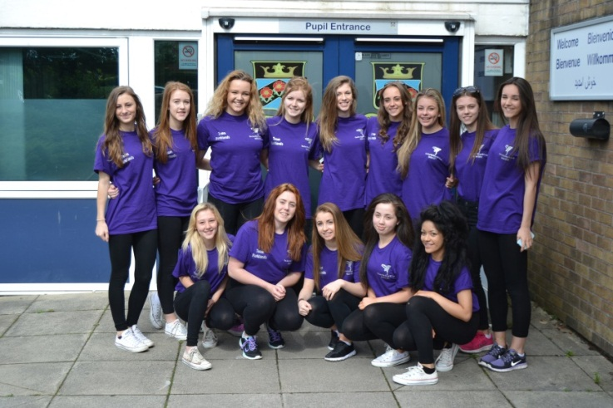

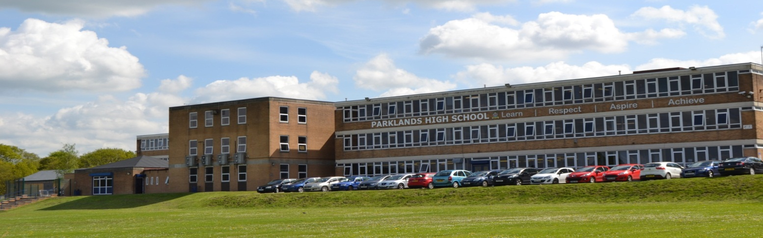

Students have good attitudes to learning….there is a calm and purposeful atmosphere …. many students are involved in extra-curricular activities and in leadership roles’
(Ofsted November 2014)

Job Title | Teacher of Food & Nutrition
Department/Area | Food & Nutrition
Responsible to | Headteacher, SLT Curriculum Manager, Curriculum Leader Food & Nutrition

Working Time
a. 190 days (or part time equivalent) of teaching a designated timetable plus 5 days (or
equivalent) in which the teacher may only be required to perform other duties.
b. Any other session as directed by the Headteacher
Prompt attendance and leadership/participation as appropriate in:
c. Staff Briefing - 8.30am and any other designated meetings.
d. Agreed pre-school, break, lunch time and post school duties
Calendar:
g. Full participation at directed time events on the annually published calendar.
h. Attendance at calendar sessions, meetings and INSET will be agreed at the start of the academic year.
i. Attendance at optional CPD opportunities.
Safeguarding | To report all information and concerns to the Designated Senior Leader.  This should be completed promptly, factually, and in line with the school’s confidentiality requirements.
Health and Safety | To comply with the school’s Health and Safety Policy and report all information and concerns to the designated representative. This should be completed promptly.

Main Duties

- Principal responsibilities:
Under the direction of the Curriculum Leader for Food & Nutrition
• To contribute to teaching and learning in Food & Nutrition including production of shared resources.
• To participate in the development and implementation of appropriate syllabi, materials and schemes of work reflecting the school’s published aims, policies and procedures. This includes the school SEF and development plan, teaching and learning policy and behaviour policy.
• To maintain accurate and complete assessment records and use them constructively to inform learning and to report to parents as required.
• To participate in the process of student target-setting, developing and implementing schemes of work and maintaining progressive learning outcomes in lessons.
• To attend and contribute to department meetings, TLC sessions and INSET training as required.

- Additional specific responsibilities:
• To be the form teacher of an assigned form group.
• To undertake the pastoral care and guidance of each individual in the form and monitor their academic progress.
• To deal with and administer all routine business connected with the form, including returns as required.
• To take responsibility for the conduct of form time.
• To provide or contribute to reports and keep records as appropriate.
• To check and comment on reports to parents as needed.
• To keep a general eye on the personal appearance and behaviour of the form and insist on a high standard.
• To attend and contribute to assemblies when required and actively supervise the form's movement both to the place of assembly and whilst it is in progress.
• To attend House meetings.

- General duties:
• To have responsibility for safeguarding and promoting the welfare of the young people for whom you are responsible and all those you may come into contact with.
• To mark the register of all groups in accordance with the procedures determined by the attendance policies.
• To carry out a share of supervisory duties in accordance with published schedules.
• To share responsibility for good order and discipline in the school.
• To participate in appropriate meetings with colleagues and parents or carers.
• To participate in Appraisal and School Self Evaluation arrangements.
• To adhere to published school policies.
- Be courteous to colleagues, students and parents and provide a welcoming environment to guests.
- Discharge your duty of care for your own and others’ health and safety.

- Please note:
• The above responsibilities are subject to the general duties and responsibilities contained in the "School Teachers' Pay and Conditions Document".
• This job description does not direct the particular amount of time to be spent on carrying out any of your duties and no part of it may be so construed.

Other duties will be required as and when necessary to the post from time to time. The job description is current at the date shown but, in conjunction with the postholder, may be revised by the Headteacher to reflect and anticipate changes in the job. These would be commensurate with the grade and job title. Such variations that are made to the duties and responsibilities will not change the general character of the post.

All aspects of the post will be evaluated by appropriate means including discussions with those staff the holder is responsible to, including the Headteacher and members of the SLT.

Please advise the school of any disability you may have or develop so that the school may endeavor to make any necessary reasonable adjustments to the job and the working environment.

Person Specification – Teacher
Department - Food & Nutrition
 | Essential | Desirable | How Assessed
QUALIFICATIONS
Qualified teacher status |  |  | A/C
A recognised degree or equivalent |  |  | A/C
EXPERIENCE OF TEACHING
Successful Food & Nutrition teaching in an 11-16 school- either in placement or employment |  |  | A/R
Experience of the teaching of Food & Nutrition |  |  | A/I/R
PROFESSIONAL UNDERSTANDING
Assessment for learning |  |  | A/ I/R
Planning |  |  | A/ I/R
Differentiation/personalisation to include the needs of SEND pupils |  |  | A/ I/R
Behaviour management strategies |  |  | A/ I/R
ICT literacy |  |  | A/ I/R
Awareness of health and safety issues in the teaching of Food & Nutrition |  |  | A/ I/R
APPLICATION FORM AND LETTER
Letter should be clear, concise, accurately written and presented in an organised way: |  |  | A
Letter should outline a clear educational philosophy and relate directly to the requirements of the post and the school as outlined in the Job Description, this Person Specification and other documentation |  |  | A
Application form should be fully completed, accurate and legible |  |  | A
Candidates will have to demonstrate their suitability to work with children |  |  | A/I/R
KNOWLEDGE, SKILLS AND ATTRIBUTES
Candidates should be able to show that they have:
Excellent subject knowledge and effective classroom practice |  |  | A/I/R
Knowledge and understanding of current educational issues, including national policies, priorities and legislation |  |  | A/I/R
Knowledge and understanding of current curricular, teaching and learning issues relevant to the needs of the school |  |  | A/I/R
Understanding of strategies for school improvement |  |  | A/I/R
Ability to use ICT to enhance learning and to administer professional duties |  |  | A/I/R
Self-confidence, self-motivation, personal impact and presence |  |  | A/I/R
The ability to relate well to pupils, parents and staff |  |  | A/I/R
Effective communication and exceptional interpersonal skills |  |  | A/I/R
High levels of commitment, enthusiasm and motivation |  |  | A/I/R
A clear understanding of the needs, values and aspirations of all pupils being educated in this school |  |  | A/I/R
A good sense of humour |  |  | A/I
Willingness to make a substantial contribution to the school’s vision and future development |  |  | A/I R

Note: We will always consider your references before confirming a job offer in writing.

Key: A = Application (including letter) C = Certificate I = Interview R = Reference

