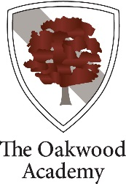

PERSON SPECIFICATION FOR TEACHER OF ART
 | Essential | Desirable
Qualifications | - QTS  - Degree level qualification in Art | - Good Honours Degree  - Further Professional Qualifications
Teaching | - Able to teach full range of ability 11-16.  - Able to create an excellent climate for learning within teaching area.  - Able to use a range of strategies to promote learning.  - Able to manage and encourage good behaviour.  - Able to develop positive and meaningful relationships with students.  - Able to make appropriate use of ICT for learning.  - Understanding of how to use data to inform planning and improve students’ performance.  - Understanding of a range of assessment for learning approaches, including grades where appropriate.  - Able to communicate with students, parents and carers about student’s progress. | - Able to develop best practice through wide range of imaginative approaches.  - Participation/development of extra-curricular activities.  - Engaged with developments in teaching and learning strategies to raise achievement.
Personal Qualities | - Enthusiasm  - Team-working skills  - Reliability and Integrity  - Personal Organisation  - Flexibility | - Strategic Planning  - Engagement in own continuous professional development

