JOB DESCRIPTION

TITLE OF POST: TEACHER OF SCIENCE
Responsible to: Director of Teaching and Learning
Head of Department
Pupil Progress Managers
Responsibilities:
- To plan, deliver and assess appropriate lessons which ensure that the potential of all students is fulfilled.
- To continue positively and accept delegation, with department colleagues, to the production, implementation and evaluation of department Schemes of Work and resources.
- To encourage students by regular marking, advising constructively by using targets and giving appropriate praise.
- To be aware individual students’ needs, whether they are academic or social, and liaise with Support Staff when necessary.
- To perform the role of Form Tutor
- To monitor assessment through use of data and target setting, and to maintain records of assessments of the students and levels of attainment as laid out in the National Curriculum, where appropriate.
- To ensure quality of students regardless of ability, age, class, culture, disability, faith, gender, race or sexual identity.
- To follow the ethos of the school and the department by promoting high standards of all students and maintaining high expectations both in and out of lessons.
- To provide a positive environment where effective teaching and learning can take place and create opportunities for students to develop wider skills for later life.
- To communicate effectively and be willing to develop and share good practice with colleagues in meetings and through lesson observations.
- To be committed to the demands of a high achieving school, both in the classroom and beyond.
- To remain familiar with national and local initiatives within the subject area and focus on own professional development to the benefit of students.
- To be responsible for the formation and implementation of whole school policies and attend meetings and Parents’ Consultation Evenings schedule in the school calendar.
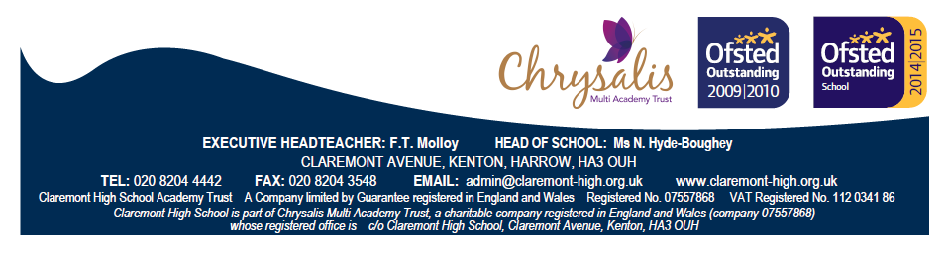

GENERAL TEACHER SPECIFICATION

Qualification Criteria
- Qualified to degree level and above
- Qualified to teach in the UK, PCGE, or similar.

Experience
- Teachers of all levels of experience including NQTs are welcome to apply for general teacher posts.

Teaching and Learning
- Excellent classroom practitioner (whose lessons are rated as good or above consistently).
- Effective and systematic behaviour management, with clear boundaries, sanctions, praise and rewards.
- Has good communication, planning and organisational skills.
- Demonstrates resilience, motivation and commitment to driving standards of achievement.
- Commitment to regular and on-going professional development and training to establish outstanding classroom practice.
- Has a passion for teaching.
- Results orientated.
- Relentless drive to do whatever it takes to ensure all students succeed.
- The courage and conviction to make a difference.

Communication skills
- The ability to listen and communicate effectively to influence and motivate others
- Empathy and the ability to understand the needs, aspirations and motivation of diverse individuals and group problem solving.
- Identify, analyse and resolve problems and issues.
- Develop plans with concrete outcomes and effective solutions.

Resilience
- Sustain energy, optimism and motivation in the face of pressure and setbacks.
- Stay calm in difficult situations and maintain clarity of vision.
- Be adaptable in the face of adversity.

