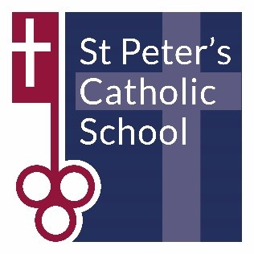
MATHS DEPARTMENT

The Mathematics Department at St Peter’s School is a dynamic, successful, supportive and exciting place in which to teach mathematics.

All members of the Maths department are highly motivated and dedicated professionals, who teach throughout the age and ability ranges. There are currently eight members in our department. There are excellent opportunities for personal and professional development, particularly for those looking to broaden their experience of A-level teaching. There is a mentoring and support structure for newly qualified teachers and there are also opportunities to mentor trainee teachers working towards a teaching qualification through a variety of schemes.

We are particularly proud of the work ethic and self-discipline displayed by our students who thrive within the community ethos of our Catholic School. Results are significantly above the national average for KS4 and KS5. The Edexcel Maths GCSE course is covered by all students from year 9 to 11. We also offer the OCR Additional Maths qualification in year 11 for our able and driven Mathematicians. A-levels in Maths and Further Maths are offered in the sixth form and Maths is the most popular course in the sixth form with a number of our students choosing to continue with Maths as a significant part of their university education.

If you are interested in joining our friendly department, we look forward to hearing from you and showing you around. Please contact mgallagher@st-peters.surrey.sch.uk

