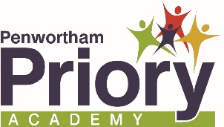

Welcome to the English Department

Department Overview

English is taught in modern, spacious and flexible learning spaces which we urge you to come and visit in person. We operate a 1:1 iPad scheme, with staff and pupils alike actively using iPads and Apple TVs and Interactive Whiteboards to engage with and enhance teaching and learning. The department also have a newly refurbished library and learning centre alongside many tranquil outdoor working spaces.

English is taught by a team of six dedicated professionals who have a fantastic record for outstanding progress and attainment, and who are specifically mentioned in the Ofsted report.

The curriculum is organised so that Year 7 and 8 receive four hours of English per week whilst Years 9 to 11 receive five hours teaching. We currently follow the EDUQAS specification for English Language and English Literature at GCSE.

Beyond the formal curriculum we offer a wide number of opportunities for enrichment, including support for Primary Schools, AG&T competitions and trips and visits and we actively engage in national initiatives such as World Book Day and the BBC School Report.

