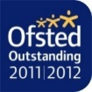
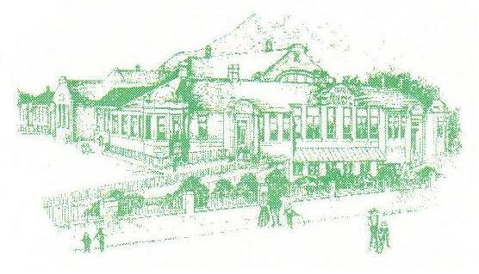
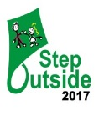
Headteacher:
Alison Padgett

Our Ref:

Telephone: (01254) 231583
Peel Park Primary School
Alice Street, Accrington, Lancs. BB5 6QR.
E-mail: head@peelpark.lancs.sch.uk

To our future staff,

Peel Park is an outstanding school because we work hard in everything we do and we never give up. We love our sporting activities, trips, outdoor learning and the opportunities our staff offer. As a Rights Respecting School, we welcome others and we believe that everyone should treat others as they would like to be treated themselves.
We are looking for a new headteacher who is friendly, caring and always has a smile on their face. They must be a good listener as we have brilliant ideas for how to make our school better and always need someone to listen to us and help with our problems. Our headteacher will understand that we are all unique and learn differently. Most importantly, they must make learning fun!

Peel Park is a fantastic place to learn in a safe and fun environment.

From the School Council

