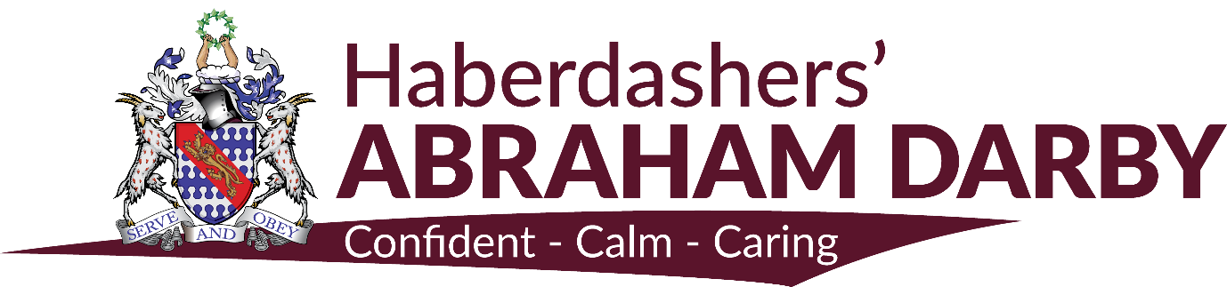

TEACHER OF ENGLISH

Haberdashers’ Abraham Darby is fully committed to the delivery of high quality teaching and learning which promotes engagement, enjoyment and achievement for each pupil in every subject. We offer our pupils a variety of pathways to ensure that each pupil has an individualised curriculum with the ability to achieve their potential.
We are seeking to appoint a committed and enthusiastic teacher of English to join us from September 2018 to teach across the age range. The aptitude to demonstrate excellent subject knowledge and to consistently teach inspirational and innovative lessons is essential.

The successful applicant will join the Academy at a very exciting stage in its development. The Academy was graded ‘Good’ when inspected by OFSTED in June 2015 and our aspiration is to move this to ‘Outstanding’.
We are looking to appoint a colleague who will:
- Provide engaging and creative learning experiences for all pupils
- Contribute to teamwork within the department and the whole Academy
- Have high expectations and commitment to the wider life of the Academy.
If you have the drive and vision to work in an Academy which strives to raise aspirations and achievements, as well as set and maintain high standards and expectations we want to hear from you.
THE ENGLISH DEPARTMENT

The English department consists of a strong team of dedicated and flexible specialists who work closely and collaboratively in all matters concerning the curriculum and school life.

As such, we have worked together to develop a modular system which offers a curriculum that is broad, balanced, differentiated and relevant, and which is constantly reviewed in the light of Local and National needs and statutory requirements. Our curriculum develops the skills required for the new GCSE requirements from year 7 and aims to promote the emotional, social, moral and personal development of each individual student.

Each module sets out clear aims and includes learning objectives, learning outcomes, teacher’s notes, outline teaching approaches, use of ICT and differentiated activities to cater for varied learning styles. A wide range of resources is deployed to enhance teaching, including use of the IWB. All English classrooms are furnished with interactive whiteboards and the department continues its work on developing a bank of resources and flip charts which are stored electronically.

In Key Stage 3, drama and media studies have been successfully integrated into the curriculum and all staff teach these modules. All pupils in Years 10 and 11 are currently following the new AQA specification for English Language and English Literature.

In both Key Stages, there is a structured Assessment for Learning system that involves all pupils. One of the many strengths of the department lies in its organisation and structure. Its success lies in the commitment of the staff to these systems.

At Key stage 5, we offer the A Level English Literature course.

The English department is committed to raising achievement and has implemented a range of strategies to facilitate this. Our success is reflected in our pupils’ results in external examinations.

In addition to our subject-based work, as a department, we also make a significant contribution to the extra-curricular life of the school. We arrange a number of theatre trips, workshops, visits, visiting speakers and a Book Week festival amongst many other varied activities.

In the English department at the Abraham Darby Academy, every member of staff is expected to work as an active team member, constantly striving to raise expectations and standards, and to implement the curriculum and departmental policies with zeal and commitment.

Our aim, in the English department, is to continue to raise standards of attainment. We have a number of strategies in place which we hope will have a positive impact on achievement and this will continue to be one of our development projects.

RESULTS:

Over the past few years, the trend in results in English and English Literature has been positive and we have maintained these standards with the move from the legacy GCSE to the new curriculum. Our most recent results showed 74% of our pupils achieved a standard pass or above for English Language or English Literature.

PERSON SPECIFICATION

The successful applicant will be extremely well organised, energetic and willing to “go the extra mile”. They will be focused on the attainment of all pupils, accepting no excuses for under achievement. A commitment to extra-curricular and curriculum enrichment activities is essential.

We are looking for a person who:
- Can deliver the English curriculum across KS3, KS4 and KS5 to all ability levels
- Can build positive and productive working relationships with staff, pupils and parents
- Can deliver a creative and innovative approach to teaching
- Is committed to making learning a challenging, exciting and worthwhile activity for our youngsters
- Enjoys working with young people, has high expectations and can unlock potential
- Is ambitious and will welcome professional development opportunities
- Has a good sense of humour.

The post is suitable for both experienced and newly qualified teachers. We welcome colleagues who relish sharing their skills and ideas, and want to contribute to the development of the English department and the Academy.

March 2018

