8th September 2017

Dear Applicant
Thank you for your interest in the vacancy for a Class Teacher. Please find an application form and supporting documents on the TES portal, which should be completed and handed in by the deadline of 12 noon on Wednesday 11th October 2017.
In order to comply with safeguarding requirements, candidates short-listed for interview should be aware that written references will be sought prior to interview.
Woodcote Primary School is committed to safeguarding and ensuring the welfare of our children. This post is subject to a satisfactory Enhanced DBS check and references. We actively promote equality and diversity.
I look forward to receiving your application.
Yours faithfully
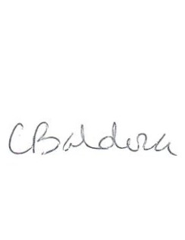
C Baldock
Acting Head of School

