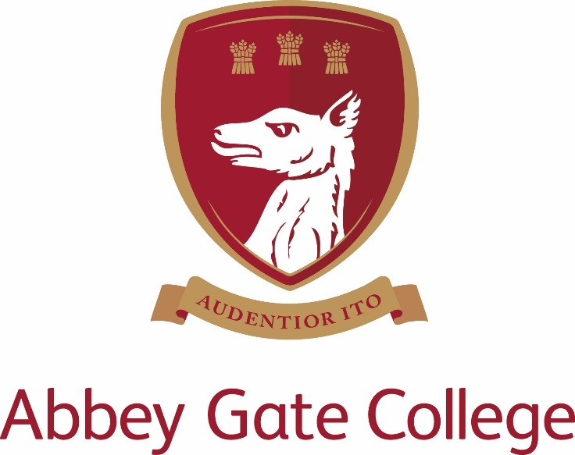
Head of Drama (Maternity Cover)
Part Time 0.95 FTE over four days
Required by December 2017

TO START BY DECEMBER 2017

Abbey Gate College – Head of Drama (Maternity cover)

The College
Abbey Gate College is the longest-running coeducational independent school in the Chester area, catering for circa 485 pupils aged 4-18 years. Set in the idyllic rural villages of Saighton and Aldford on the outskirts of Chester.
Our pupils are at the heart of everything we do. We believe education is about building self-esteem, a love of learning and igniting a desire in all our pupils, to ensure they fulfil their academic and personal potential. We strive to guarantee our children leave Abbey Gate College as confident, articulate, respectful and happy young high achievers.
From the youngest in Foundation to our Sixth Formers, we aim to develop skills for life; core values such as respect and compassion within the framework of an excellent education. Developing talents and skills in a wide range of areas are encouraged, success is celebrated and endeavour is recognised.
The Post

We are seeking a dynamic and committed Part Time (0.95 FTE over four days) Head of Drama to join our enthusiastic department in order to cover maternity leave. We require the candidate to start with us by December 2017. The successful candidate will teach across the year groups in the Senior School.

The Head of Drama is responsible for the overall control of Drama and Theatre. The successful applicant will be an enthusiastic and capable drama practitioner with excellent teaching skills, a detailed understanding of drama theory and varied directional experience.

Drama and Theatre is currently delivered in two adjoining rooms. One room operates as a Studio space and the other is a 96 seat Theatre for practical exploration and performances. The Theatre houses sound equipment and stage lighting to illuminate performance work.

Curricular

Year 7 and 8: Drama provision is provided weekly and is on a three week carousel basis with ESB lessons.
Year 9: Drama provision is twice weekly on an option basis.
Year 10 and 11: GCSE Drama. (OCR) Three lessons per week.
Lower Sixth: AS Drama and Theatre. (OCR) Five lessons per week.
Upper Sixth: A Level (OCR) Six lessons per week

Extra- curricular

Key Stage Three:
Drama Club: This club meets weekly, when there are no other productions ongoing, to play theatre games, build teamwork, concentration, confidence and Drama skills. The Club members also take part in larger scale productions for the public in the Summer Term, most recently A Midsummer Night’s Dream and Alice. The productions are traditionally performed in the College Gardens. Sixth Form students are encouraged to help run the club and assist the Head of Drama.

Whole School:
Annual Production: The annual production is performed in the Autumn Term and pupils are selected to take part through an audition basis. Lunchtime, afterschool and weekend rehearsals are scheduled to produce a high quality performance. Pupils are also encouraged to take a backstage role such as lighting technician or make-up artist. Recent productions include A Christmas Carol, Oklahoma and Our Country’s Good.

Musical Theatre Club: In the Spring and Summer Terms, pupils are invited to join MTC and learn songs and choreography for a short performance slot in the annual Gala Concert. A selection of the materials performed should be discussed with the Head of Music and all choreography must be developed by the Head of Drama and Theatre.

GCSE and A Level Drama and Theatre:
Trips: Trips are arranged to enable pupils to answer specific questions on the GCSE and A Level examination papers. We strive to take the pupils to see a variety of work throughout the year and most trips take place afterschool so as not to impact on curriculum time. Residential trips are also arranged for AS and A2 Drama and Theatre pupils. Trips arranged for the next academic year are: Autumn Term: Blood Brothers (Storyhouse, Chester), Yerma (Theatr Clwyd), Othello (NYT- London). Additional trips can also be arranged.

Additional Rehearsals and Revision Sessions: After school and occasional weekend rehearsals are offered to pupils to ensure their practical performance is of the highest standard. The exams take place in the Spring Term and rehearsal sessions are organised accordingly. Revision sessions for the theory papers run after the practical exams have taken place through to study leave.

Key responsibilities:

- To manage and deliver the teaching of Drama as an examination subject at GCSE and Drama and Theatre in the Sixth Form, alongside some Key Stage Three Drama teaching.
- To monitor the progress of individual students, including recording and reporting.
- To manage the teaching of Drama as a curriculum subject throughout the School.
- To promote Drama as an extra-curricular activity throughout the School.
- To manage the departmental budgets.
- To manage drama resources, including Health and Safety issues.
- To manage any staff involved with teaching the subject
- To coordinate extra-curricular Drama including:
a) Overall responsibility for KS3 Drama Club productions
b) Encouragement of Drama Club activities
c) Organisation of Drama in assemblies etc.
d) Organisation of theatre visits
e) Organisation of Musical Theatre Club
f) Organisation of additional rehearsals and revision sessions
g) Assistance in the Infant and Junior School annual production

In addition to these duties as Head of Drama and Theatre, all staff at the College are expected to help with the pastoral development of pupils, which will include acting as a relief form tutor and the duties associated with this role. Other contributions to the extra-curricular life of the College will also be welcomed.

The post-holder’s responsibility for promoting and safeguarding the welfare of children and young persons for whom s/he is responsible, or with whom s/he comes into contact will be to adhere to and ensure compliance with the school’s Child Protection Policy Statement at all times.

Key qualities and person specification:-

The person appointed should demonstrate the following skills and qualities:-

- Inspirational teacher
- Enthusiastic, innovative and creative
- Committed to raising standards and monitoring pupil progress
- Act as a good role model to staff and pupils
- Have outstanding professional and personal qualities
- Caring, supportive and willing to adapt their teaching to suit the needs of the pupils
- Proficient with the use of ICT in the classroom
- Show good planning skills
- Well organised
- Calm under pressure

Salary
The salary for this position will depend upon the qualifications and relevant experience of the successful candidate.

Child Protection
Abbey Gate College regards as paramount the welfare and safety of children. Whilst criminal convictions are not necessarily a bar, this safety consideration will be key to all decisions regarding the employment of staff, approval of volunteers and standards of external contractors.

Equal Opportunities
We are committed to treating all employees with dignity and respect regardless of race, ethnic background, nationality, colour, gender, transgender status, pregnancy, age, sexual orientation, religion or belief. We therefore welcome applications from all segments of the community.

Applications
Candidates should complete an Abbey Gate College Application Form and submit this together with a letter explaining their interest in and suitability for the post.

The closing date for applications is 4pm on Wednesday 27 September 2017; interviews scheduled for the week commencing 9 October 2017.

The interview process will include; the candidates will meet the Headmistress, Deputy Heads and have a tour of the College. Candidates will be asked to prepare and deliver a drama lesson (details confirmed before interview).

References will be taken up prior to interview, please inform your referees.

Please mark the envelope:

Rebecca Upton
Human Resouces
Abbey Gate College
Saighton Grange
Saighton
Chester CH3 6EN

Alternatively you can make your application electronically by email to: - rebecca.upton@abbeygatecollege.co.uk

