Appointment of

Second in Mathematics

For September 2018

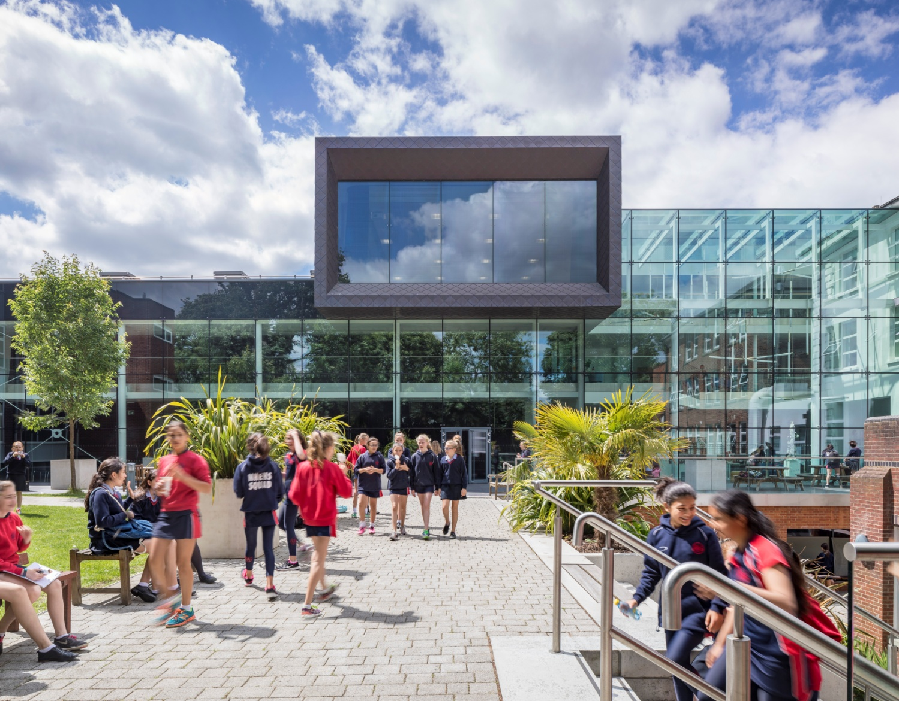

About the School
“Teaching here is all about being able to have in-depth conversations with students about your subject and helping to enthuse them with the same passion as you have. Teaching at NHEHS is exactly what I imagined teaching would be like when I got my first teaching job; it’s what teaching should be!”
Liberty: joined NHEHS in September 2017 as a Head of Department
Notting Hill & Ealing High School is one of London’s leading independent girls’ day schools. Founded in 1873 it is the oldest of the 25 schools which make up the Girls’ Day School Trust (GDST) having begun life in Notting Hill and moved to Ealing in 1930. We are an all through school (ages 4-18). Around 300 girls in the Junior School and 600 in the Senior School, including 150 in the Sixth Form, make up a friendly and welcoming community. The Junior and Senior Schools occupy their own parts of the site and in day-to-day terms operate independently. We occupy a site in suburban, leafy, west Ealing with excellent transport links. (We are an easy walk or bus ride from Ealing Broadway or West Ealing stations: District and Central underground lines, mainline trains and Crossrail from 2018.) The school is oversubscribed and a very popular choice at all ages with girls joining us from most parts of West London as well as areas further afield.
NHEHS is an academically selective school. Our girls are ambitious, bright, enthusiastic and eager to learn. In our latest ISI inspection we achieved the highest possible grades across the board and the inspectors noted that ‘the quality of the pupils’ achievements and learning is exceptional.’ Public examination results are consistently outstanding and girls go on to study a wide range of subjects at prestigious universities including Oxbridge. (Latest results and the university destinations of Leavers can be found on our web site.) The school is highly regarded for the way it achieves its outstanding outcomes within a particularly warm and supportive environment, and pastoral care and achieving the best for every girl is at the heart of everything we do.
About the GDST
GDST schools share an ethos and heritage of girls-only education and are members of a unique network which adds value to each school, student and member of staff. Networking opportunities with other teachers across the Trust enable staff to share best practice and develop initiatives that benefit all our schools and students. In addition to supporting the work of individual schools in supplying excellent induction and development opportunities for staff, the GDST network provides access to an extensive training programme. This includes development opportunities (including a Middle Leaders Development Programme and Aspiring Leaders Programme) and to grants for individual courses of study.
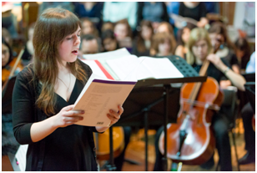
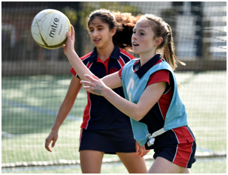
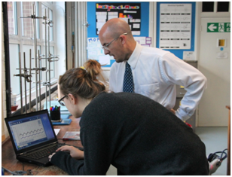

“We are delighted that you are considering NHEHS and hope that you will want to apply for this post once you have found out more about us. Our website, www.nhehs.gdst.net will tell you more about the school and give you a taste of the atmosphere here.”
Matthew Shoults, Headmaster
Second in Mathematics

The Post
The full-time post is available from September 2018.
The vacancy provides the opportunity for a well-qualified, inspirational teacher of Mathematics to teach up to A-level and Oxbridge entrance and to contribute further to a flourishing department in both its curricular and extracurricular activities. It is an opportunity to take a lead on particular roles within the department.

Person Specification
We are looking for a well-qualified graduate of Mathematics with a passion for teaching the subject together with excellent subject knowledge. The successful candidate will have a strong understanding of the curriculum and be efficient and organised. She/he will be a good communicator who can enthuse and inspire both pupils and colleagues and will have exciting ideas about the teaching of Mathematics and the ways in which it can be further developed and encouraged within the school. The successful candidate will be able to create engaging schemes of work, lead trips/visits, support university preparation (particularly to Oxbridge level) and offer full commitment to the vibrant extra-curricular life of the school.

The Department
The Mathematics Department comprises eight teachers, six full-time and two part-time. Mathematics is the most popular subject within the school. Mathematics is the most popular subject within the school with currently two thirds of the sixth form taking the subject at A-Level. Our results at IGCSE and A-Level are consistently outstanding. Our lessons are challenging and thought-provoking with a strong emphasis on problem solving and discovery. Within a supportive environment, we encourage all students to achieve their full potential and we aim to instil a genuine love of subject.

Extra-curricular provision

The department, in conjunction with sixthformers who act as subject representatives and ambassadors, runs Pi Club for Year 7 and 8 while Enigma Club caters for gifted students in this age group and provides enrichment beyond the classroom and an opportunity for project work. For KS4, there is a monthly Breakfast Club where students tackle problems from the UKMT mentoring scheme. Every year the department enters large numbers of students for the UKMT challenges as well as entering the team competitions. We take Year 10 and Year 12 students to enrichment lectures in London, and, last year, four of our students delivered presentations as part of the Maths Slam run by Maths Fest. Every year we participate in the London-wide Hans Woyda competition and our Year 10 students have had great success at the Maths Feast competition. Finally, Pi Day is a much-anticipated day in the school calendar where subject representatives organise a variety of events for all students including an annual Pi recital.

The Mathematics Curriculum

Years 7 and 8

We deliver a balanced curriculum of numeracy, algebra, shape and space, and data handling whilst developing mathematical confidence. Students develop the numeracy skills required to support them across all their subjects.

In Year 7 students are taught in mixed ability classes and at the start of Year 8, students are placed in divisions by their level of achievement.

Years 9, 10 and 11

All students are entered for Higher Level Edexcel IGCSE and the department consistently achieves excellent results, with 94% of girls achieving A*/A this year. In Year 11, students in the top division also prepare for the FSMQ Additional Mathematics qualification.

A Level

At NHEHS, we offer A-Levels in both Mathematics and Further Mathematics. To encourage sixthformers whose A Level subject choices do not include mathematics, but who loved the subject at GCSE and would like to develop and demonstrate a breadth of skills, we also offer the AS Level qualification taught over two years in separate classes from A Level candidates. We are following the Edexcel course in all three. Excellent results and the popularity of the subject at IGCSE have led to increasing numbers at A Level over recent years. We have a large take up for Further Mathematics and currently there are two groups in Year 12.

The department also prepares students for mathematical study at University, including Oxford and Cambridge with a structured scheme of work that both broadens and stretches their mathematical knowledge.

ICT

Use of ICT is key within Mathematics and both students and staff use a variety of Mathematical software packages including geogebra, autograph and desmos.

Facilities and Equipment

The Mathematics department has its own dedicated area within the school and is well equipped and well resourced. There are laptops and ipads available for student use both in and out of lessons.

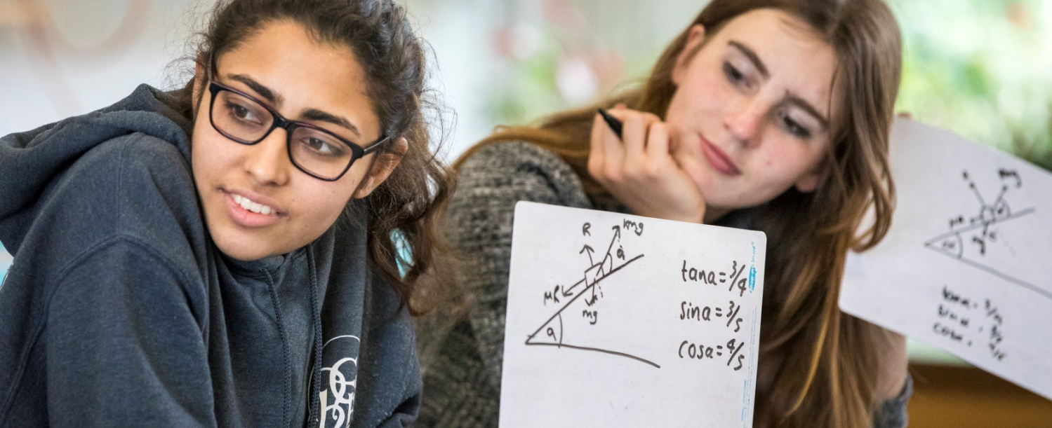

Terms and Conditions of the Post
The GDST offers attractive salaries and pay progression, when compared with the education sector generally, and has its own pay and grading structure, and system of career progression. Leadership and teaching excellence are recognised and rewarded in its schools. The salary reflects London weighting.

Benefits include:
- Membership of Teaching Staff Pension Scheme
- Access to the GDST central training and development programme
- Up to 50% discount on fees for children at GDST schools
- Training grants for obtaining further qualifications
- Season Ticket Loans: Interest free loans for travel are available to staff to enable them to buy annual season tickets
- Computer Loans: Interest free loans are available to staff to enable them to buy a computer for personal use at home
- Cycle Scheme: the School is part of the scheme which enables staff to purchase bicycles and equipment at a tax advantageous rate and pay for the equipment over 12 months
- Lunches: free lunches are provided to all staff during term time
- Four weeks’ study leave for teachers after ten years’ continuous service
- Accredited NQT induction

Application and Interview Process
Applications should be submitted by midday, on 24th January at the latest; however, applications may be considered in advance of the deadline. Candidates should complete the application form provided and also include a covering letter and full curriculum vitae with details of qualifications and experience and the names, addresses, telephone numbers and email addresses of two professional referees, one of whom should be the Head of their present or most recent school.
Completed applications should be sent to:

Mr Matthew Shoults
Headmaster
Notting Hill & Ealing High School
2 Cleveland Road, London W13 8AX

or may be emailed to: recruitment@nhehs.gdst.net

Shortlisted candidates will be invited for interview on 1st February. As part of this process, they will be expected to teach a lesson of up to 35 minutes for which a full prior briefing will be given. All applications will be acknowledged and candidates who have not heard from us further within two weeks of the closing date should assume that the post has been filled.
All adults employed at the school are cleared for working with children and young people through the Disclosure & Barring Service. Please see attached full information regarding the Girls’ Day School Trust guidelines on the Safeguarding of Children.

Further information about the school can be found on our website at: www.nhehs.gdst.net
Application Form

