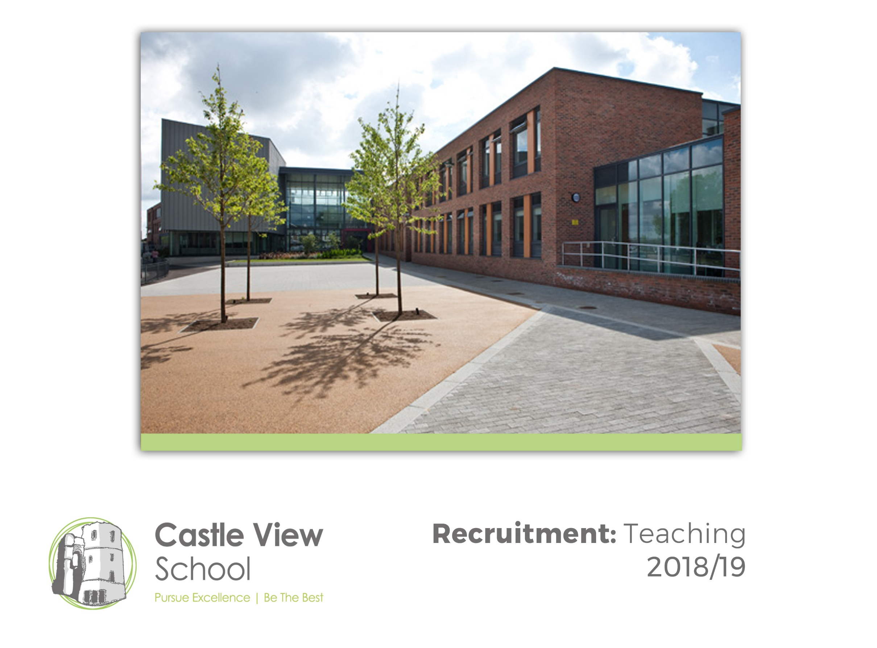
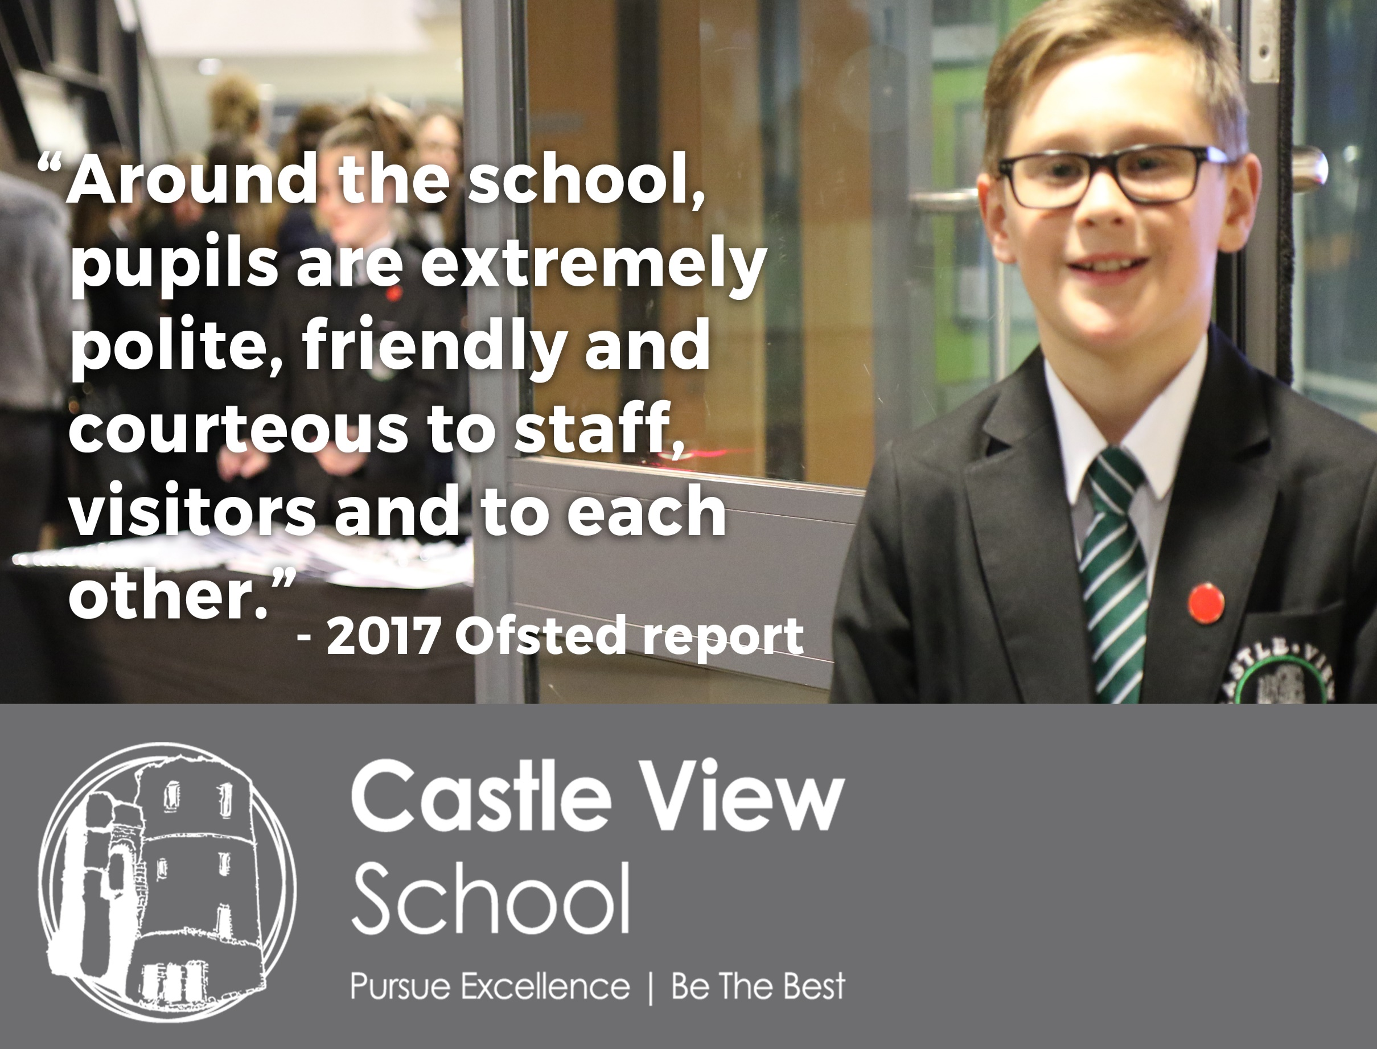

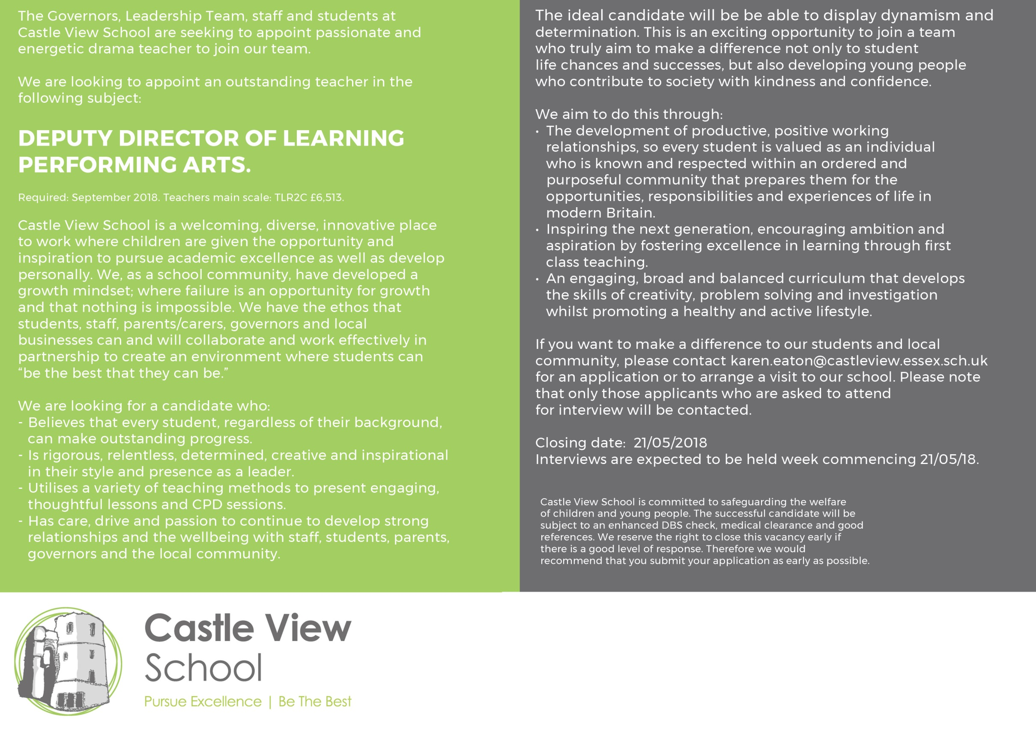
Deputy Director of Learning for Performing Arts
Job Description
Accountable to: Director of Learning.
The Deputy Director of Learning is responsible for:

Leadership
Leading and managing staff working within the Curriculum Area focusing on school improvement
Supporting teaching staff to secure GOOD and towards OUTSTANDING
Establishing the learning climate of the Curriculum Area in line with whole school policy
Ensuring priorities within the Curriculum Area are developed and implemented though curriculum focused development
in line with whole school priorities
Contributing significantly to raising standards in every aspect of school improvement
Contributing to the School Development Plan
Regular tracking and monitoring of students through Review Days, Learning Walks and monitoring.
Working with the Humanities team to ensure maximum impact
Working with the Director of Learning to ensure maximum impact.

Teaching and Learning
Overseeing the implementation and reviewing regular of differentiated schemes of work
Setting and monitoring progress towards Curriculum Area targets
Monitoring the use of displays in all Curriculum Areas
Contributing to cross curricular work
Ensuring the highest standards of teaching, learning and progress throughout the Curriculum
Area, in line with school targets and School Development Plan.
Overseeing accurate assessment all KS3 and KS4.
Early identification of underperformance and recovery of progress
Ensuring regular tracking and monitoring
Ensuring impact in students’ progress and attainment
Analyse student progress attainment.
Managing behaviour for learning within the Curriculum Area including behaviour and safety.
Ensuring quality assurance in all aspects of the Curriculum Area

Resources
Prioritising, allocating and monitoring the Curriculum Area budget to impact student progress and meet student need
Ensuring the Curriculum Area fulfils health and safety requirements.

People and Relationships
Identifying and communicating Curriculum Area staff development needs with Director of Learning in line with whole
school policy
Appraising staff as required in line with the school’s performance management policy
Building a Curriculum Area ‘team’
Co-ordinating links with Special Educational Needs Staff
Inducting new staff within the Curriculum Area.
The governing Body is committed to safeguarding and promoting the welfare of children and young people, and expects all
staff and volunteers to share this commitment.

Person Specification in addition to that for a Mainscale Teacher

Qualifications
- Evidence of professional development relevant to the role and linked to teaching standards expectations.

Knowledge and Understanding
- Excellent knowledge of the National Curriculum for Performing Arts at KS3 & KS4 in order to help other curriculum areas as necessary.
- Excellent understanding of the assessment processes at KS3 and KS4 and how to use these to support planning and raise student achievement
- Excellent knowledge of a wide range of pedagogic approaches to cater for different learning styles and ensure that all students are engaged.
- Excellent understanding of what constitutes effective teaching for learning
- Excellent knowledge and understanding of strategies for promoting good relationships with students and effective behaviour management techniques
- Excellent knowledge of a wide range of software for use with interactive technologies and the application of these to engage and interest students.
- Excellent knowledge of Ofsted requirements, ensuring keeping up to date.

Experience
- Experience of leadership roles within a team including designing and developing resources to support learning.
- Experience of working with other teachers and support professionals to extend their understanding of educational issues.
- Experience of robust self-evaluation and development planning linked to this.
- Experience of coaching other staff so that their classroom practice develops.
- Experience of preparing and leading training sessions. .

Skills and Attributes
- Excellent communication skills orally and written, including confident presentations.
- Excellent use of ICT to make learning engaging and dynamic and to support assessment and management functions.
- The capacity to form positive learning - centered relationships with other professionals at different stages in their careers.
- The capacity to consistently perform to a high level of success and act as a role model for other professionals.

