

Appointment to the post of

KS1 Classroom Teacher

Information for Applicants

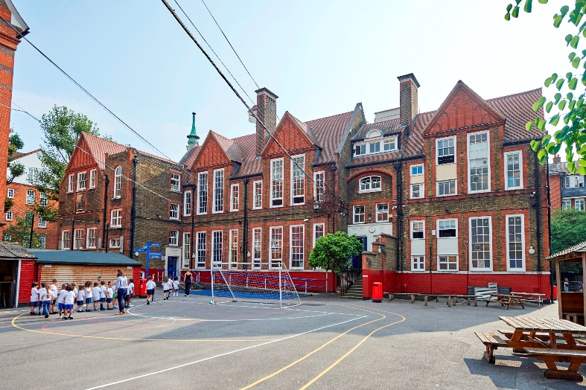

2018


March 2017
Dear Colleague,

Millbank Academy is an ‘Outstanding’, two-form entry primary school situated in beautiful Victorian buildings in Westminster. It is part of Future Academies: a family of three primary schools and two secondaries. We serve communities that are amongst the most deprived in the country. Nonetheless, we have the highest expectations of our students and what they can achieve, and we are committed to providing them with a rigorous education in a well-disciplined but caring environment that will help them to compete on a level playing field with their more advantaged peers. We know that central to achieving this vision is our ability to recruit and to develop outstanding teachers with first-rate subject knowledge, a passion for their subjects and a genuine concern for the children in their care. We do this by providing a supportive and friendly working environment, and through our highly successful on-site teacher training centre.

We can offer you:
- A strong commitment to your professional development
- Clear opportunities for career progression
- A friendly and supportive school community

Our three primary schools are close-knit communities that retain their own separate identities and unique characters, but their staff work closely with colleagues in our other schools to share ideas and to explore new ways of ensuring the best outcomes for our children. We have a knowledge-led curriculum. From Year 1 onwards, we gradually introduce teaching by subject specialists. In Key Stage 2, our children are taught almost all their lessons by teachers able to share with them their expertise in and love for their particular subject. Our curriculum brings together well-proven programmes including Read Write Inc, Talk for Writing, Maths Mastery, with our own specially-designed resources for history, geography and art to ensure that children’s learning is knowledge-rich, logically sequenced and engaging.

We hope this information pack encourages you to apply. Please do visit our websites to find out more about our school www.millbankacademy.org.uk and about our educational family www.futureacademies.org.

To apply, please return a completed application form to recruitment@millbankacademy.org.uk

I look forward to receiving your application, and to welcoming you to our innovative and ambitious Trust.

Yours faithfully,

Paul Smith
CEO


Millbank Academy
Erasmus Street
London
SW1P 4HR

Future Academies is a charity regulated by the
Department for Education, and is sponsored by Future, charity number 1114396.
Registered office: Lupus Street, London SW1V 3AT


The Trust's Principles

Our work is built on three principles: Knowledge, Aspiration and Respect.
These give us a shared language and link the many things we do together.

Knowledge
We believe in the transformational power of knowledge, structured through subjects.

Aspiration
We are ambitious for our pupils, and set high standards for ourselves.

Respect
We value every child and each other.
We respect our planet, our history, and British values.



Job Description – KS1 Classroom Teacher

Job Purpose:

- Be responsible for planning, teaching and learning and assessment
- To deliver outstanding teaching and learning for all children in the class
- To implement either the Year 1 Phonics Screening Assessment or the end of KS1 National Curriculum tests and assess children’s achievement and progress against the interim teacher assessment frameworks

The successful candidate will be required to:

- Provide high quality education and care appropriate to the developmental needs of the children, working in partnership with their parents and other agencies as appropriate
- Manage additional adults within the classroom
- Ensure that that all children are supported to keep safe, stay healthy, achieve and enjoy, make a positive contribution and work towards economic well-being

Teaching and Learning:

- Deliver the curriculum, as relevant to age and ability, and be accountable for the attainment, progress and outcomes of pupils’ taught
- Prepare children for their end of year assessments
- Be responsible for the preparation and development of teaching materials and plans as appropriate, in collaboration with the rest of the KS1 team
- Be aware of pupils’ capabilities, their prior knowledge and plan teaching and differentiate appropriately to build on these demonstrating knowledge and understanding of how pupils learn
- Have a clear understanding of the needs of all pupils, including those with special educational needs and be able to use and evaluate distinctive teaching approaches to engage and support and having high expectations for all
- Give pupils regular feedback, both orally and through accurate marking, and encourage pupils to reflect and respond to the feedback to develop their learning
- Use an appropriate range of observation, monitoring and recording strategies and make accurate and productive use of assessment to secure pupils’ progress
- Use relevant data to monitor progress, set targets, and plan subsequent lessons

Relationship with Parents and the Wider Community:

- Ensure that parents are well-informed about their child’s attainment and progress
- To develop an effective partnership with parents and help them understand how they can support their child’s learning and personal development.

Assessment and Evaluation in KS1:

- To keep appropriate records of individual learners’ work and achievements, consistent with school policy; to make a proper contribution to the writing of school reports; to complete National Curriculum assessments as are required.
- Work with other professionals to ensure the use of comparative data about pupils’ prior attainment, to establish benchmarks and set targets for improvement
- Use this information to form annual action plans to inform address areas for improvements

Safeguarding:
- To ensure the safeguarding of pupils in accordance with school policies.

Essential skills, experience and qualities
- Experience of teaching in KS1.
- A clear understanding of how children learn best and how to make accelerated progress.
- Have a strong working knowledge of the Key Stage 1 curriculum and assessment processes.
- Knowledge of Key Stage 1 moderation process.
- Excellent ICT skills
- Sound data analysis skills
- Experience of working with pupils with special educational needs.
- Experience of working with bilingual pupils and families.
- Have enthusiasm and commitment to high standards of teaching, learning and self-improvement, and be able to demonstrate this.
- Have a calm approach and positive attitude.
- Have good inter-personal skills, e.g. the ability to listen and respond appropriately to children, parents and colleagues.
- Knowledge and experience with the following curriculum programs would be desirable but not essential:
- Read, Write, Inc phonic programme
- Talk for Writing programme
- Maths Mastery programme

Safer Recruitment at Future Academies

Future Academies is committed to safeguarding and promoting the welfare of children and young people. We undertake very thorough checks to ensure that we meet our obligations to protect the children attending our schools. We expect all staff and volunteers to share this commitment and to undergo appropriate checks, including an Enhanced DBS and barred list check. We also ensure staff in a teaching capacity are not subject to a prohibition order or an interim prohibition order. Teachers from the EEA are also subject to a check for any restrictions/sanctions. Those appointed to a management position will be subject to a ‘Section 128 direction’ to ensure they are not prohibited from taking part in the management of a school.

- Candidates should be aware that all posts at Future Academies involve some degree of responsibility for safeguarding children and young people, although the extent of that responsibility will vary depending on the nature of the post. All members of staff will have access to the DfE Keeping Children Safe in Education guidance, September, 2016.
- Longlisted candidates will be required to complete a Disclosure of Criminal Record form and bring the completed form to interview. If the job involves contact with children up to age 8 you will also be required to make a Disqualification Declaration. The information you give will be treated as strictly confidential. Disclosure of a conviction, caution, warning or reprimand will not automatically disqualify you from consideration. Any offence will only be taken into consideration if it is one which would make you unsuitable for the type of work you are applying for. However, offences relating to children may make you unsuitable since this is a “regulated position” under the Criminal Justice & Courts Services Act 2000.
- If you are currently working with children, on either a paid or voluntary basis, your current employer will be asked about disciplinary offences, including those related to children or young people (whether the disciplinary sanction is current or time-expired), and whether you have been the subject of any child protection allegations or concerns and if so the outcome of any investigation or disciplinary proceedings. If you are not currently working with children, but have done in the past, that previous employer will be asked about these issues.
- You should be aware that provision of false information is an offence and could result in the application being rejected or summary dismissal if the applicant has been selected, and possible referral to the police and/or Independent Safeguarding Authority.

Invitation to Interview – please bring with you:
- Disclosure of Criminal Record, or Disqualification Declaration form in a sealed envelope. This form will be sent to candidates invited to interview.
- Documentary evidence of identity that will satisfy DBS requirements such as a current UK Photo card driving license and/or a current passport and/or a full birth certificate
- Documentary proof of address (i.e. utility bill, financial statement etc.)
- Where appropriate any documentation evidencing a change of name
- Original certificates confirming any educational or professional qualifications that are necessary or relevant for the post
- Evidence that you have the right to work in the UK

Please note that originals of the above are necessary. Photocopies are not sufficient.

Candidates will be asked to account for any gaps in their employment history and to address any discrepancies or anomalies in their application form. We will require information in accordance with statutory guidance for anyone who has worked or been resident overseas in the previous five years.

We will seek references on longlisted candidates and may approach previous employers for information to verify particular experience or qualifications before interview.

Pimlico – The Local Area

Our schools are ideally located in the heart of Pimlico, South Westminster. They are easily accessible by bus, train or tube, and the area has a number of docking stations for the Barclays Cycle Hire scheme.

Pimlico is a busy, vibrant area with an abundance of restaurants, cafes and shops, although it remains predominantly a residential area. Victoria, just a short walk or bus ride away, offers a fashionable shopping precinct, Cardinal Walk, with a variety of shops, banks and a Marks & Spencer store. The House of Fraser department store and many other well-known shops are on Victoria Street. Trendy Sloane Square, with its chic shops and lively restaurants, is also close by. Other amenities include the Queen Mother Sports Centre and Dolphin Fitness.

Pimlico is known for its pretty garden squares and impressive Regency architecture, and we are lucky to have Tate Britain within walking distance. Pimlico has had a few famous residents: Winston Churchill lived in Eccleston Square, and Mozart composed his very first symphony when he was an eight years old staying in Ebury Street.
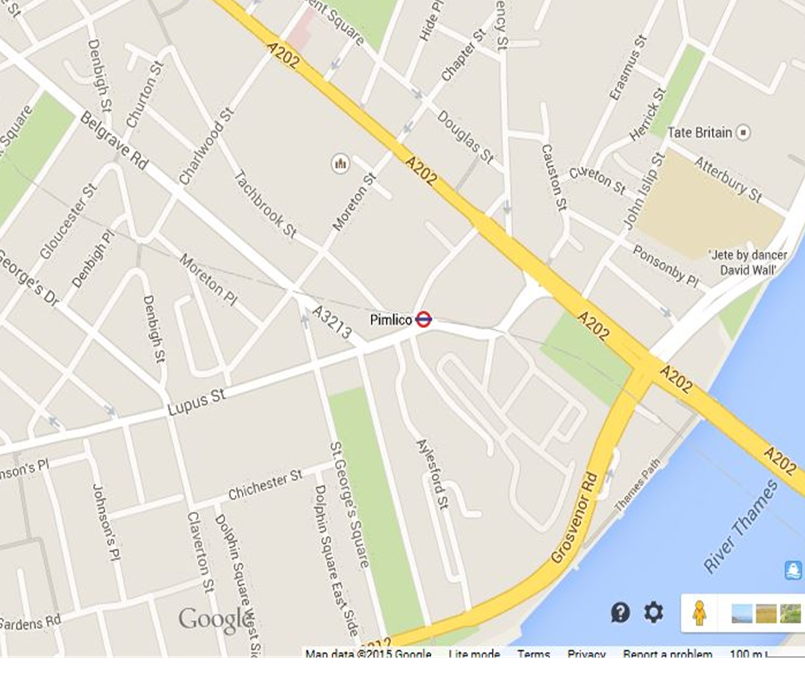
Millbank Academy
Pimlico
Primary
Churchill Gardens

Pimlico Academy

