Dear Applicant,

Thank you for your interest in this post at The Grange Academy. We are extremely proud of our learning community and how learners and staff work together in order to achieve the highest possible educational outcomes.

This application pack is designed to help you decide whether or not you feel this school is one in which you would like to further your career by helping our young learners to raise their standards of attainment to their maximum potential.

To apply for this post;

- Review the detail contained in this information pack.
- Complete the Application Form, ensuring that all boxes are filled in.
- Outline, in no more than two sides of A4 (Arial font size 12), why you are interested in this post and how you have prepared yourself so far, what contributions you feel you can make to learners’ development within our school, and any particular areas of strength and expertise you feel you may have

Please note that we do not accept or require your CV.

Applications will be assessed on evidence of professional competence, communication skills, leadership qualities and personal attributes.

We look forward to receiving your application.
Yours faithfully,

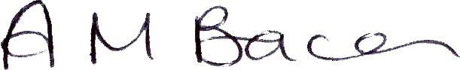
Mrs M Bacon
Lead Principal

