May 2018

Dear Applicant

Thank you for your interest in this post as Assistant Head of English at Archbishop Tenison’s. This vacancy has arisen due to the current post holder moving into a part-time role.

As you will see from the details, English is a great strength of the school. We have an excellent track record in English at all Key Stages, including at A Level. We were also particularly pleased with the results in GCSE English Language in the first year of the new qualification last year. The Department is very well led by a strong Head of Department, Mrs Kelly Jefferson, with whom the person appointed will have the opportunity to work together closely over the next few years.

This is a great opportunity for someone with a good experience of teaching, but who now wishes to exercise a wider responsibility within a very good departmental team. This is a highly regarded department within the school, which offers pupils and students unique opportunities to engage in a deep and searching way with a wide range of texts and human experience. We want our diverse Croydon School and its Christian educational tradition to be a good context for that exploration.

Archbishop Tenison’s is a lively, friendly and high achieving school, where pupils take their studies seriously. As a Church of England school we are always pleased to receive applications from those keen to help us develop our Christian ethos and educational vision.

We look forward to receiving your application and to meeting with you to talk about the opportunities here. In your letter please include the following points:
- why you would like to take up this post at this time;
- which experience and qualities make you particularly suitable for the post;
- examples of how your contribution to the leadership of English would bring the subject alive to our pupils, if you were appointed to this post.

Please see our website for further details.

Yours sincerely
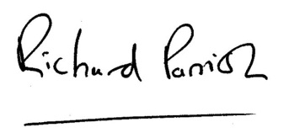
Richard Parrish
Headteacher

