**GENERAL INFORMATION**

Child Protection & Safeguarding Contact

Fire Evacuation Plan

Welcome to Finance

Privacy Notice

Map of the School

The School Day & Term Dates



Child Protection & Safeguarding

**Designated Persons for child Protection**

|  |  |  |
| --- | --- | --- |
| **DESIGNATED SAFEGUARDING LEAD / Deputy Headteacher** | **HEATHER FORD** | **Ext: 174**  **Direct Line: 020 8254 33**  **Email: heather.ford@rutlish.merton.sch.uk** |
| DESIGNATED SAFEGUARDING DEPUTY / Inclusion Manager | DEBORAH WILDMAN | Ext: 163  Direct Line: 020 8254 3314  Email: Deborah.wildman@rutlish.merton.sch.uk |
| DESIGNATED SAFEGUARDING PERSON / SENCO | ESTELLE TIBERTI | Ext: 187  Email: Estelle.tiberti@rutlish.merton.sch.uk |

**In all cases of Safeguarding, please email any concern to**

[**safeguardingconcerns@rutlish.merton.sch.uk**](mailto:safeguardingconcerns@rutlish.merton.sch.uk)

Fire Evacuation Plan

**If you discover a fire or see smoke:**

* Do not attempt to fight the fire
* Raise the alarm by breaking the nearest call point glass and call 999
* Walk to the nearest available exit and leave the building – DO NOT go back to retrieve personal belongings
* Report to the assembly point and await further instruction

**In the event of an evacuation**

* You will hear a loud pulsing electronic tone
* Move calmly and quickly to the nearest indicated safe exit, if possibly, closing doors and windows as you go
* Report to the assembly point: the school field, at the south edge of the playground
* Do not re-enter the building until instructed by a member of the Senior Leadership Team

Remember, when the alarm sounds we always evacuate.  *Alarm testing is 4:30pm on Fridays and is the only exception.*

To ease congestion near the footpath could Innes staff teaching in En6, En7 and En8, ICT3, MFL1, MFL2, MFL3, Art 2, Art 3, Drama1&2 and ICT4&5 all exit via the east (attendance office) doors.

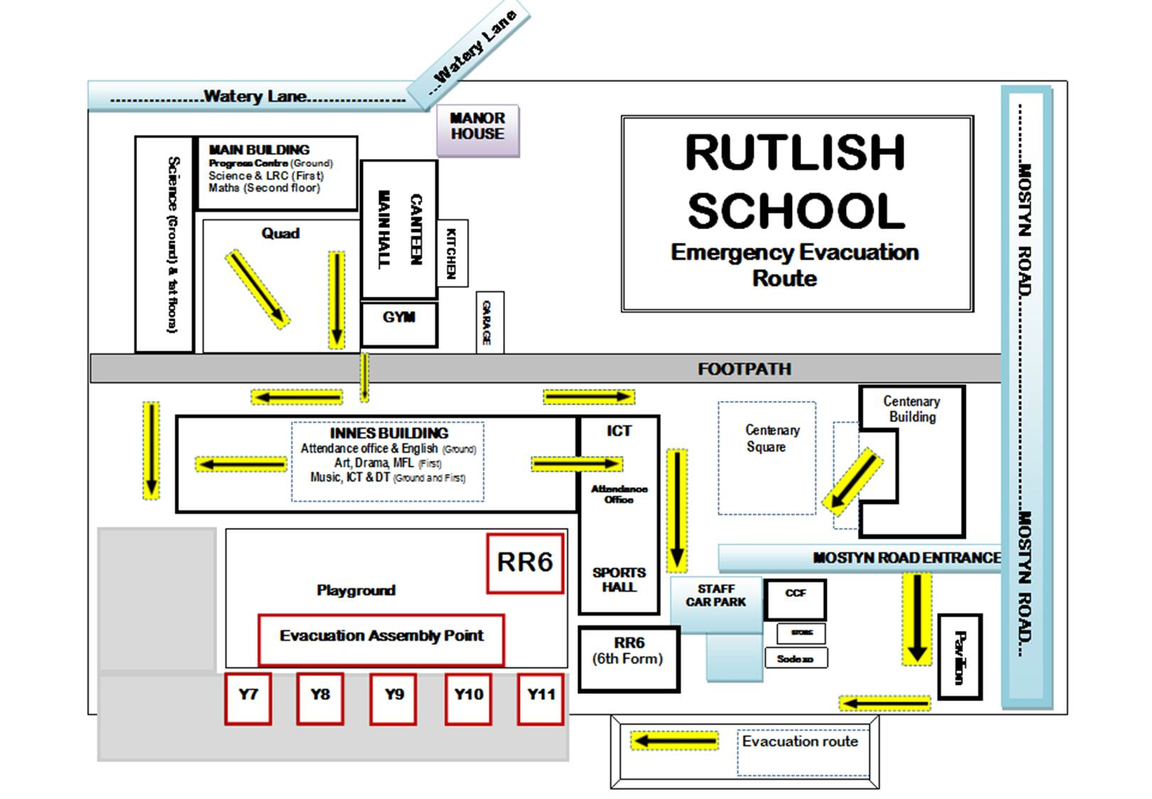

Welcome to Finance

We are located on the First Floor of the Manor House, from here all orders are placed, invoices paid, school uniform and stationery for students sold and staff absences recorded! Our door is always open to help you in any way we can.

**Ordering**

If you need an item for your classroom, please check with your Head of Department. Please be aware that there are a number of companies offering free teaching resources to download on-line. They are not always ‘free’ and we have found that you are, by downloading these resources, entering into contracts that the school is subsequently invoiced for. We would advise that you study the company’s Terms and Conditions very carefully, also, check with your colleagues as they will be able to advise you of favourable websites offering good resources.



**Stationery**



We sell a selection of pens, pencils and other stationery at vastly reduced rates to the students. They can come to Reception at break or lunchtime to purchase these items.

[](http://www.google.co.uk/imgres?q=money&um=1&hl=en&sa=N&biw=1536&bih=717&tbm=isch&tbnid=LUoDlZA-Rij5yM:&imgrefurl=http://bishopbjj.com/2012/04/13/money-jiujitsu-part-1-how-to-win-the-pan-ams/&docid=46XISo8TmSY82M&imgurl=http://bishopbjj.files.wordpress.com/2012/04/hands-holding-money2724991187645861.jpg&w=476&h=461&ei=O7fhT4DOFI-w8QPi4c2fBA&zoom=1&iact=hc&vpx=193&vpy=313&dur=476&hovh=221&hovw=228&tx=105&ty=98&sig=110671376373350105316&page=4&tbnh=163&tbnw=177&start=75&ndsp=24&ved=1t:429,r:18,s:75,i:448)

**Salaries/Wages**

We are happy to help you if you have any queries relating to your pay; your payslip will be placed in your pigeon-hole in the Manor House Staffroom.

**Absences**

Following any sick absence, you will need to complete a self-certification form which should be emailed to you. Please complete this form and return it to us as soon as possible, this form enables us to ‘close’ your absence and therefore prevent your pay from being affected!



If you need to be absent for any other reason, i.e. training courses or personal, you will need to complete a ‘Leave of Absence’ form, available from the staff Handbook.

**School Trips**



If you would like to organise a trip for your students you will need to complete a ‘Trips Pack’ after first discussing this with your Head of Department. The pack is available to download from the staff Handbook. We would be happy to assist you with the planning.

**Food**



Finally, here at Rutlish, we have a biometric cashless system in the canteen, if you wish to buy food there, you will need to have your fingerprint taken! If you have any objections to this, you can purchase a card for £5 instead. For either option – come and see us!!

Privacy Notice

School Workforce: those employed or otherwise engaged to work at a School or Local Authority

**Privacy Notice - Data Protection Act 1998**

Rutlish School are the Data Controller for the purposes of the Data Protection Act.

Personal data is held by the school about those employed or otherwise engaged to work at the school or Local Authority. This is to assist in the smooth running of the school and/or enable individuals to be paid. The collection of this information will benefit both national and local users by:

* Improving the management of school workforce data across the sector;
* Enabling a comprehensive picture of the workforce and how it is deployed to be built up;
* Informing the development of recruitment and retention policies;
* Allowing better financial modeling and planning;
* Enabling ethnicity and disability monitoring; and
* Supporting the work of the School Teacher Review Body and the School Support Staff Negotiating Body

This personal data includes some or all of the following - identifiers such as name and National Insurance Number and characteristics such as ethnic group; employment contract and remuneration details, qualifications and absence information.

***We will not give information about you to anyone outside the school or Local Authority (LA) without your consent unless the law and our rules allow us to.***

We are required by law to pass on some of this data to:

* the Department for Education (DfE)

If you require more information about how the LA and/or DfE store and use this data please go to the following websites:

* Merton Council and
* <http://www.education.gov.uk/schools/adminandfinance/schooladmin/a0077963/what-the-department-does-with-school-workforce-data>

If you are unable to access these websites, please contact the LA or DE as follows:

* London Borough of Merton Data Protection Officer at [data.protection@merton.gov.uk](mailto:data.protection@merton.gov.uk) or by writing to:   
    
  The Data Protection Officer  
  London Borough of Merton  
  Civic Centre  
  London Road  
  Morden, SM4 5DX.  
  Telephone: 020 8545 4182 Fax: 020 8545 4105
* Public Communications Unit  
  Department for Education  
  Sanctuary Buildings  
  Great Smith Street  
  London SW1P 3BT

Website: [www.education.gov.uk](http://www.education.gov.uk/)

Email: [info@education.gsi.gov.uk](mailto:info@education.gsi.gov.uk)

Telephone: 0370 000 2288.

Map of the School

**PAVILION**

p

**PLAYING FIELDS**

**WATERY LANE ENTRANCE**

**Reception**

**Headteacher**

**School Office**

**Finance**

**Exams**

**CENTENARY BUILDING**

**Business Studies**

**Geography**

**History**

**RE**

**MAIN BUILDING**

**Maths, Science, Library, Progress Centre**

**CANTEEN &**

**MAIN HALL**

**QUAD**

**GYM**

**FOOTPATH**

**MOSTYN ROAD ENTRANCE**

**PARKING**

**INNES BUILDING**

**Attendance Office**

**Sports Hall**

**English**

**Art**

**Drama**

**Music**

**DT**

**ICT**

**Media**

**MFL**

**Performing Arts**

**CAGE**

**RR6 SIXTH FORM**

**BUILDING**

**WATERY LANE ENTRANCE**

**MANOR HOUSE**

The School Day / Term Dates

|  |
| --- |
| THE SCHOOL DAY & REGISTRATION |

|  |  |  |
| --- | --- | --- |
| **Period** | **Time** | **Length of Period** |
| Registration / Assembly | 8.30 – 8.50 | 20 minutes |
| Period 1 | 8.50 – 9.50 | 60 minutes |
| Period 2 | 9.50 – 10.50 | 60 minutes |
| Break | 10.50 11.15 | 25 minutes |
| Period 3 | 11.15 – 12.15 | 60 minutes |
| Period 4 | 12.15 1.55 | 60 minutes |
| Lunch | 1.15 – 1.55 | 45 minutes |
| Early Warning Bell | 1.55 |
| Period 5 | 2.00 – 3.05 | 65 minutes |

