21st November 2018

Dear Applicant,

Re: Scale 7 & 6 Teaching Assistant Post & Scale 4 Learning Support Assistants.

Thank you for your interest in the above positions, you will find the relevant information required to apply is enclosed.

Castlebar is an exciting and unique school to work in. We are proud of all that we achieve for our children and particularly of the positive atmosphere that exists in our school.

Please use the Person Specification enclosed as a plan for your application. All supporting statements must be typed.

The closing date for applications is Thursday 10th January 2019 and the Interview date is TBC.

Please indicate on the application form which Scale you are applying and to ensure you meet the necessary criteria as this is important when shortlisting potential candidates for interview.

We hope that after reading the information you will wish to apply for this post and if there is anything you require, please do not hesitate to contact us.

Yours faithfully

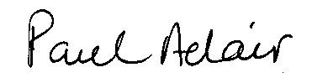

Paul Adair

Headteacher

