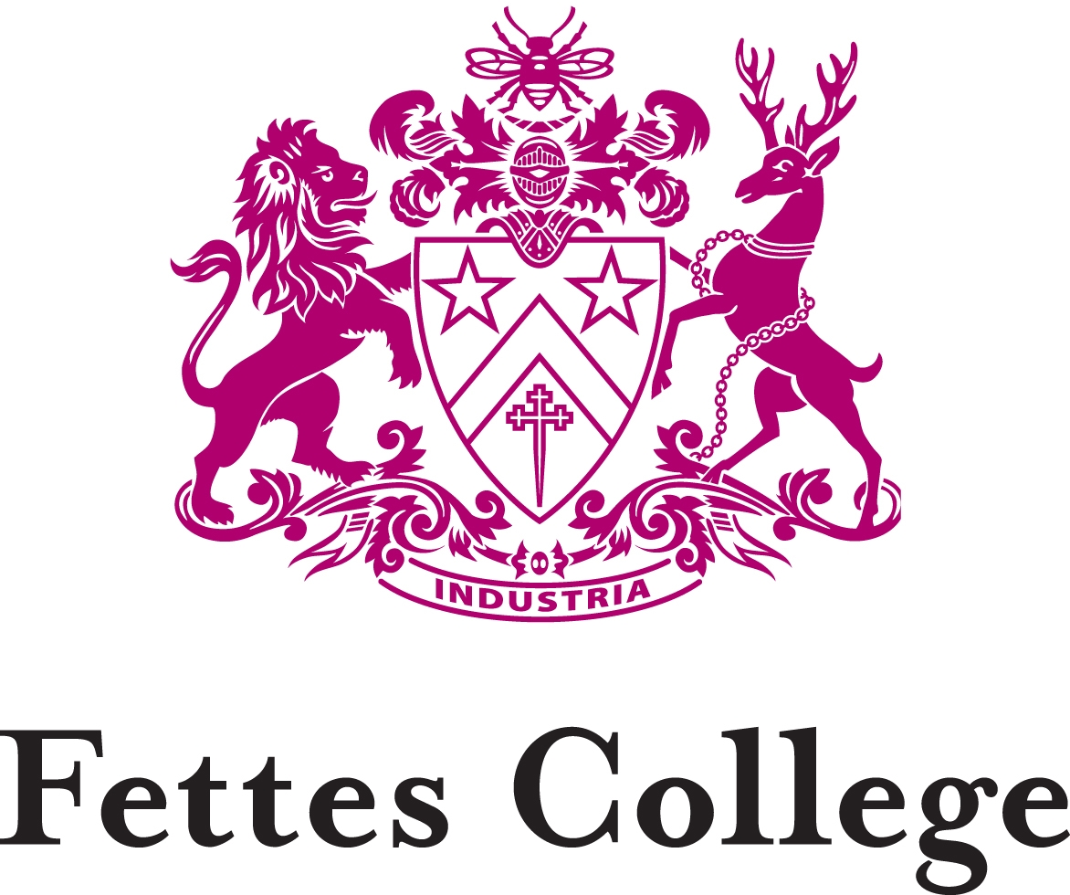

(HMC, IAPS, Co-educational, 760 students aged 7-18)

TEACHER OF CLASSICS

For September 2018

The School
Fettes College, founded in 1870 and administered by the Governors of the Fettes Trust, is an independent school of some 760 boys and girls. There are 560 students in the Senior School (13-18 years), of whom 75% are boarders, and 200 students in the Preparatory School (7-13 years). The School is in membership of AGBIS (Association of Governing Bodies of Independent Schools). The academic staff consists of the Headmaster (a member of the Headmasters’ and Headmistresses’ Conference), the Headmaster of the Fettes College Preparatory School (a member of the Incorporated Association of Preparatory Schools) and seventy-five full-time members of the Common Room. There is a strong Old Fettesian Association.

The School stands in a magnificent park of approximately 100 acres close to the centre of Edinburgh. The main building contains the Chapel, the Library, the Classics, English and History Departments, the Medical Centre and two boarding houses. The Preparatory School and the other seven boarding houses, the Dining Hall, the recently-opened Spens Building which houses Art, Economics, Geography, History, Mathematics, Modern Languages and Music, the Concert Hall, the Science laboratories, the Sports Centre, the all-weather Games Pitches, squash and fives courts are situated in the grounds. A new boarding house has been built adjacent to the Science Block to accommodate the whole of the Upper Sixth Form. There are extensive playing fields.

The College has been fully co-educational since 1980.

Classics at Fettes College

There are currently three full-time Classics teachers in the Senior School at Fettes and one in the Prep School. The Department is flourishing, with Latin and Greek both attracting talented students for GCSE, A Level and IB. There are usually some 15-20 students doing GCSE Latin each year and a reasonable number taking Greek. Classical Civilisation usually attracts about the same number for GCSE as Latin, many of whom continue to A Level and IB as Classical Greek and Roman Studies. We follow the OCR boards for all Classical subjects at GCSE and A Level.

There is a very firm base of teaching in the Prep School provided by an enthusiastic and popular specialist teacher. Pupils (11-13 years old) get two years of Latin teaching in the Prep School before they are given the chance to opt for it in the Third Form, which many of them choose to do, resulting in three Third Form sets. There is also a class for beginners.

In the Third Form, pupils are set according to their abilities and all of them study Latin using the Cambridge Latin Course, beginning at the start of Book 3. Classical Greek is also taught as an activity outside the timetable using Taylor’s Greek to GCSE Part 1, again focusing on the language but also exploring the Greek world in general.

At GCSE, there are usually two Latin sets who continue to study using as well as other resources, before beginning their set texts at the end of the Fourth Form. For Greek, there is usually a reasonably-sized class which finishes their previous textbook and Taylor’s Greek to GCSE Part 2 before beginning their set texts at the end of the Fourth Form. For Classical Civilisation, students study the Homeric World and Myth and Religion, using the prescribed OCR textbook, as well as other resources to expand on the basic information.

In the Sixth Form, Latin and Greek students study their set texts alongside the language, where we teach a mixture of translating unseen passages and composition of the relevant language. We tend to use Taylor’s Greek and Latin Beyond GCSE textbooks as well as Ashdowne and Morwood’s Writing Latin, and Anderson and Taylor’s Writing Greek. For Classical Civilisation, we currently teach the World of the Hero, Greek theatre and the Politics of the Late Republic. For IB, we currently teach Greek Tragedy, Augustan Rome, Roman Epic and Alexander the Great.

Our results have been excellent. At GCSE for Latin and Greek, the majority of students comfortably achieve A*/A and nearly all students in the Sixth Form will obtain A*/A at A Level or 7/6 at IB. For Classical Civilisation, nearly all students achieve a B grade or above for both GCSE and A Level, with IB students having achieved 7/6 in Classical Greek and Roman Studies. In recent years we have had several Oxbridge applicants with a good success rate.

As a Department we believe strongly in traditional standards, but we encourage a variety of teaching approaches that involve ICT and classroom drama, as well as other creative activities. All classrooms are equipped for AV teaching and the School has excellent ICT facilities for use in teaching. A wide range of supplementary materials is available in our departmental resources room and on the shared area. The School uses Firefly as its Virtual Learning Environment and the Classics Department makes extensive use of shared resources, which students are actively encouraged to access.

There is a well-attended Classical Society which meets once a term to which visiting speakers are invited to deliver lectures for students of all the year groups. Recent speakers have included Dr Calum MacIver from the University of Edinburgh who spoke about the ending of Virgil’s Aeneid, and Dr John Holton from Newcastle University who discussed different representations of Alexander the Great. The Department runs biennial trips to classical sites abroad, with a trip to Sicily, combined with the Geography and Italian departments, currently being planned. We also take part in local Classics Reading Competitions, and we take the Sixth Form down to London for the day to the British Museum. We often take students to classical plays, galleries and films inspired by the Classics, as well as organising a Classics Christmas meal in the summer for the Sixth Form.

The Appointment
Fettes College wishes to appoint a teacher of Classics in the Senior School. This is an exciting opportunity to join an outstanding Department which has enjoyed considerable academic success at all levels. The successful candidate will be encouraged to promote Classics both in and outside the classroom and he or she will be an excellent classroom practitioner.

Energy, drive and good organisational and interpersonal skills will be vital, as will the vision and flexibility necessary for tailoring the languages’ provision to students’ needs.

In addition to their classroom teaching, all Fettes staff make significant contributions to the wide-ranging extra-curricular life of this vibrant boarding school.

The Head of Classics, Miss Clare McDonnell, is happy to discuss this post with interested candidates before a formal application is made. She can be contacted via email at: c.mcdonnell@fettes.com.

Conditions of the Appointment
- The appointment will date from the start of the Autumn Term 2018.
- Salary will be by negotiation and will depend on the qualifications and experience of the successful candidate.
- There is remission available for all members of staff whose children attend the school as day students. Fettes is a member of the Scheme for the Education of the Children of Teaching Staff.
- Employment will be subject to one term's notice on either side.

Other details and conditions of service can be discussed at interview.

An Application Form (including the names and addresses of three referees), accompanied by a covering letter should be sent to the Human Resources Manager, Fettes College, Carrington Road, Edinburgh EH4 1QX or emailed to recruitment@fettes.com. Closing date for completed applications will be 1pm on Monday 19th February 2018. Interviews for short-listed candidates will be held on Tuesday 27th February 2018.

January 2018

