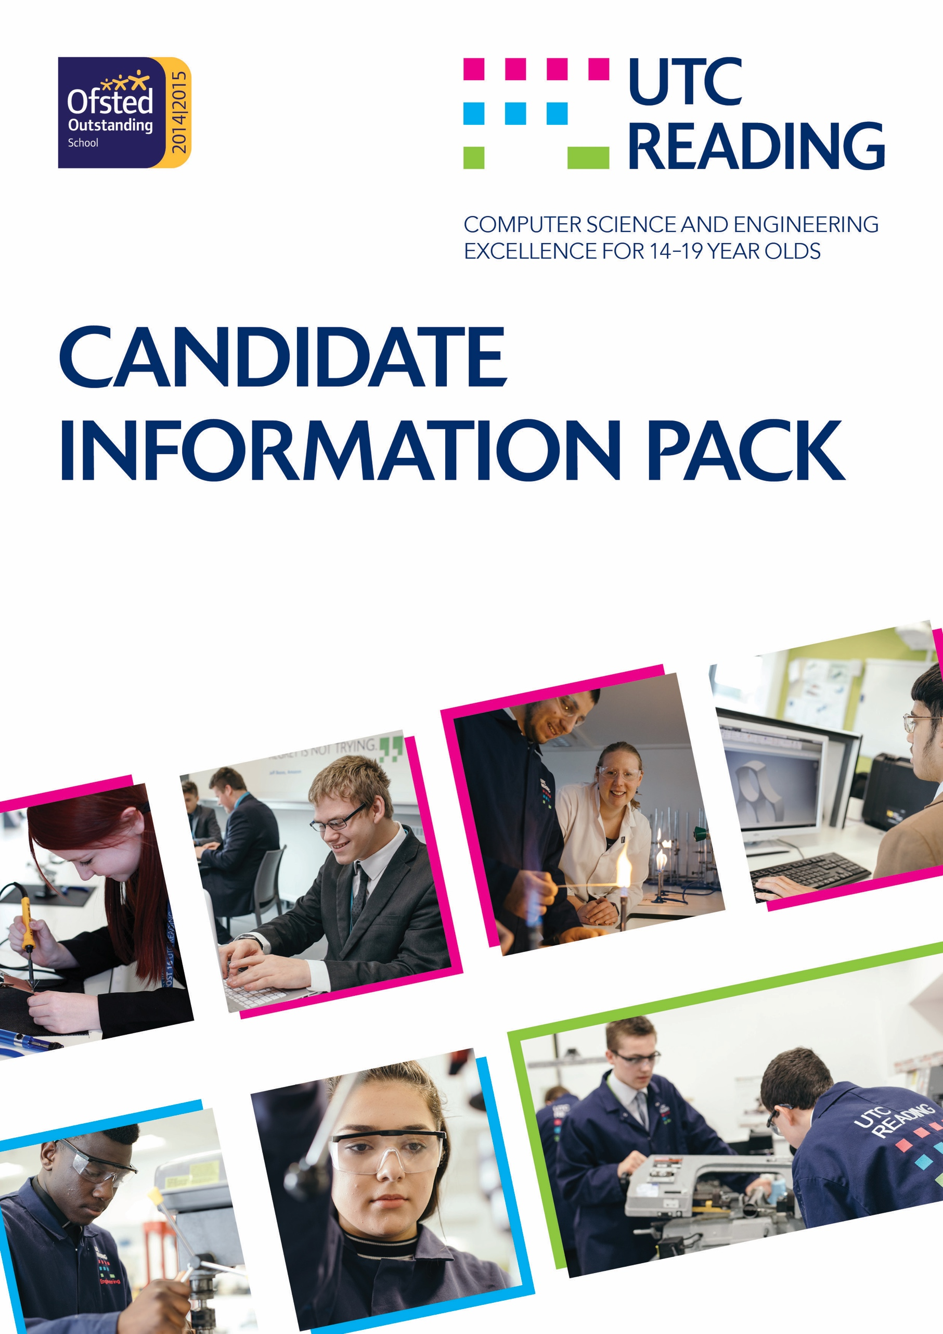
Teacher

Dear Candidate

Thank you for expressing an interest in the role of Teacher of Mathematics at UTC
Reading.

UTC Reading is a University Technical College (UTC) specialising in Computer Science and Engineering which opened in September 2013 in a ‘state-of-the-art’ building. The specialist curriculum appeals to secondary school-aged students keen on developing their talent in these areas. A UTC is different from the average school because it is designed with the backing of the local business community and has industry partners involved. UTC Reading connects students with industry partners Microsoft, Cisco, Peter Brett Associates, and Network Rail, offering great access to employment and sponsorship opportunities.

We have created an inspirational learning environment where learning is central, UTC Reading offers a unique learning opportunity for young people interested in computing and engineering, by developing the technical, personal and employability skills needed to progress to university and the world of work.

Our aspiration is for UTC Reading to become the leading UK Centre specialising in the broad spectrum of computer science and engineering. It will lead the way in establishing computer science as a mainstream school subject with a variety of progression routes into employment and higher level study. We are part way along this journey and were recognised by Ofsted as an Outstanding school in May 2015. In December 2017 the UTC was awarded the World Class Schools Quality Mark.

We have high aspirations and want every student to leave us ready to take their place in the global computing and engineering sectors. A relentless focus on excellence and a leading-edge approach will make that happen.

We recruit a balanced intake of students across the ability range in each year of entry. We currently have 450 students on roll across Years 10-13 and when at capacity will have a total of 560 students; it is anticipated we will reach capacity in 2019.

The information in this pack has been designed to give as much detail as possible to allow you to decide if UTC Reading is the right career move for you. Please do feel free to contact the Principal, Jonathan Nicholls, via jessica.bryant@utcreading.org.uk or telephone 0118 9381020 if you would like to make an appointment to discuss the role in further detail.

Yours faithfully

Jonathan Nicholls

Principal

Our vision

Through close collaboration with our academic and industry partners, leading organisations in the IT and engineering sectors, the UTC offers a unique learning opportunity for young people with a strong interest in engineering and computer science. It sets the standard for 14 to 16 computer science education nationally, delivering an innovative curriculum which promotes the computer science literacy that employers and universities seek in school leavers.

Having made a positive choice to join the UTC, students will be well motivated to work hard and benefit from the UTC’s innovative and inspirational learning experience. UTC Reading’s ‘graduates’ will gain the reputation for demonstrating the skills, attitudes, knowledge and experience sought by the world’s leading employers. Through the ongoing links with industry partners, they will be personally known to local organisations such as Microsoft, Cisco, Peter Brett Associates and Network Rail, giving them greatly increased opportunities of sponsorship or employment.

Activate Learning Education Trust

UTC Reading is part of the Activate Learning Education Trust (ALET), which is a Multi Academy Trust (MAT) established by Activate Learning.

ALET’s mission is “to deliver excellence in education and to transform lives through learning”, bringing to life core values of empowerment, enterprise, connectedness and transformation. ALET work hard to ignite confidence, expand opportunities, energise the community and generate prosperity.

These values are further supported by the learning philosophy, rooted in the dynamics between the brain, motivation and our emotions. Together they shape the learning experience of thousands of students across our group, fostering a culture of high aspirations.
ALET has developed a model for a high quality learner experience, which:
- Supports student progress, attainment and preparation for progression
- Focuses on secondary education, aligned to regional business needs
- Operates a delegated model of school governance and leadership, striking the right balance between autonomy and sharing.

Activate Learning (lead sponsors) lead further education colleges and five schools in the region, offering a broad spectrum of vocational courses including Key Stage 4 vocational options, Post 16 vocational and academic courses as well as higher education courses. Developing skills for employability and enterprise is at the heart of the colleges’ mission.

Industry and academic partners

Our academic partners are:

- The University of Reading

The key industry partners are:

- Microsoft
- Cisco
- Network Rail
- Peter Brett Associates LLP

Industry partners are involved in a number of ways:

  - consultancy, advice and guidance on curriculum development
  - product and services donations
  - employer accreditations
  - employer-led projects and challenges
  - coaching and mentoring
  - work experience.
  - Participation in the governance of the UTC.

Industry partners enable students to study specialisms and gain globally accepted industry standard accreditations.

Location and facilities

The UTC provides advanced, best of breed facilities for computer science and engineering, giving our students an environment that will feel more like a global company than a school, further preparing them for employment.

Over £8 million has been invested in developing this state-of-the-art learning centre for computer science and engineering. The campus includes a building dedicated to computer science, a building for engineering and related project work and a brand new science centre.

Our UTC is truly at the leading edge of technology in learning. Personal devices can be used anywhere to access your work and study resources. Our Microsoft and Cisco learning labs are hi tech and have their own dedicated server and IT infrastructure that is used for learning.

Right at the heart of the UTC complex is the special place that makes us really different. Our independent learning zone is a vibrant hub combining learning resources with a flexible ‘hot desk’ working environment.

Curriculum

The focused curriculum prepares students for a career in the IT and engineering sectors while keeping other career routes open. It develops well-rounded and well educated leaders, professionals and entrepreneurs for the future.

Students are encouraged to take GCSEs and A levels alongside technical qualifications and gain industry standard employer certifications and professional society memberships. They will be able to make the most of their talents and move on successfully to higher education, further education, apprenticeships and employment.

Formal learning will be enhanced by a variety of enrichment activities:
- sports
- arts
- leadership, building activities, e.g. Young Enterprise, Duke of Edinburgh Award, Combined Cadet Force.

Environment

Students at the UTC learn in an environment more like a workplace than a traditional school. The working day is longer than students usually experience, with on-site learning starting at 8.30am and ending at 4:30pm (4:00pm on Monday and Friday) each day. Equipment and facilities in the UTC will be industry standard as specified by our industry partners.

Learning experience

The learning experience blends different forms of learning. It develops a very broad reach of knowledge and strong practical and social skills. Students are coached by tutors and mentored by industry and academic partners. Instructor-led seminars provide students with a formal learning structure that are extended through project based activities that will be designed by the industry partners to replicate the issues faced in industry. Students are encouraged to develop effective personal learning techniques during individual learning sessions.

The Key Stage 4 programme

All students study GCSE, English, Maths, Science and computer science. They then can choose to study technical qualifications in either Engineering or Computing, which they can do for two years, or they can swap at the end of year 10. In addition, the students are expected to choose one GCSE option subject from Geography, History, Business Studies and Smart Product Design and Manufacture

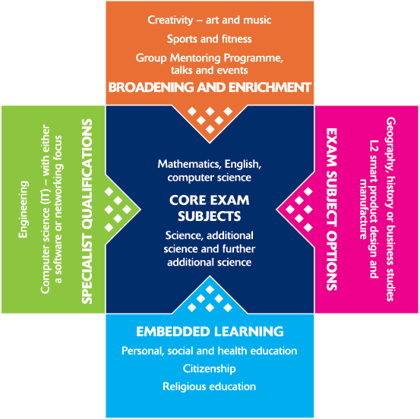

The Key Stage 5 programme

Students are able to join the UTC at 16 or progress to this stage from Key Stage 4. Core subjects will include A levels in Maths, Further Maths, Physics, Chemistry Biology, Business, 3d Design with Architecture, and computer science. In addition, students can study technical qualifications in computing or engineering through the BTEC qualifications in engineering and Computer Science. There is also an opportunity to take globally recognised employer accreditations from Microsoft, Cisco and Autodesk.

Specialisms started at Key Stage 4 can be developed into employer accreditations (e.g. Microsoft and Cisco) and, when combined with work experience, enable students to apply for membership of professional associations. The embedded learning and enrichment activities at this stage are specifically targeted towards developing the skills and attitudes that make students employable.

Students in the 6th form can study in one of three different routes:

Route 1 (A Level route) : Students will study 3 A Level’s of their choice

Route 2 (Combination Route) : Students will study 2 A Level’s of their choice alongside a Level 3 BTEC Extended Certificate in Engineering or Computing.

Route 3 (Technical Route): Students will study a Level 3 BTEC Extended Diploma in Engineering or Computing. This route is equivalent to 3 A Levels.

Terms and Conditions of Employment

Proposed start date
Please see advertisement

Salary
Please see advertisement

Pension
Teachers’ Pension Scheme.

Holidays
You will be entitled to receive your normal remuneration for all Bank and Public Holidays normally observed in England and Wales and to a further 40 days holiday in each holiday year (being the period from 1st September to 31st August).

Working hours
The post holder will be required to work as many hours as are reasonably necessary to fulfil the requirements of the role. Our core working hours are 8:15 – 17:15 Monday to Thursday and 16:45 on Friday

Place of work
The principle place of work will be Crescent Road, Reading RG1 5RQ. As part of your duties, you may be required to travel within the United Kingdom or further afield. Such travel may include attendance at conferences or seminars or meetings.

Travel to work
As part of your Contract of Employment you should live within reasonable travelling time/distance of the UTC to fulfil the requirements of the role.

Health check
Confirmation of appointment to the post will be contingent on a satisfactory health check.

References
Confirmation of appointment is also subject to satisfactory references.

Background
In accordance with the criteria defined in and the provisions of the joint Home Office/
Department of Education and Science circular Protection of Children; ‘Disclosure of Criminal background of those with access to children’ dated 17th July 1986; the appointment is subject to a check by Criminal Records Bureau in respect of any possible criminal convictions.

The Employee warrants as follows:

- The post holder will disclose to the Employer any previous criminal convictions that he/she may have and which are not spent within the meaning of section 1 of the Rehabilitation of Offender’s Act 1974 (Exceptions) Order 1975 9for example, where the Employee is involved in the teaching, supervising or training of persons under the age of 18.

- That the post holder will disclose to the Board of Governors immediately upon conviction, the fact that he/she had been convicted of any offence during the period of his/her employment.

AND in the event that the Employee fails to disclose any convictions in accordance with paragraphs 1 and 2 above, such failure to disclose may be deemed by the Board of Governors to be gross misconduct.

The Application Process
Please see the advertisement

