

EXPLORE OUR WORLD

**Apprentice HR Assistant**

**Required January 2019**

**INFORMATION FOR CANDIDATES**

**A Catholic Independent Day School for Girls 2-18**



# cid:image022.jpg@01CFD347.D2E5AD80

**The School**

Set in 26 acres of beautiful parkland in Cobham, Notre Dame School nestles in a picturesque 18th century mansion beside the River Mole. Notre Dame is a Catholic School and is a Foundation of the Company of Mary Our Lady with an ethos shaped by the life and work of St Jeanne de Lestonnac. Despite the tranquil setting Notre Dame School is a hive of activity, with over 600 children and teachers working hard in the important business of education. The school has an enviable reputation for the highest academic standards and a progressive, holistic, academic education that is underpinned by over 400 years of international educational tradition in 30 countries. Established in England in 1937, the school has always had the philosophy that the greatest success comes from knowing how to learn and how to ask the right questions; training pupils to take an active role in reaching and exceeding early expectations. From the vibrant Nursery to the exciting Sixth Form, tomorrow's professionals acquire the skills, knowledge and qualifications that give them the best possible start in life.

The school is filled with a strong sense of purpose, offering a wide-ranging and active education with facilities encompassing new science laboratories, music and drama studios, sports fields, indoor swimming pool, dedicated Sixth Form Centre, a forest school for the youngest pupils, and a fully equipped, West End quality theatre seating over 350. The school is currently developing its all-weather facilities to complement the existing outdoor and indoor netball and sports facilities. The girls participate in choirs, sports teams, orchestras, language groups, outreach work, craft clubs, swimming squads and debating societies. The school councils for the different age groups and the peer mentoring and 'big sister' system provide pastoral care in a place that values the individual and always stretches a hand to help others, leading to charity initiatives as well as a happy and fulfilled community.

Leadership is prized and all are encouraged to fully engage in the life of the school. In recent years educational research has shown that this type of all-round education adds limitless value to the lives and experiences of our young people, as well as enhancing academic success and personal confidence, so it is a delight to find a world-class school on the doorstep that has promoted this so strongly and so successfully for over three quarters of a century.

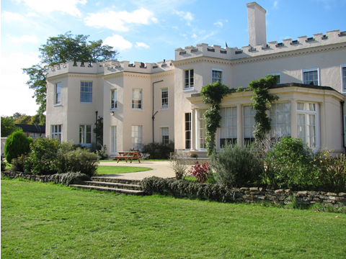 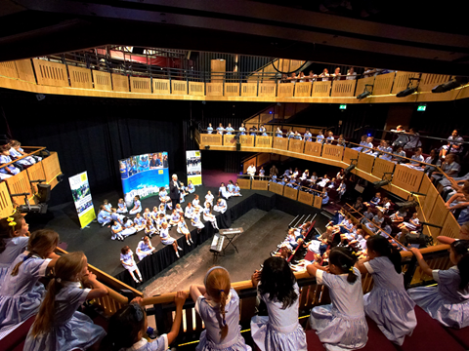 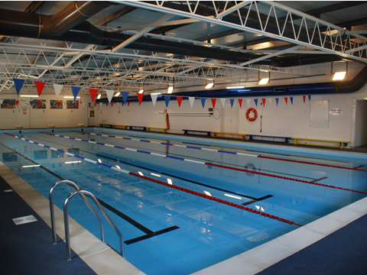

**Heritage and ethos**

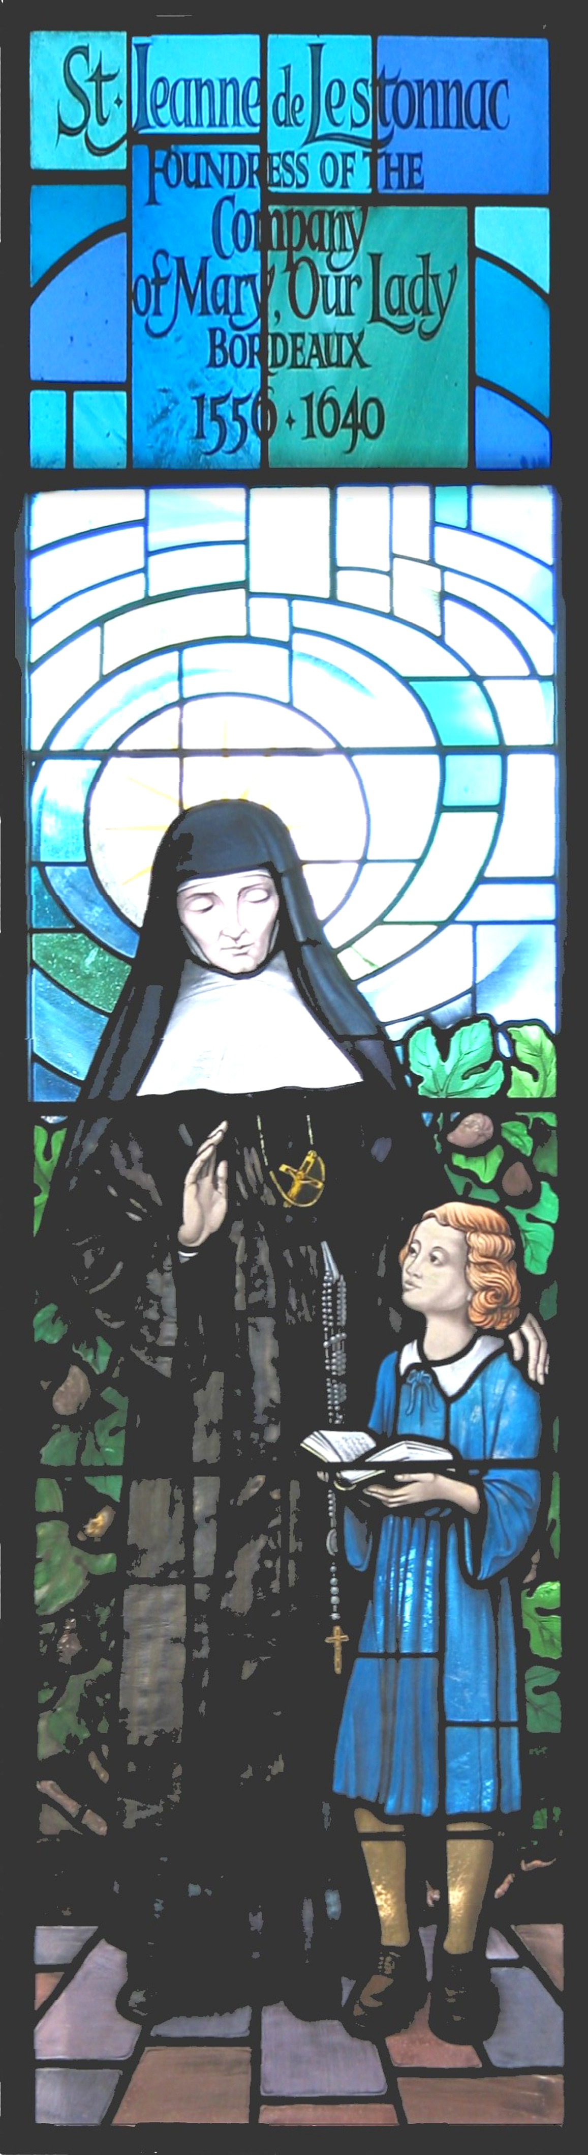

The School has a long heritage in matters spiritual and philosophical. Notre Dame, Cobham is a Catholic School, but with an ecumenical attitude to those of other faiths. It was established in 1937 by the Sisters of the Order of the Company of Mary Our Lady. The Company of Mary was founded in France in the 17th century by St Jeanne de Lestonnac and has over 300 educational establishments throughout the world. The Sisters of the Company of Mary continue to play a very important role in the pastoral life of the school ensuring that the ethos is maintained. Our values are rooted in our heritage, however, as an inclusive, outward-looking School; we are committed to encouraging a questioning spirit of mutual tolerance and informed dialogue based on openness, reciprocal respect and trust. We welcome girls of all faiths and none.

**The Department**

The Bursary is responsible for the School’s support services and in particular for the financial, HR, communications, legal, H&S, administrative, estates and facilities management work of the School.

The Bursary also provides (through the Bursar and Clerk to Governors) a governance resource and is the secretary to the Governing Board.

The Office handles much sensitive and confidential material. It is essential therefore that staff understand the need for absolute confidentiality.

**The Role**

**Function of the Post**

As an Apprentice you will support the HR Manager in providing a professional, customer-focused HR generalist service for the School. You will be supported in your learning and attend college on a weekly day release to study the HR Support Level 3 apprenticeship and be work based for the remainder of the week.

**Main Accountabilities**

**Administrative**

* + Create and maintain personnel files, and personnel data, both in hard copy and electronic form on the school database (SIMs). This includes requesting outstanding documentation and transferring old files to archive.
  + Maintain and update the Staff Employment Handbook with guidance from the HR Manager
  + Update the Single Central Register of appointments in accordance with safer recruitment legislation.
  + Manage absenteeism in conjunction with the Assistant Head, Curriculum and Assistant Head of Prep, directing staff to complete self-certification forms and updating SIMs
  + Process annual leave requests for support staff and update SIMs
  + Generate and issue letters for staff, including confirmation of employment, variation and maternity/paternity leave, and advise the Finance Office of changes for Payroll
  + Provide administrative support for the appointment of and contract renewals for peripatetic teachers, visitors and casual staff, liaising with line managers in advance.
  + Undertake the administration of staff leavers, draft correspondence and notify the Finance Office

**Recruitment**

* + Respond to candidate enquiries regarding current vacancies by telephone/email.
  + Prepare position descriptions in conjunction with the HR Manager and line managers, and upload adverts to the School website, TES and other relevant websites.
  + Collate job applications, forward to selection panel and liaise with the Heads PA and line managers to organise an interview schedule.
  + Undertake the administration of new starters, ensuring appointment checklists are complete with application forms, qualification certificates, training certificates and pre-employment checks, including references
  + Obtain and conduct DBS checks, barred checks, prohibition checks and assist line managers with risk assessments where appropriate.
  + Work in conjunction with the Exams Officer to manage the onboarding of Exam Invigilators and conduct DBS update checks.
  + Notify the Heads, Bursar, Finance, ICT, Front Office and Estates of new starters and ensure all relevant information is provided in a timely manner.

On completion of your Apprenticeship you will have achieve a nationally recognised qualification and have the opportunity to apply for employment opportunities within relevant companies HR departments.

***No job description can fully cover all aspects of the role and consequently the responsibilities are likely to evolve and change over time.***

**Person Specification**

**Qualifications**

Five GCSEs A*-C/9-4 including Maths and English or equivalent

**Experience**

You must be interested in working in a HR role

**Knowledge**

* + Excellent IT skills and strong office systems knowledge.
  + Good communication and listening skills.
  + Good organisational and administrative skills including record keeping.
  + Outstanding written ability.
  + Experience of Microsoft Word together with experience of working with spreadsheets and databases.

**Personal Attributes**

* + Adaptability and flexibility
  + Positive attitude
  + Willingness to learn
  + Ability to work unsupervised
  + A good level of numeracy
  + Experience of using Microsoft Office
  + excellent attention to detail
  + excellent communication both written and verbal
  + an interest in HR

*Notre Dame School is committed to safeguarding and promoting the welfare of children and young people and expects all staff and volunteers to share this commitment.*

*All successful job applicants will be required to undergo child protection screening, including reference checks with previous employers and a criminal record check with the DBS.*

**Benefits of Service**

A formal contract of employment will be drawn up on appointment. The following notes provide guidance, without prejudice, on the likely main provisions of the agreement.

**Hours of work**

* + Monday to Friday 8.30am to 4.30pm.
  + Total hours per week: 37.5 (with 30 minutes unpaid lunchbreak), 52 weeks per year
  + 1 day per week release at College
  + Apprentice duration is 24 months

**Salary**

* + Year 1 £7.07 per hour; Weekly wage £265.13; Annual salary £13,786.76
  + Year 2 £8.10 per hour; Weekly wage £303.75; Annual salary £15,795.00

**Holidays**

* 5 weeks paid holiday pro rata per annum in addition to Public Holidays.

**Benefits**

* The School has high expectations of its staff, and therefore looks to reward them with a competitive salary scale and beneficial conditions of service
* There is an extensive induction programme for all new colleagues and ongoing professional development is encouraged
* There is ample opportunity to take on additional responsibility

**Personal**

* The School enjoys a fantastic situation: central London is 30 minutes away, the M25 and A3 are 5 minutes away. Heathrow is less than half an hour.
* Fee concessions are available for the pupils of any member of staff who meet the school’s entry requirements
* Free on-site parking
* School Nurse on site during term time

**For Recreation**

* Free use of the school’s leisure and sporting facilities, including a heated indoor pool during certain times.
* Free lunch and refreshments are available throughout the working day

**Selection Process**

Please complete the online application form available on our career site on eTeach:

notredame.careers.eteach.com

# Applications to:

Human Resources Department

Notre Dame School

Burwood House

Convent Lane

Cobham

Surrey KT11 1HA

Email: [HR@notredame.co.uk](mailto:HR@notredame.co.uk)

Any questions, please contact HR on 01932 589092.

**Closing Date: 9am on Monday 10th December 2018**

**Interviews: 11th – 14th December 2018**

**Start date: January 2019**

Shortlisted candidates will be interviewed by senior members of the School and take a tour of the school.

The School is committed to safeguarding and promoting the welfare of children and young people and expects all staff and volunteers to share this commitment. Applicants must be willing to undergo child protection screening appropriate to the post, including checks with past employers and the Disclosure and Barring Service.

The School is an equal opportunities employer and is fully committed to a policy of treating all its employees and job applicants equally and does not discriminate on the grounds of race, sex or marital status.