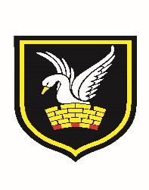 | Carshalton Boys Sports College  Winchcombe Road  Carshalton  Surrey  SM5 1RW

Art & Photography Department

The Art department is part of a Creative Arts Faculty within the school encompassing Music, Drama, Photography and Media Studies. We are a forward looking innovative department within the school, sharing good practise across all subject areas.

Art & Photography are popular subjects with pupils working towards examination courses in GCSE, NCFE and GCE. Strong cross curriculum links across the Creative Arts faculty support students wishing to continue their education at college and post graduate level. Each year students have gained places on foundation and degree courses at universities such as Central Saint Martins and Wimbledon Art College.

The Department is constantly expanding and developing the teaching and learning of Art & Photograph. Practical exam based units begin in Year 9 providing students with a solid foundation for their exams in Year 11. Assessment, self-assessment, tracking and target setting are used to help pupils’ progress and gain ownership and understanding of the subject. We constantly strive to empower pupils to become truly independent learners with strong creative skills.

We have three art rooms, housed in a purpose built suite of rooms and a photography studio. Within Art, Photography and Media the students regularly make use of SLR cameras, IPADS, Photoshop and editing programs. The Music Department houses a suite of Apple Macs and a DJ mixing table, as we believe today’s technology plays a huge part in developing creativity.

The Art and Photography Department is held in high esteem within the school and students work is proudly displayed throughout the building. There is a well-established rolling programme of art exhibitions. We have strong links with UCA and UAL and take part in external workshops, tutorials and visit student exhibitions.

April 2018

