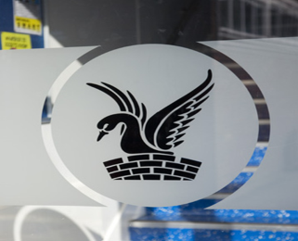
Carshalton Boys
Sports College

About our school
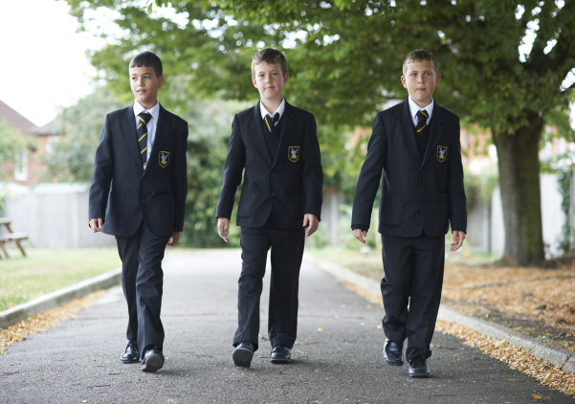
Carshalton Boys Sports College is a popular, oversubscribed all-boys community comprehensive school for students aged 11 to 16 with a mixed Sixth Form in the London Borough of Sutton. The ethos of the school is based upon a happy, warm, thriving atmosphere with a clear purposeful approach. We are a caring community where everyone’s talents are recognised and nurtured. It is our belief that happy students achieve and this can be seen in our outcomes at both Key Stage 4 and 5, which have risen year on year.

Our goal is to transform achievement: to enable every student to seize the best possible opportunities in life. Carshalton boys are serving their country in the armed forces, the Health Service and the police, and an increasing number leave us to study at some of the best universities in the country: Carshalton boys currently study at Nottingham, Sussex, Reading, Keele and Royal Holloway, London. We are immensely proud of our students’ achievements: they are a vindication of our belief in the potential of young people of any aptitude.

What we teach the boys
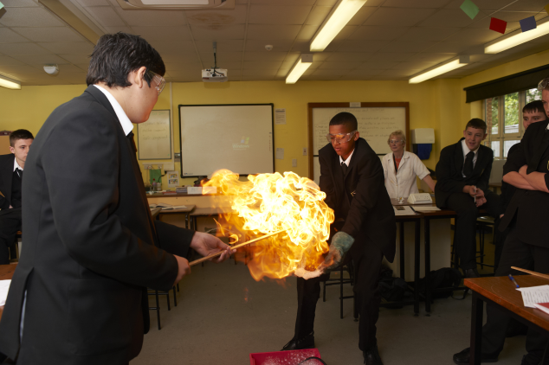
The school aims to provide every student with a broad, balanced and relevant curriculum in order to prepare them for the changing demands of our society. We have adapted and evolved with considerable success to the demands of the National Curriculum including a comprehensive Personal, Social, Health and Citizenship programme

KS3 (Years 7–8)
All students follow the same curriculum in the first two years. The subjects studied are: Mathematics, English, Science, Design & Technology, ICT, Geography, History, Art, Modern Foreign Languages (French/Spanish), Music, Drama, Dance, RE, PE and PSHCEE.

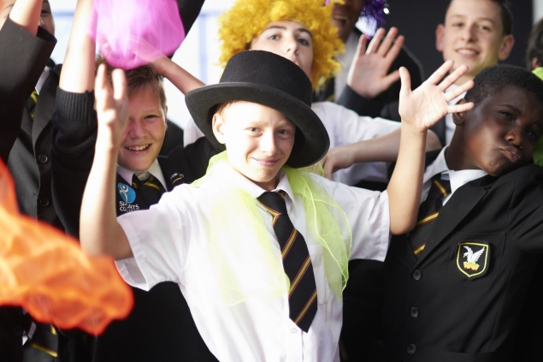
KS4 (Years 9–11)
The curriculum offered at Key Stage 4 is varied and incorporates new subjects which are not studied at KS3. We offer courses at different attainment levels which will enable all students learning needs to be catered for. In January of Year 8 students will select their Options for KS4.

KS5 (Years 12-13)
Not only do we welcome students from Carshalton Boys’ Year 11, but we also welcome both girls and boys from other schools. Our sixth form is a caring, learning community and the numbers of students have increased year on year. We have great links with universities, the local community and other schools. Sixth form is the bridge from school to the rest of your life and you need to be happy, well-taught and well-supported.

Expectations
As a member of Carshalton Boys Sports College students are expected to follow the principles:
• Perseverance
• Respect
• Independence & Collaboration
• Discovery
• Enthusiasm

The main emphasis in the school is on praise and reward, so that a positive school ethos is engendered. Students are encouraged at all times to take a pride in themselves, their work and the school.

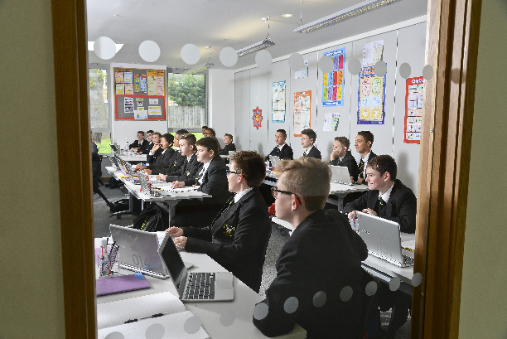
Results

GCSE Results
A*-C Grades including English & Maths 48%
A*-C overall 66%
5+ GCSE’s A*-A 10%
5+ GCSE’s A*-G 98%
There were many outstanding individual performances:
- Fourteen full GCSE’s, incl. 6 A*, 4A and 2 B Grades
- Thirteen full GCSE’s, incl. 5 A*, 6A and 2 B Grades

A2 Results
A* -B 59% 100% pass rate in Art, Drama, German, Graphics and Further Mathematics
A* -B 50% 50% pass rate Economics, English Literature, Geography, Government & Politics, History, Mathematics, Media, PE, Photography and Spanish

Well done and roll on 2017/2018!

What Ofsted say about our school
An inspection of Carshalton Boys Sports College was carried out by Ofsted on 25 April 2017. A summary of their findings are listed below:

• The leadership team has maintained the good quality of education in the school since the last inspection…… achieved this by successfully addressing the areas identified for improvement and maintaining a good culture of ambition among pupils and staff.
• The school community continues to share your vision for the school to raise aspirations and pupils’ performance.
• Parents who responded to Ofsted’s survey were overwhelmingly positive about the school.
• The school and sixth form are increasingly popular choices for parents, with the number on roll increasing and the school continuing to be oversubscribed.
• The opportunities provided for pupils’ personal development form a significant part of the school’s appeal to pupils.
• Governors have been precise in their scrutiny of leaders’ decisions and actions.
• There is a wide range of enrichment and extra-curricular activities on offer, many of which link directly with pupils’ academic studies and contribute to pupils’ strong attitudes to learning.
• Enrichment, clubs and the sense of community that exists within the school featured prominently in parents’, pupils’ and staff’s feedback to inspectors.
• Students in the sixth form made good progress across a range of subjects and overall last year.
• Parents, staff and pupils feel that this is a safe and caring school where bullying is rare.
• Staff manage behaviour effectively and pupils demonstrate a high degree of respect and tolerance towards one another.
• Most-able pupils are challenged through good questioning and tasks that stretch their learning, particularly in groups set by ability.

Extra-Curricular Activities
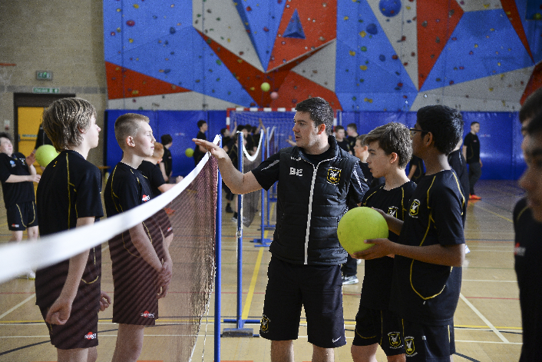
We endeavour to put on a full and inclusive extra-curricular programme of sports and activities that caters for all abilities and interests. We dominate England’s Handball scene, sending six UK representatives to Sweden recently to play for the national Handball team. Our work in art, drama, media studies and music has brought awards, excellent public exam results and uncommonly high levels of participation throughout the school. Our boys benefit from activities as varied as helping to design new playground facilities to visiting Ecuador and campaigning against the closure of a local hospital. Our staff work creatively to make sure that students can access many activities both inside and outside the classroom which are designed to increase confidence and responsibility and to provide experience that would not normally be available.

Pastoral Organisation
The school is arranged into two sections:

Lower School – Years 7 & 8
Upper School – Years 9, 10, 11, 12 & 13

The Principal, supported by a Vice-Principal, three Deputy Principals and four Assistant Principals, are responsible for the total welfare of each student in the school. They are in turn assisted by Learning Co-ordinators and Form Tutors for each year. Our three Pastoral Support Officers assist all these staff.

Working with us
Carshalton Boys Sports College (CBSC) is on a mission to find passionate and inspirational staff to join us. If you would relish the challenge of assisting us in leading the school in the next stage of its journey towards excellence we look forward to hearing from you. Join us on our growth and mission to make a real difference in children’s lives and help them to achieve to the best of their abilities.
Benefits
- Pleasant working environment with easy access from London
- Excellent sporting facilities
- Cycle to Work scheme
- Childcare Voucher Scheme
- Membership of Teachers Pension Scheme/Local Government Pension Scheme
- First class training and development opportunities with a bespoke CPD programme designed to address individual, departmental and whole-school development needs.
- An outstanding two year programme to support Newly Qualified Teachers.
- Supportive, friendly staff and a committed and loyal Governing Body.
