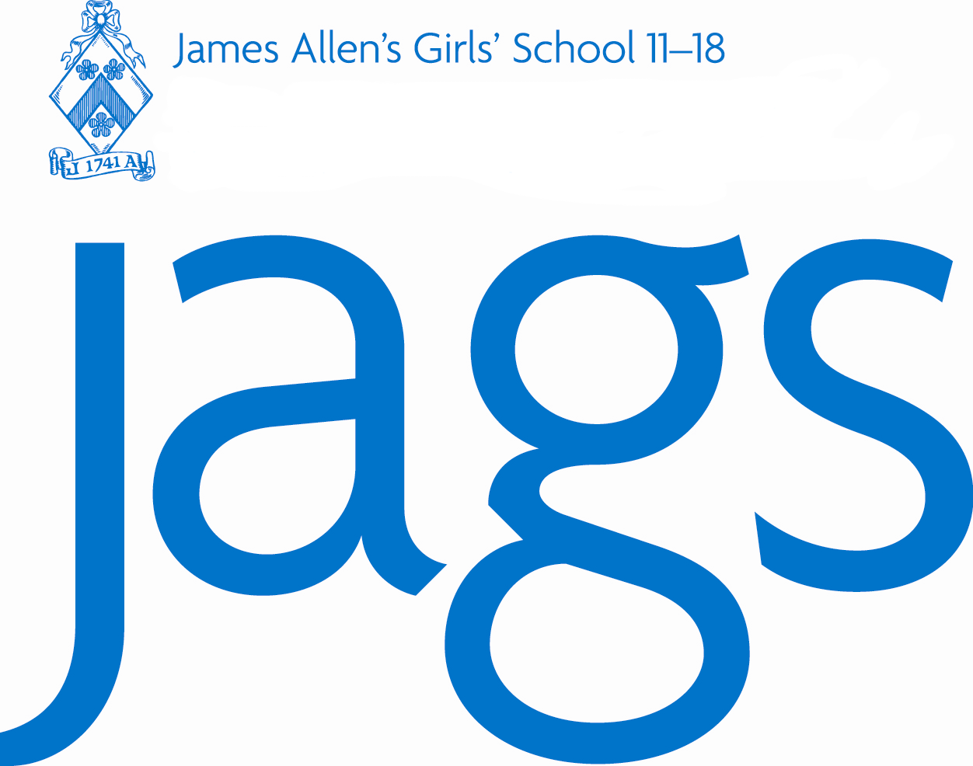
James Allen’s Girls’ School 4-18
JAGS address: 144 East Dulwich Grove| London SE22 8TE Headmistress: Sally-Anne Huang

Telephone: 020 8613 6321 HR Email: recruitment@jags.org.uk

Website: www.jags.org.uk HR Direct line: 020 8613 6327
James Allen’s Girls’ School

Job Application Form: Support Staff

Applicants must complete and return this Job Application Form for their application to be considered. Applicants must incorporate further details (including their own bespoke CVs), together with any observations on the job description they may have, within their covering letter. All candidates are also invited to complete and return the optional confidential Equal Opportunities Monitoring Form at the same time.

Post Applied For Start Date

Section 1 – Personal Details

First Name: | Last Name:
Title: | Any Former Names:
Address:
Postcode:
Please state where you saw this post advertised:
NI Number:
Daytime Tel Number: | Evening/ Mobile Number:
Email Address:
Do you have Driving Licence? | If ‘Yes’ is it ‘clean’?
Do you need a Permit to Work in the UK?
Notice Period:
PLEASE NOTE: to comply with our statutory obligations, including those under the Asylum & Immigration Act 1996, all applicants invited for interview will be asked to bring with them their passport or evidence of a National Insurance number.

Section 2 – Education

(a) Secondary/ A level/ Degree
Name of School/College and Address | Dates |  | Subject and Qualification | Grade and Date Awarded
Name of School/College and Address | From | To | Subject and Qualification | Grade and Date Awarded
PLEASE NOTE: to comply with our statutory obligations, applicants invited for interview will be asked to bring with them their ORIGINAL certificates to confirm the data given above.

Section 3 – Professional Qualifications

Name of the Awarding Bodies and Address | Dates |  | Subject and Qualification | Grade and Date Awarded
Name of the Awarding Bodies and Address | From | To | Subject and Qualification | Grade and Date Awarded
PLEASE NOTE: to comply with our statutory obligations, applicants invited for interview will be asked to bring with them their ORIGINAL certificates to confirm the data given above.

Section 4 – Present Post

Name and Address of Present Employer:
Postcode:
Job Title:
Present Salary: | Start Date:
Period of Notice:
Outline of Duties:
Reason for Leaving:

Section 5 – Previous Posts

Please list below details of previous employment since leaving full-time education until taking up your present post. Give names of all employers, together with dates in chronological order, positions held and reasons for leaving. Continue on a separate sheet if necessary.

Company Name | Address | Job Title | From / To | Reason for Leaving

Section 6 – Interests

Section 7 – Equal Opportunities

The School is an equal opportunity employer and is committed to ensuring that, within the framework of the law, the School is free from unlawful or unfair discrimination on the grounds of gender (incl. gender reassignment), colour, ethnic origin, nationality, age, marital status, socio-economic background, disability, religious or political beliefs, family circumstances, sexual orientation or other irrelevant distinction.

Section 8 – Existing Contacts within School

Please indicate if you know any existing employees or governors at the School, and if so how you know them.

Section 9 – References

Please provide at least two references. One referee should be your current or most recent employer. Where you are not currently working with children but have done so in the past one referee must be from the employer by whom you were most recently employed in work with children. Please note, references will not be accepted from relatives or from referees writing solely in the capacity of friends.

Reference 1

Name:
Position (Job Title):
Work Relationship:
Organisation:
Address:
Postcode:
Telephone Number:
E-mail (Mandatory):
Are you willing for this referee to be approached
prior or during the interview process?

Reference 2

Name:
Position (Job Title):
Work Relationship:
Organisation:
Address:
Postcode:
Telephone Number:
E-mail (Mandatory):
Are you willing for this referee to be approached
prior or during the interview process?
Section 10 – Statement: Please indicate here the personal qualities and experience which you consider are relevant to your suitability for this post, and how you meet the person specification.
(No more than 1000 words)

Data Protection Act 1998

James Allen’s Girls’ School (including James Allen’s Preparatory School) will use the information given for the purposes of recruitment and selection. If you become an employee of the School the information will remain confidential. It will be used for the purpose of personnel administration, including pay and pensions, and by designated staff only. We may check the information provided by you on this form with third parties. By signing the application form you consent to the processing of sensitive personal data.

Declaration

I am aware that the post for which I am applying is exempt from the Rehabilitation of Offenders Act 1974 and therefore that all convictions, cautions and bind-overs, including those regarded as ‘spent’ must be declared. I have not been disqualified from working with children, am not named on Children’s Barred List maintained by the Independent Safeguarding Authority, am not subject to any sanctions imposed by a regulatory body (eg the General Teaching Council), and either (please tick one of the options below as appropriate):

I have cautions, convictions or bind-overs YES NO
If yes, please attach details of any cautions convictions or bind-overs in a sealed
envelope marked ‘confidential’.

Signed Date

