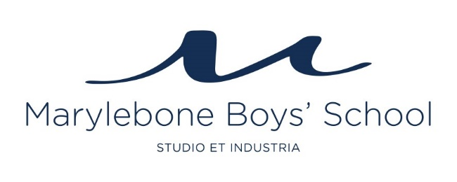

APPLICATION PROCESS
- Contact us if you would like more information about the school or the position on jobs@maryleboneschool.org.
- Complete the application form fully, including the separate supporting statement (maximum 2 pages).
- Send your applications to jobs@maryleboneschool.org.
- We will interview applicants on receipt of suitable applications.
- We will only interview candidates who provide 2 satisfactory references in advance, of whom one must be your current Headteacher.
- The interview process will include a panel interview and a lesson observation of you teaching.
- We will inform all candidates of the outcome of their application and provide feedback to those who are unsuccessful.

