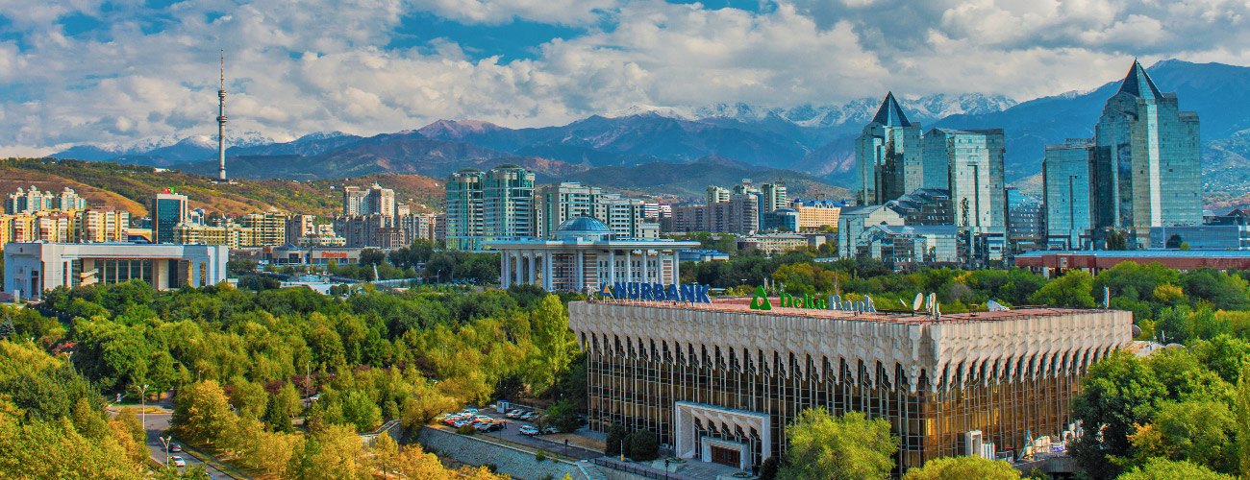

About Almaty
Almaty is the cultural and commercial capital of Kazakhstan. Although Astana has been the capital of Kazakhstan since 1997, Almaty remains the largest city in the country by a wide margin, with a population of over 1,500,000 people. Its beautiful location and vibrant city life continue to attract families, students and professionals from across Kazakhstan, as well as a diverse expatriate population from across the world.
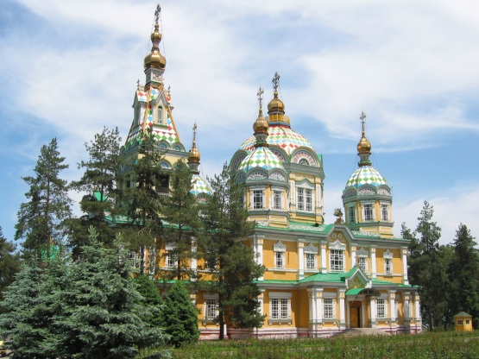
Located among the foothills and rivers of the stunning, snow-capped Tien Shan mountains, with the grassy steppe stretching away to Lake Kapchagai and Lake Balqash to the north, Almaty enjoys sunny summers and crisp, dry, snowy winters, divided by a gorgeously colourful autumn and a refreshingly green spring. Almaty’s architecture varies from the wooden nineteenth–century Zenkov Cathedral and colourful Tsarist-era academic buildings, to imposing Soviet concrete blocks, to the present day’s steel-and-glass towers and glitzy designer shopping malls. Almaty is blessed with an abundance of trees and parks - and like Kazakhstan in general, is a family-oriented and child-friendly place to live.

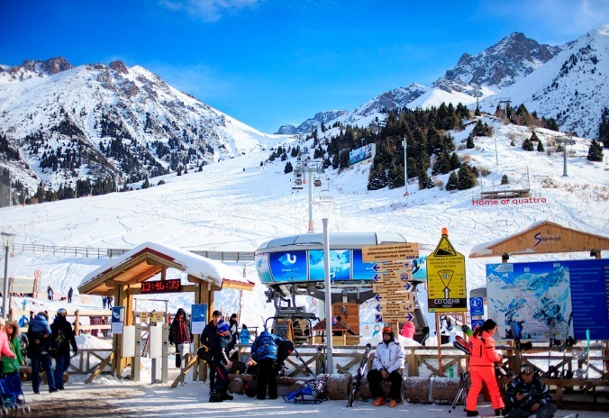
The city and its surrounding area are ideal for outdoor pursuits such as hiking and mountaineering, running, road cycling and mountain biking, and of course winter sports such as ice-skating (on the world’s highest ice rink!), skiing and snowboarding. The nearest resort can be reached within an hour by bus and cable car from the city. Other sights in the region include the picturesque Big Almaty Lake and Charyn Canyon. Cultural life in the city includes art exhibitions, concerts, opera, ballet, and live bands, as well as a wide and cosmopolitan variety of shops, malls and markets, restaurants, cafés, bars and clubs.

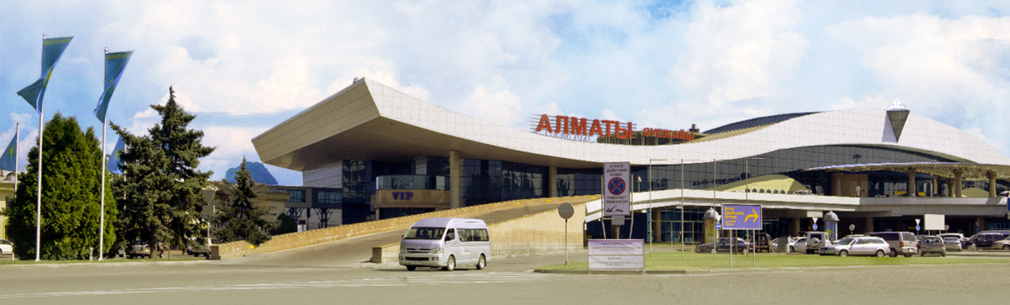
Almaty International Airport is served by a range of airlines with links to many global hubs (including London, Frankfurt, Moscow, Istanbul, Abu Dhabi, New Delhi, and Beijing) with new destinations being added regularly. Carriers include Turkish Airlines, Lufthansa, and Fly Dubai. The national carrier Air Astana is rapidly expanding, and offers a high quality service to a wide range of destinations within Kazakhstan as well as internationally. Other national airlines offer remarkably cheap connections within the region.
Living in Almaty
Almaty has all the advantages of a major city with few of the disadvantages. There is plenty to see and do and the city has a youthful, cheerful atmosphere. The range of cafés, bars and restaurants is similar to that of any western European capital and you will recognise many of the products on sale in supermarkets. Some items are hard to find and there may be one or two things you will miss, but on the whole shopping and cooking here are straightforward. The cost of living is somewhat lower than that of the UK, with some goods being relatively cheap here and others more expensive, especially imports (e.g. electrical goods). Kazakhs love children and Almaty is both safe and welcoming for children. There is a good and very cheap network of buses, trams, and metros in the city, and you can get to many places on foot or by bicycle. Taxis are plentiful, and Uber and similar taxi apps are widely used as an inexpensive alternative.

The biggest challenge in Almaty can be the extremes of weather. It is hot in the summer months and can be very cold in the winter, though we often enjoy clear, blue skies throughout the winter which allow you to enjoy the dramatic scenery. Although the winter temperatures sound daunting, it is a dry cold with little or no wind, and with the right clothing you will encounter few difficulties. Winter often feels colder in the UK than in Kazakhstan, even if the temperatures in Kazakhstan are lower!

