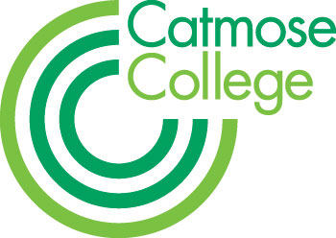
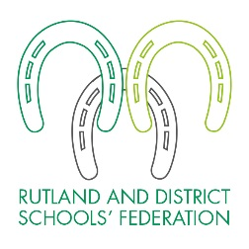
TEACHER OF LANGUAGES
MPS + Federation Benefits
To start January 2018
Full or Part Time considered

Catmose College is an outstanding school based in Oakham and we are looking for a well-qualified and highly motivated teacher of Languages who has a love for their subject, any specialism considered. The role would be to teach GCSE however, there is the possibility of teaching Languages at A Level at our partner sixth form, Harington School.

We welcome applications either from NQTs who will be well supported by experienced mentors and through our teaching school alliance or from more experienced candidates where there are exceptional opportunities for further professional development and promotion.

The successful candidate will be joining a strong and supportive team of specialist teachers who take pride in achieving the best outcomes for all students. Catmose College is an over-subscribed 11-16 academy and was graded as ‘Outstanding’ by Ofsted in all four categories and overall in February 2012. We have outstanding, state of the art facilities and technology throughout, with purpose-built laboratories offering excellent teaching resources and access to numerous iPads, laptops and computers; the College is able to offer a truly outstanding technology-led learning environment.

Catmose College is part of the Rutland and District Schools’ Federation which currently consists of Catmose College, Catmose Primary and a Preschool provision. We are also proud to include Harington School, an academic sixth-form, in the Trust. This provides wider opportunities for staff, giving them broader experience across different organisations, including the opportunity to teach A levels in an academically able environment, should their skills and experience be appropriate.

Based in Oakham, the school is in rural Rutland and very close to the stunning Rutland Water, so teachers who work here can enjoy working in beautiful countryside. Oakham, Leicester and Peterborough all have great rail links and London is accessible from there.

Being an outstanding school, at Catmose College we really do pride ourselves in providing first class teaching, and offering a wide variety of extra-curricular activities. Our main aim is for our students to become mature and independent minded adults who can be of value to themselves and society.

Taking care of our teachers is something we take very seriously at Catmose College. For successful candidates there are exceptional opportunities for further professional development and promotion across the Federation. Each Wednesday afternoon from 2:30 to 3:30, teachers’ have the opportunity to dedicate time to their personal development and we’re part of the Rutland Teaching Schools Alliance so we have over 100 training workshops teachers can become involved in.

Teachers are able to enjoy many additional benefits that come as part of working within the Federation. These include, amongst others:

- Teachers at top of scale may receive up to a 2% pay award annually for good performance, in addition to any incremental pay progression;
- Relocation support for hard-to-recruit subjects;
- Vast range of staff training including a funded Masters scheme;
- Outstanding facilities;
- Primary and secondary form teaching opportunities;
- Staff laptops;
- On Site Gym.
- Free Car Parking.
- Priority admission for children of staff to the College and Primary.

At Catmose College we adopt a holistic approach to our Students’ development and the successful candidate will appreciate this approach and enjoy working within a collaborative and supportive environment with their fellow colleagues.

The Federation is committed to safeguarding and promoting the welfare of all students in our care and expects all staff to share this commitment. All staff are responsible for ensuring safeguarding, health and safety policies are implemented in line with the Federation policy and current legislation. Applicants must be willing to undergo child protection screening appropriate to the post, including checks with past employers and the Disclosure and Barring Service. We are an equal opportunities employer.

HOW TO APPLY
Application forms and information are available online at www.catmosecollege.com or by emailing the College on office@catmosecollege.com

- You should write a letter of application on no more than 2 sides of A4.
- You should complete all sections of the application form.
- On the form clearly state the names, addresses, telephone numbers and e-mail address of two professional referees; it is our usual practice to ask for references before shortlisting and always to ask for references before interviews.
- It is a condition of employment that you have a successful DBS check made and can provide proof of identity and qualifications gained.

Please note that due to the high number of applications we receive for positions, your application is unlikely to be considered if you do not follow these requirements. CVs are not accepted. The closing date is 22 November 2017. You should send your application to Stuart Williams, Principal, Catmose College, Huntsmans Drive, Oakham, Rutland, LE15 6RP. Applications can also be emailed to office@catmosecollege.com

Please enclose a SAE if you would like your application acknowledged.

