The Science Department

The Science Department at Chipping Norton School is a strong, cohesive and supportive team where innovative teaching techniques are trialled, shared and encouraged. We aim to provide engaging Science lessons in which students are challenged to really think about scientific concepts. Developing Assessment for Learning techniques and implementing their regular use is a core focus of the teaching and learning within the department.

The drive to continually become better teachers is fundamental to the department ethos. As such, staff have completed Master’s courses at local Universities, completed training and delivered CPD courses, regularly attend and take up CPD opportunities and share good practice and ideas willingly. Our staff induction programme is well established and we also participate in ITT delivery.

The Curriculum

At Key Stage 3 students follow a balanced Science course. At Key Stage 4 all students study AQA Biology, Chemistry and Physics (Triple Award Science). Students are in both ability and mixed teaching groups.

GCE AQA A level Biology, Chemistry and Physics are traditionally strong and popular options with many students going on to study Science at university.

Examination results at GCSE and A level are good with further improvement expected over the coming years.

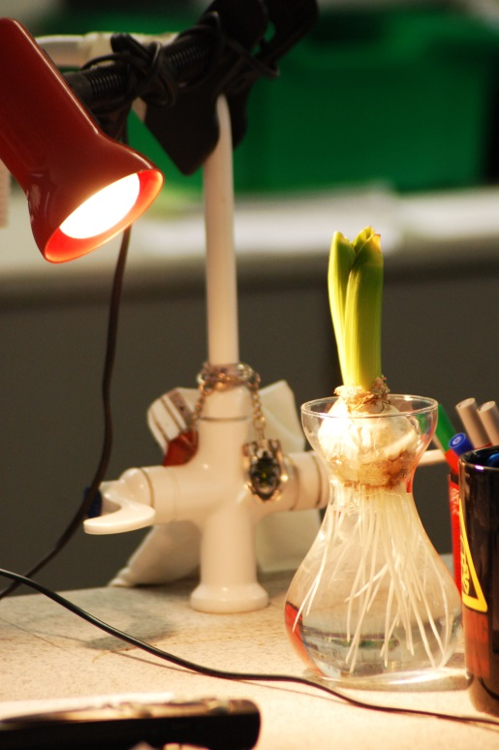
The new post holder will need to be capable of teaching up to and including Key Stage 5. All teachers deliver a balanced curriculum at Key Stage 3. Students are taught within specialism at KS4. Excellent teacher subject knowledge at A level ensures high level delivery of Biology, Chemistry and Physics.

The Department has long been innovative and imaginative in its enrichment of the Science curriculum. Many students from all year groups have benefited from a wide range of highly regarded industrial and technological links with both local and national organisations and companies, enrichment dates and Science clubs. The local Learning Partnership is currently giving excellent support in this direction. Field courses and other educational visits are an integral part of the curriculum. Two-way cross phase links with our partnership primary schools continue to go from strength to strength.

Examination Results
Examination Results 2017 in Science
GCSE | No. of Students | %A*/A | %A*-C
GCSE Biology | 88 | 44 | 92
GCSE Chemistry | 88 | 40 | 90
GCSE Physics | 88 | 44 | 92
GCSE Science | 69 | 0 | 55
GCSE Additional Science | 68 | 1 | 60
A LEVEL | No. of Students | %A*-B | %A*-E
AS Biology | 25 | 44 | 92
A2 Biology | 22 | 32 | 100
AS Chemistry | 12 | 33 | 83
A2 Chemistry | 12 | 42 | 100
AS Physics | 36 | 22 | 72
A2 Physics | 24 | 50 | 100

Staffing, Resources and Accommodation

The Science curriculum is delivered by eight full time specialist teaching staff. This team is supported by two full time laboratory technicians and a curriculum Learning Support Assistant. This well established team collaborates as a whole or in sub-groups on all aspects of the delivery of the curriculum.

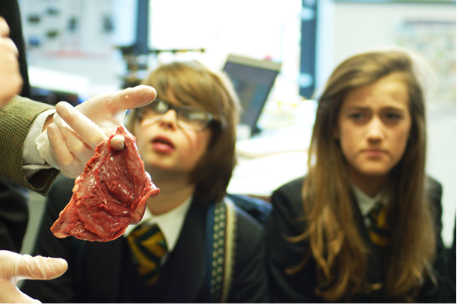
The Department moved into brand new accommodation at Easter 2011. The new Science building has nine laboratories (three for each specialist area), one teaching room with lab equipment, three prep rooms, an office and staff workroom distributed over three floors. Wirelessly networked, each room has a short throw projector. All staff have access to laptop computers.

Science receives an appropriate level of capitation which is assigned to agreed priorities, supplies and developments under the guidance of the Head of Science.

Informal visits to the school are welcome; please telephone to make an appointment to be shown around.

Chipping Norton School operates a ‘No Smoking Policy’ within establishment.

