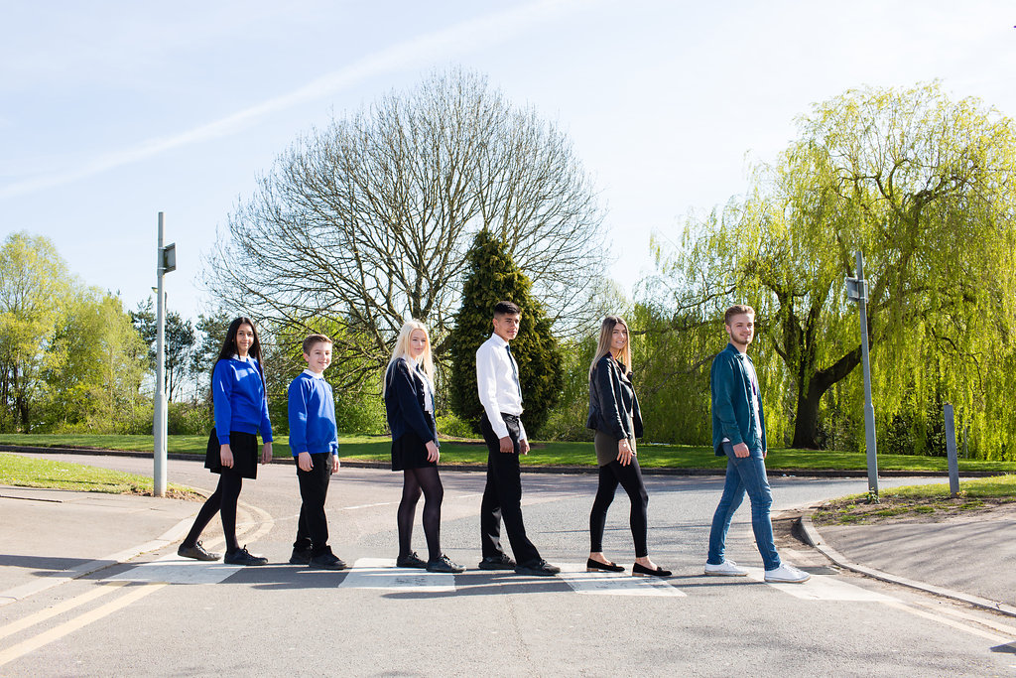

Associate Teacher

Grade 7, £13,440 – for day to day cover and intervention
Pay grade will be adjusted should long term cover be required –
please see General Information contained within.
30 hours per week term time, permanent
Monday – Friday, 8.30am – 3.15pm
Plus 30 additional hours for training, meetings etc.

Content
Vision, Values and Ethos |  | Page 3
Testimonials |  | Page 4
General Information |  | Page 5
The Application Process |  | Page 6
Vacancy Advert |  | Page 7
Letter from the Headteachers |  | Page 8
Job Description |  | Page 9 - 12
Person Specification |  | Page 13-14

Vision, Values and Ethos
The shared vision and values of the Trust underpins all that we do, including the governance arrangements for the Trust.

Our Vision
Valuing Everyone, Achieving Excellence

Our Motto
Work Hard, Be Kind

Our goals
The goals of our trust:
- Outstanding levels of progress and achievement for all
- Outstanding levels of wellbeing for all
- Outstanding preparation for adult and working life
- Outstanding family and community engagement
- Outstanding levels of professional learning for all
Informed by “Schools of Tomorrow”

Testimonials
Extract taken from email correspondence, following a tour of the school by a prospective parent
(April 2016):
‘I would just like to say thank you for the time spent with me today on my tour of the campus, and state how impressed I was with the school. There seems to be a very calm, relaxed and organised approach to how the school operates, and I believe that obviously shows in the way your students behave’.

Written comments from parents following Year 9 Progress Evening (2017):
‘My child always talks positively about school to other children the same age, which I think is a good indicator that he is enjoying school’

‘Welcoming, approachable, friendly and knowledgeable staff’.

Written comments from parents following Year 11 Progress Evening (2017):
‘The teachers have pride in their teaching and in the pupils’ progress. They really care and are prepared to go the extra mile to support the students’.
‘My son seems to have progressed so well in most subjects. I feel this is due to good relationships he has been able to form with teachers and the standard of the lessons’.
Written comment from parent at the end of KS5 (2016):
‘This is my final parents evening after my youngest daughter is coming to the end of her years at GCE. Thank you for very happy years for my three daughters and for their excellent education!’
Thank you from parent of ex-student taking up a place at Cambridge University (2013):
‘To all the staff at Brookvale Groby Learning Campusl.
My son has just started at Cambridge University studying Engineering. It was his ambition to go there and this summer, he achieved the grades he needed. We want to acknowledge the great teaching and support he received during his time with you. He progressed well academically, but also grew so much in maturity and confidence. With thanks to you all for your hard work and dedication.’

Extract of letter from staff member:
‘I have thoroughly enjoyed my time on campus. It has been a real pleasure working with staff who are always friendly, extremely supportive and willing to share ideas and knowledge. I have really appreciated having a senior leadership team which is so warm towards its staff and open to their comments and new ideas.

The children I have taught have made me smile, laugh and cry! I will miss my relationship with them and that buzz you get from seeing them progress. It does, however, give me great satisfaction to think that I have put into place schemes of work for pupils and created learning opportunities for them which should continue even after I have left.

I am sad to leave a post which I still love. Once more, thank you for all of your support and kindness.’

Extract of letter from staff member:
‘I have been very fortunate to have worked with amazing people. I have learnt so much as both a Teacher and as a Head of Department.

I will truly miss everyone here, and it really has been an amazing experience. Thank you for allowing me to be part of such a wonderful group of people.

I wish every success to the campus.’

GENERAL INFORMATION

The Brookvale Groby Learning Campus is a highly successful 11-19 educational organisation created from the integration of two schools on the same site. Brookvale High School is an ‘outstanding’ 11-14 school and Groby Community College is a 14-19 upper school graded ‘good with outstanding features’ in its last Ofsted. Together, the campus meets the educational needs of 1,600 students with nearly 400 at Post 16, and we operate as one school within our own Multi Academy Trust.

We have a strong ethos of valuing everyone and achieving excellence for all. We set very high standards for our students and ourselves, we work hard, we look after each other, and we are committed to professional learning for all staff. As a consequence the motto we use on a daily basis with our young people is work hard, be kind which we feel symbolises the culture we aim to create on campus.
We have a spacious semi-rural campus location and most of our students live in the surrounding villages with some travelling from Leicester and its western suburbs.
The Cover Supervision Team works across the campus to provide day to day cover for absent teachers. Led by the Cover Manager, Karen Middleton, we have a small, dedicated team of Cover Supervisors who are highly skilled at stepping in to any curriculum area to deliver lessons in order to make sure learning continues in spite of the teacher’s absence.
This Associate Teacher post is aimed at graduates, with previous classroom experience, who are considering teaching as a career and would like some further school experience before applying for teacher training. The post will start as a Cover Supervisor role across the curriculum. If a long term teacher absence arises during the course of the year in a curriculum area that is relevant to the Associate Teacher’s expertise, consideration will be given as to whether the Associate Teacher could step in to provide long term cover, and if that is the case, the pay grade will be adjusted accordingly for the relevant period, and professional support will be put in place to ensure success.
If you thrive in a fast-paced environment, and enjoy being part of a busy friendly team, then we’d love to hear from you.

The Application Process

Complete application forms should be returned to efreeman@brookvalegroby.com

Or by post to

F.A.O. Elaine Freeman
Brookvale Groby Learning Campus
Ratby Road
Groby
Leicester
LE6 0FP

An email will be sent to shortlisted candidates with details of the interview process.

Queries

If you have any queries on any aspect of the application or need additional information please contact Elaine Freeman, PA to the Senior Team on 0116 2879921.

Thank you.

The Role

Associate Teacher

Grade 7 - £13,440, for day to day cover and intervention
Pay grade will be adjusted should long term cover be required
30 hours per week, term time, permanent
Monday – Friday, 8.30am – 3.15pm
Plus 30 additional hours for training, meetings etc.

We are seeking to appoint an Associate Teacher, with previous classroom experience, to join our busy, friendly Cover Supervision Team.
The Associate Teacher post is aimed at graduates who are considering teaching as a career and would like some further school experience before applying for teaching training.
The post will start as a Cover Supervisor role across the curriculum, but could progress to providing long term cover, should a teacher absence arise during the course of the year in a curriculum area that is relevant to the Associate Teacher’s expertise. If this is the case, then the pay grade will be adjusted accordingly for the relevant period, and professional support will be put in place to ensure success.
Full details can be found on our website – www.brookvalegroby.com
For further details, or if you would like to visit us, then please email Elaine Freeman - efreeman@brookvalegroby.com

Closing Date: Wednesday 21st November 2018
Interviews will be held within 2 weeks of the closing date

The Brookvale Groby Learning Campus is committed to safeguarding and promoting the welfare of children and young people and expect all staff and volunteers to share this commitment. Applicants must be willing to undergo appropriate child protection screening, including checks with past employers and the Disclosure and Barring Service.

November 2018

Dear Applicant

Associate Teacher

Thank you for your interest in the Associate Teacher vacancy within the Brookvale Groby Learning Campus.

We hope the documents provided help you to gain a feel for the school and if you would like to visit us as well, we would be delighted to show you round. Please contact Elaine Freeman on 0116 2879921 or efreeman@brookvalegroby.com to make an appointment.

All the documents to support this application process are available on our campus website – www.brookvalegroby.com.

To apply please complete the following:

- Application Form
- A letter of application, no more than two sides of A4, word processed using font size no smaller than 10

Your letter needs to be addressed to ourselves, and if you would like to e-mail your application then please send this to Elaine Freeman on the email address above.

The closing time and date for this post is end of day on Wednesday 21st November 2018. The interviews will be held within 2 weeks from that date. If you have not heard from us by then, please assume that your application has not been successful on this occasion. If this is the case, we would like to thank you for your interest and the time spent in applying.

This post will be subject to an enhanced level Criminal Records Bureau check. All Brookvale Groby employees are expected to promote and safeguard the welfare of students at the school. Our Safeguarding Policy is made known to all and is designed to guide staff, students and parents/carers with regard to Safeguarding issues.

In line with best practice guidance re safeguarding we do not require an additional CV and any included with application forms sent to the school will not be taken forward to the short listing panel.

Yours sincerely
Robert Coles
Executive Headteacher
Brookvale Groby Learning Campus

Job Profile

Job Title: |  |  | Associate Teacher
Grade: |  |  | Grade 7 for day to day cover and intervention  UQT1 for cover of longer term teacher absence
Responsible To: |  |  | Cover Manager
Responsible For: |  |  | n/a
Key Relationships/  Liaison with: |  |  | Teachers, other classroom support staff
Job Purpose: |  |  | Day to day cover and intervention:  To provide supervision of classes across the curriculum in the event of the absence (planned or unplanned) of the teacher, ensuring that students are engaged in pre-set work, managing student behaviour and ensuring a safe environment.  To provide supervision and support for students in the Inclusion Centre.  To lead intervention activities with small groups.  Cover for longer term teacher absence:  To assume the responsibility for a teacher’s classes and form group, subject to relevant expertise. This enhanced responsibility would be negotiated on an individual basis, and would be supported by the relevant Faculty Leader or Assistant Faculty Leader.
MAIN DUTIES AND RESPONSIBILITIES FOR DAY TO DAY COVER AND INTERVENTION:

1. | In the absence of a teacher, to be solely responsible for a class of students, ensuring they are engaged in learning activity that has been set by a teacher.
2. | In conjunction with the Student Wellbeing Team manage the Inclusion Centre as part of a rotation of staff.
3. | To lead intervention activities with students as required.
4. | To effectively manage instances of poor behaviour and any other immediate issues or emergencies that arise in accordance with school/college policy.
5. | To support students to engage with the work provided, including providing support where necessary with literacy, numeracy and organisational skills.
6. | To liaise with teachers / other relevant staff with regard to work set for a class, and ensure you are suitable equipped and informed to be able to effectively supervise the assigned lesson.
7. | To feedback to the class teacher on student engagement in the set work and also on any issues that may have arisen during the covered lesson(s).
8. | To help prepare, monitor and maintain a safe and secure learning environment in line with the teacher’s lesson plans.
9. | To support the maintenance of an activity bank, contributing general activities as appropriate, and draw upon this in the event that students complete the pre-set work more quickly than expected, in order to ensure that students are engaged in constructive activity.
10. | To contribute to the development and review of relevant policies (e.g. Cover, Behaviour Management, etc).
11. | To assist in the evaluation of the impact of covered lessons on students and throughout the school.
12. | To undertake student registration of a class, as required.
13. |  | To promote positive behaviour and relationships, using effective strategies in a timely manner in accordance with school policy.
14. |  | To develop positive relationships with colleagues, providing consistent and effective support and working constructively as a member of the school staff team.
15. |  | To assist with the organisation of cover for absent colleagues (teachers or support staff), for both planned and unplanned absences.
16. |  | To assist in the creation and maintenance of curriculum resources, and creation of visual displays in order to ensure a relevant physical learning environment.
17. |  | To undertake administrative duties relevant to the role.
18. |  | To invigilate internal and external tests and examinations under formal conditions.
19. |  | When not required to undertake any responsibility falling within the above, Cover Supervisors may be directed to provide additional support in the school, in accordance with the duties of other similarly or lower graded jobs for which they are suitably skilled/ qualified e.g. attend trips, support in classes, manage inclusion, mentor students
Optional Extra Responsibilities, not affecting the grade:

- To provide toileting support to students as necessary.*
- To support, as appropriate, in instances where students are unwell whilst on campus.*

*These duties only to be included by negotiation with individual employees, and after appropriate risk assessment and training have been undertaken.

SPECIAL FACTORS:
Subject to the duration of the need, the special conditions given below apply:
- The nature of the post may involve the carrying out of outside of normal working hours.
- The postholder may be required to attend, from time to time, training courses, conferences, seminars or other meetings as required by his/her own training needs and the needs of the campus.
- Expenses will be paid in accordance with the Local Conditions of Service.
- This post is subject to a check being carried out at an Enhanced level by the Criminal Records Bureau regarding any previous criminal record.

WHOLE CAMPUS RESPONSIBILITIES:
- Support current policies and recognised good practice within the campus.
- Be aware of the importance of confidentiality and data protection.
- Participate in annual Performance Management review with Line Manager, based on agreed objectives, ideally one of which should be linked to the campus improvement plan where possible.
- To work as part of a team, to act as a contact in providing basic emergency first aid, if training is provided.
- Willingness to be flexible in both approach & use of time.
- All tasks should be undertaken with due regard to Health & Safety Regulations.
- To undertake such other duties which are within the scope of the job purpose, title of the job and its grade.

All BGLC employees are expected to promote and safeguard the welfare of students at this school.

MAIN DUTIES AND RESPONSIBILITIES FOR LONGER TERM ABSENCE COVER:
- To assume the responsibility for a teacher’s classes and duties in the event of a longer term absence, subject to relevant expertise, and as negotiated on an individual basis in accordance with the skills of the post holder.
- To prepare students effectively for qualifications and external examinations
- To fulfil the roles and responsibilities of tutor and support students on an individual basis through academic or personal difficulties. To act as a mentor to specific members of the tutor group in order to raise achievement
- To take responsibility for personal CPD and to participate in campus and external CPD activities by negotiation
- To undertake all of the requirements laid down by the campus Performance Management Policy
- To participate in faculty/department and house meetings
- To participate in parental consultation/student progress evenings as well as the annual target setting evening with Year 10 and 11
- To carry out supervision duties in line with campus arrangements
- To fulfil the “Professional Standards 2012” as laid down by the DFE:

- Set high expectations which inspire, motivate and challenge students – safe and stimulating environment. Set goals and challenge students of all abilities and backgrounds. Demonstrate positive attitudes, values and behaviours
- Promote progress and outcomes by students - accountable for attainment, progress and outcomes
- Demonstrate good subject and curriculum knowledge – including literacy and numeracy
- Plan and teach well structured and engaging lessons – including setting regular homework as per campus policy. Selecting and using a range of different learning resources and equipment, including ICT and where possible the use of interactive whiteboards
- Adapt teaching to respond to the strengths and needs of all students – including differentiation / needs of SEN students
- Make accurate and productive use of assessment – use data / accurate marking / give feedback to students on how to improve / maintaining records of students' progress and development
- Manage behaviour effectively – establish rules / routines. Promote positive behaviour. Have high expectations
- Fulfil wider professional responsibilities – promote a positive contribution to the ethos of the campus. Develop own CPD

The Governing Body are seeking to promote the employment of people with disabilities and will make any adjustments considered reasonable to the above duties under the terms of the Disability Discrimination Act 1995 to accommodate a suitable candidate with a disability.

This Job Description sets out the responsibilities of the post at the time it was drawn up. Such responsibilities may vary from time to time without changing the general character and requirements of the post or the level of responsibility entailed. Variations are a common occurrence and do not necessarily constitute additional responsibilities or warrant a higher grade.

Personnel Specification

 | Essential | Desirable | How assessed
Qualifications:  Undergraduate Degree  - Level 2 qualifications in maths/numeracy and English/literacy  OR  - Able to demonstrate competency in literacy and numeracy equivalent to level 2. |  |  | App/Doc/  Ref  App/Doc
Experience:  - Previous classroom experience  - Experience of working with younger people in a social or learning environment |  |  | App/Int/ Ref
Knowledge:  - Knowledge of child protection and health and safety procedures. |  |  | App/Int/ Ref
Skills/Attributes:  - Ability and willingness to undertake professional development.  - Good interpersonal skills.  - Empathy with children and young people.  - Ability to effectively manage student behaviour in accordance with campus policy and procedure.  - Ability to use own initiative to work flexibly and respond positively to a range of situations  - Ability to work effectively as part of a team. |  |  | App/Int  Int/Ref  Int/Ref  Int/Ref  Int/Ref  Int/Ref

General Circumstances:  - Attendance - evidence of regular attendance at university or work.  - An understanding of, and commitment to, Equal Opportunities, and the ability to apply this to day-to-day situations.  - Willingness to dress as a professional, in line with the ethos of the campus. |  |  | App/Ref/  Med  App/Int  App/Int/Ref
Factors not already covered:  Must be able to perform all duties and tasks with reasonable adjustment, where appropriate, in accordance with the provisions of the Disability Discrimination Act 1995. |  |  | Med

App = Application Form
Test = Test
Int = Interview
Pre = Presentation
Med = Medical Questionnaire
Doc = Documentary Evidence (E.g., Certificates)

In addition to candidates’ ability to perform the duties of the post, all Brookvale Groby Learning Campus employees are expected to promote and safeguard the welfare of students at the school, therefore the interview will also explore issues relating to safeguarding and promoting the welfare of children including:

- Motivation to work with children and young people
- Ability to form and maintain appropriate relationships and personal boundaries with children and young people
- Emotional resilience in working with challenging behaviours
- Attitudes to use of authority and maintaining discipline

Please be aware that any relevant safeguarding issues that arise on receipt of references may be discussed at interview.

