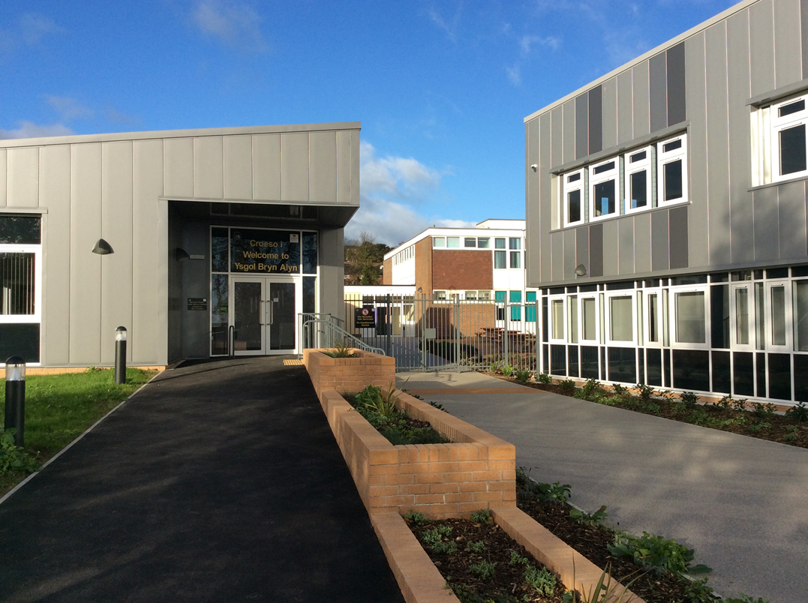  YSGOL  Bryn Alyn  Headteacher Application Pack  L25-L31  CONTENTS  School Overview Welcome note from the Director of Education Page 2 Page 2  Introduction from the Chair of the Governing body Page 3  Financial position of the school Page 4  Useful Information Page 5  Timetable for appointment Page 7  Job description and selection criteria Page 8 | Ysgol Bryn Alyn  Church Street  Gwersyllt  Wrexham  LL11 4HD  Tel: 01978 720700  Fax: 01978 752889  E-mail: mailbox@ysgolbrynalyn.wrexham.sch.uk  Application Deadline:  9th April 12 noon  Tour of the school  Tuesday 20th March 10.30am  www.ysgolbrynalyn.co.uk
School overview:-

Ysgol Bryn Alyn is an English medium co-educational community comprehensive school for pupils aged 11-16. Situated in the village of Gwersyllt 3 miles from Wrexham, 14 from Chester and 45 miles from Manchester. There are good transport links to the North West, Cheshire and Shropshire.

Pupils are drawn primarily from 7 local primary/junior schools: Gwersyllt Community Primary, Ysgol Heulfan, St. Mary's, Brymbo, Tanyfron C.P., Black Lane C.P, Pentre Broughton, Ysgol Penrhyn, New Broughton and Brynteg C.P. School. An increasing number of pupils opt for the school from other areas. The number on roll is presently 701.

The school occupies purpose-built accommodation with specialist provision for science,
design and technology, P.E., music, information technology and modern languages.

Although the number of pupils on roll is rising and expected to continue to do so in the coming years the examination results achieved by the school are falling below the expectations of both the Local Authority and the Governing body.

A comprehensive breakdown of examination performance can be found at :-
http://mylocalschool.wales.gov.uk/School/6654033?lang=en

The school has just been placed into Special Measures by ESTYN, details of the inspection and the full report can be found at:-
https://www.estyn.gov.wales/provider/ysgol-bryn-alyn

Following the departure of the previous headteacher at the end of the summer 2017, the current school leadership team comprises:-
Acting Headteacher , Acting Deputy Headteacher, two Assistant Headteachers and two Associate assistant headteachers as well as a business manager.

In addition to the above, an experienced headteacher from a nearby secondary school has been seconded 1 ½ days per week to support the leadership team.

Welcome note from the Director of Education:-

Thank you for your interest in the post of headteacher at Ysgol Bryn Alyn. Recent remodelling of the school, ensures that learners and staff are able to enjoy a first class learning environment in order to achieve the highest possible standards of achievement and well being. In Wrexham we are proud of the collaborative working of schools , the Local Authority and GwE, our regional school improvement service. I wish you well in your application.

Ian Roberts. – Director of Education – Wrexham LA

Letter from the Chair of the Governing Body.

Dear Applicant,
The Governing Body are seeking to appoint an exceptional leader to the post of Headteacher.
The post offers an exciting opportunity for a highly motivated, committed individual who has demonstrated that he / she:
- is an inspirational leader
- has vision, enthusiasm and creativity
- has a track record of raising achievement
- leads by example and works as part of a successful team
- inspires, motivates and develops others
- is committed to driving improvement through quality assured processes
- continually strives for excellence in all aspects of education provision
- is extremely committed to an inclusive approach to all learners

The successful candidate can look forward to working with a dedicated and extremely supportive governing body who are aware that changes will need to be made to secure the improvements that the school deserves.
Please note Headteachers in Wales are required to have the NPQH qualification; you may apply for the post if you have recently undertaken the final assessment of your NPQH qualification or are due to do so prior to taking up post. Existing Headteachers who have been in post since 2005 are exempt from this qualification.
Applicants are welcome to arrange a tour of our school on 10.30am Tuesday 20th March, by contacting Emma Williams (Business Manager) on 01978 722124 Ysgol Bryn Alyn are keen to share information to help you to make a successful application.
The closing date for applications for this post is noon 9th April. Interviews will be held on the 24th and 25th April.
I would like to thank you for expressing an interest in this post and I look forward to meeting the shortlisted candidates
Yours sincerely
David Edwards
Chair of the Governing Body

Financial position of the school

Ysgol Bryn Alyn has a licensed deficit with the Local Authority that it is paying back over three years, the school debt is currently in the region of £200,000 but plans agreed with the LA pay this back and create a surplus of 90,000 at the end of the plan.

Pupil numbers have increased in local primary schools and therefore the school roll is likely to increase over the next few years.

There has been significant investment in the buildings in the school over the past two years and there is generous accommodation for all the subject areas.

Useful Information

The school operates on a two week timetable of 6x50min lessons per day:-

Warning bell 8.47 a.m.
Registration 8.50 - 9.00 a.m.
Lesson 1 9.00 - 9.50 a.m.
Lesson 2 9.50 - 10.40 a.m.
Morning Break 10.40 - 10.55 a.m.
Lesson 3 10.55 - 11.45 a.m.
Lesson 4 11.45 - 12.35 p.m.
Lunch 12.35 - 1.20 p.m.
Warning bell 1.18 p.m.
Registration/Assembly 1.20 - 1.40 p.m.
Lesson 5 1.40 - 2.30 p.m.
Lesson 6 2.30 - 3.20 p.m.

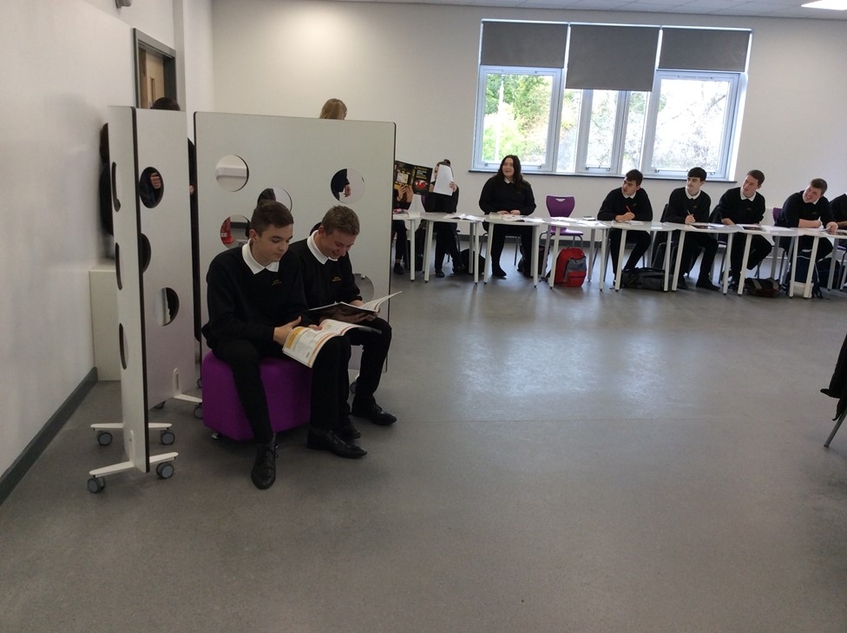

KEY STAGE 3 (Ages 11 - 13) Years 7, 8 and 9

CORE SUBJECTS English (and Drama) Mathematics Science

FOUNDATION SUBJECTS
Art Design Technology
Food and Textiles Technology
French Geography
History Information Technology
Music P.E
Personal & Social Education Religious Education
Welsh

KEY STAGE 4 (Ages 14 - 16) Years 10 and 11
All pupils continue to study the complete range of subjects required by the National Curriculum. They also choose further courses of study to develop their own interests and abilities.

CORE SUBJECTS
English and English Literature
Mathematics
Science
Religious Education
P.E. (Statutory non-examination)
Personal & Social Education (incorporating Preparation for Working Life)
Welsh
CHOICES Optional subjects drawn from:
Arts: including Art, Music, Media Studies
ICT, Business Studies
Humanities: History, Geography, Religious Studies
French, Welsh
Design and Technology: Food Technology, Child Development, Resistant Materials
P.E.
C.O.P.E.
XL Prince’s Trust.

Skills Challenge Certificate
This qualification was introduced into our school curriculum in September 2016, and is studied by KS4 students. It is an overarching qualification based on the core curriculum, followed by all students and
Options chosen to meet their individual needs.

14—19 COLLEGE
A variety of extended choices in conjunction with Colleg Cambria and other providers.

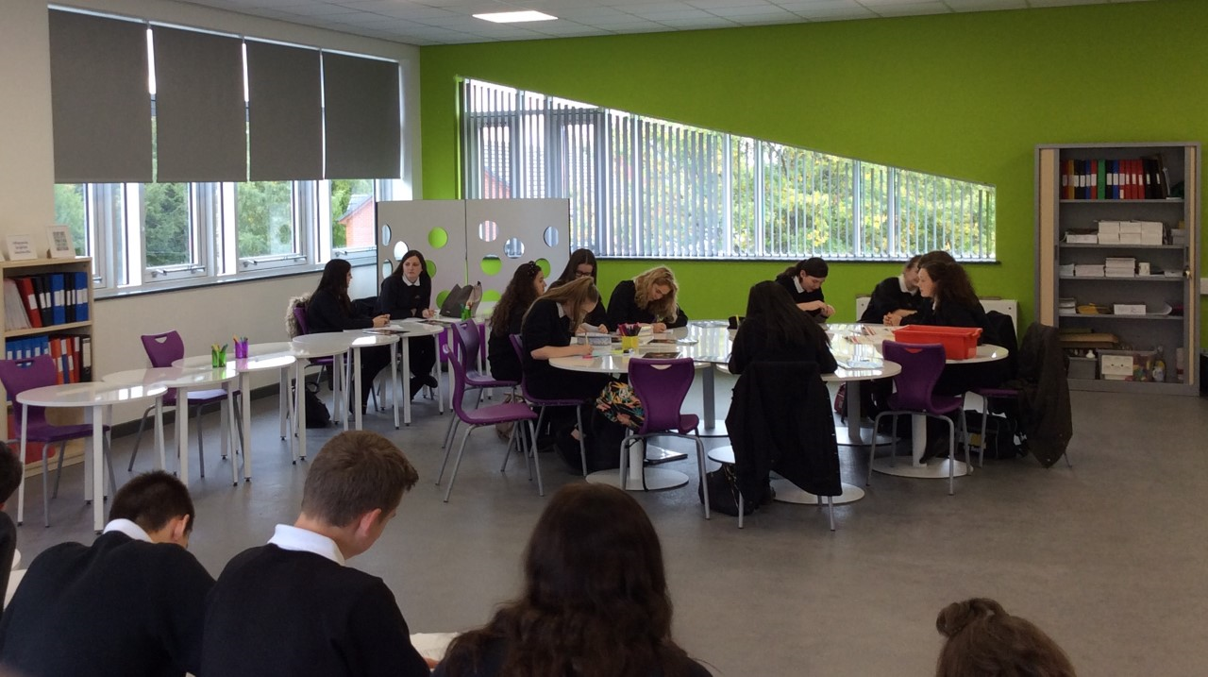
Timetable for appointment:-

Application deadline:- 9th April

Tours of the school:- 10.30am Tuesday 20th March , please book an appointment in advance.

Shortlisting:- 10th April

Shortlisted candidates informed:- 11th or 12th April

Interview dates:- Tuesday 24th April and Wednesday 25th April.

JOB DESCRIPTION: Headteacher

Title: Headteacher
Responsible to: Chair of Governors
Grade: Leadership L25-31

Shaping the Future:

- Ensures the vision for the school is clearly articulated, shared, understood and acted upon effectively by all;
- Works within the school community to translate the vision into agreed objectives and operational plans which will promote and sustain school improvement;
- Demonstrates the vision and values in everyday work and practice;
- Motivates and works with others to create a shared culture and positive climate;
- Ensures creativity, innovation and the use of appropriate new technologies to achieve excellence;
- Ensure that strategic planning takes account of the diversity, values and experience of the school and the community at large.

Leading Learning and Teaching:

- Ensures a consistent and continuous school-wide focus on pupils’ achievement, using data and benchmarks to monitor progress in every child’s learning;
- Ensures that learning is at the centre of strategic planning and resource management;
- Establishes creative, responsive and effective approaches to learning and teaching;
- Ensures a culture and ethos of challenge and support where all pupils can achieve success and become engaged in their own learning;
- Demonstrates and articulates high expectations and sets stretching targets for the whole school community;
- Implements strategies which secure high standards of behaviour and attendance;
- Determines, organises and implements a diverse, flexible curriculum and implements an effective assessment framework;
- Takes a strategic role in the development of new and emerging technologies to enhance and extend the learning experience of pupils;
- Monitors, evaluates and reviews classroom practice and promotes improvement strategies;
- Challenges underperformance at all levels and ensures effective corrective action and follow-up.

Developing Self and Working with Others:

- Treats people fairly, equitably and with dignity and respect, to create and maintain a positive school culture;
- Builds a collaborative learning culture within the school and actively engages with other schools to build effective learning communities;
- Develops and maintains effective strategies and procedures for staff induction, professional development and performance review;
- Ensures effective planning, allocation, support and evaluation of work undertaken by teams and individuals, ensuring clear delegation of tasks and devolution of responsibilities;
- Acknowledges the responsibilities and celebrates the achievements of individuals and teams;
- Develops and maintains a culture of high expectations for self and for others and takes appropriate action when performance is unsatisfactory;
- Regularly reviews own practice, sets personal targets and takes responsibility for own personal development;
- Manages own workload and that of others to allow an appropriate work/life balance.

Managing the Organisation:

- Creates the organisational structure which reflects the school’s values, and enables the management systems, structures and processes to work effectively in line with the legal requirements;
- Produces and implements clear, evidence-based improvement plans and policies for the development of the school and its facilities;
- Ensures that, within an autonomous culture, policies and practices take account of national and local circumstances, policies and initiatives;
- Manages the school’s financial and human resources effectively and efficiently to achieve the school’s educational goals and priorities;
- Recruits, retains and deploys staff appropriately and manages their workload to achieve the vision and goals of the school;
- Implements successful performance management processes with all staff;
- Manages and organises the school environment efficiently and effectively to ensure that it meets the needs of the curriculum and health and safety regulations;
- Ensures that the range, quality and use of all available resources is monitored, evaluated and reviewed to improve the quality of education for all pupils and provide value for money;
- Uses and integrates a range of technologies effectively and efficiently to manage the school.

Securing Accountability:

- Fulfils commitments arising from contractual accountability to the governing body;
- Develops a school ethos which enables everyone to work collaboratively, share knowledge and understanding, celebrate success and accept responsibility for outcomes;
- Ensures individual staff accountabilities are clearly defined, understood and agreed and are subject to rigorous review and evaluation;
- Works with the governing body (providing information, objective advice and support) to enable it to meet its responsibilities;
- Develops and presents a coherent, understandable and accurate of the school’s performance to a range of audiences including governors, parents and carers;
- Reflects on personal contribution to school achievements and takes account of feedback from others.

Strengthening Community:

- Builds a school culture and curriculum which takes account of the richness and diversity of the school’s communities;
- Creates and promotes positive strategies for challenging racial and other prejudice and dealing with racial harassment;
- Ensures learning experiences for pupils are linked into and integrated with the wider community;
- Ensures a range of community-based learning experiences;
- Collaborates with other agencies in providing for the academic, spiritual, moral, social, emotional and cultural well-being of pupils and their families;
- Creates and maintains an effective partnership with parents and carers to support and improve pupils’ achievement and personal development;
- Seeks opportunities to invite parents and carers, community figures, businesses or other organisations into the school to enhance and enrich the school and its value to the wider community;
- Contributes to the development of the education system by, for example, sharing effective practice, working in partnership with other schools and promoting innovative initiatives;
- Co-operates and works with relevant agencies to protect children.

Headteacher Person Specification

SECTION 1 – Qualifications and requirements

Criteria | Essential | Desirable | How Assessed
1.1 Qualified teacher status | * |  | Application form
1.2 NPQH qualified or qualified by start date | * |  | Application form
1.3 Substantial successful teaching experience within the Secondary phase | * |  | Application form and  reference
1.4 Successful senior leadership experience with evidence of raising standards | * |  | Application form,  interview and reference
1.5 Wide experience in a number of schools and/or varied roles |  | * | Application form,  interview and reference

SECTION 2 – Professional experience and knowledge

Criteria | Essential | Desirable | How Assessed
2.1 Evidence of effective strategic, financial and resource management | * |  | Application form,  interview and reference
2.2 Evidence of a strong contribution to raising standards in current post | * |  | Application form,  interview and reference
2.3 Excellent knowledge of the Estyn Inspection Framework, or equivalent |  | * | Application form and  interview
2.4 Experience as an Estyn school inspector or equivalent |  | * | Application form and  interview
2.5 Experience of a recent inspection |  | * | Application form and  interview
2.6 A clear understanding of staff development and the role of Performance Management in raising standards | * |  | Application form and interview
2.7 Have a good understanding of the secondary curriculum in Wales and its future development | * |  | Application form and  interview

SECTION 3 - Personal aptitudes, qualities and skills

Criteria | Essential | Desirable | How Assessed
3.1 Ability to plan strategically to deliver a school vision, ethos and priorities | * |  | Application form and  interview
3.2 Ability to lead, influence and manage change | * |  | Application form and interview
3.3 Ability to communicate, inspire and motivate staff, students and parents using excellent interpersonal skills | * |  | Application form,  interview and reference
3.4 Proactive, innovative and versatile with high level of resilience and integrity | * |  | Application form,  interview and reference
3.5 Ability to reflect on own practice and manage own personal development | * |  | Application form and  interview
3.6 The ability to speak Welsh or a commitment to learn |  | * | Application form and  interview

SECTION 4 – Leadership and management

Criteria |  | Essential | Desirable | How Assessed
4.1 A high profile role model with a strong visible presence that commands respect |  | * |  | Application form and  interview
4.2 Experience of working collaboratively with a Governing Body |  | * |  | Application form and  interview
4.3 Substantial experience of improving student behaviour and attendance |  | * |  | Application form and  interview
4.4 In-depth knowledge of safeguarding guidelines |  | * |  | Application form and  interview
4.5 A commitment to, and vision for, working with the wider community |  | * |  | Application form,  interview and reference
4.6 A commitment to working in partnership with external agencies, the local authority and the Regional School Improvement Service(GwE) |  | * |  | Application form and  interview
4.7 The experience to work with local schools both primary and secondary, and all post 16 providers |  | * |  | Application form and  interview
4.8 Substantial experience of using school improvement planning to significantly impact on standards. |  | * |  | Application form and  interview
4.9 Ensuring accountability of staff at all levels |  | * |  | Application form and  Interview
4.10 Be able to understand the financial management of a school and manage education budgets accordingly |  | * |  | Application form and  interview

SECTION 5 – Leading learning and teaching

Criteria | Essential | Desirable | How Assessed
5.1 Ability to monitor, evaluate and improve performance while sustaining staff motivation | * |  | Application form and  interview
5.2 Experience of developing and leading curriculum initiatives | * |  | Application form and  interview
5.3 A commitment to student-centred, inclusive education | * |  | Application form and interview
5.4 Experience of achieving success with pupils that have specific learning need | * |  | Application form and  interview
5.5 Experience of challenging the most able of learners to aspire to the highest levels of  achievement | * |  | Application form and  interview
5.6 A strong commitment to continuing professional development for all staff | * |  | Application form and  interview
5.4 Experience of promoting the role of parents in their child’s education | * |  | Application form and  interview

SECTION 6 – Securing accountability

Criteria | Essential | Desirable | How Assessed
6.1 Experience of managing rigorous internal and external reviews | * |  | Application form and  interview
6.2 Experience of securing improved outcomes by working with Governing Bodies | * |  | Application form and interview
6.3 Experience of successfully working with a school improvement professional or similar person to raise standards | * |  | Application form and  interview

