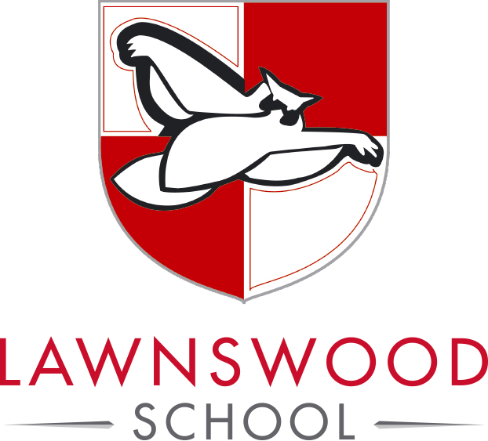
Person Specification
Casual Administrative Assistant

Essential Skills | The post holder should be able to demonstrate the following essential skills:  - To be a team player  - To be literate and numerate  - Be competent in the use of Excel, Word and email  - Good personal presentation  - Communicate effectively with a wide range of people in person or via various media  - File, retrieve, sort and complete documents accurately  - Be able to use a range of office equipment (e.g. printers, photocopiers, fax).
Desirable Skills | The post holder should be able to demonstrate the following desirable skills:  - Work in a sometimes pressured environment  - Ability to use PowerPoint and Publisher software  - Knowledge of SIMS (School Information Management System)  - Be able to create Mail Merge documents  - Experience of organising work tasks and duties to meet appropriate service standards e.g. in terms of timeliness, accuracy and customer care
Working Environment | The post holder will be expected to have the following knowledge and understanding:  - Willing to abide by the Council’s Equal Opportunities Policy in the duties of the post, and as an employee of the Council.  - Working within a busy, modern and diverse environment  - To display a responsible and co-operative attitude to working towards the achievement of the service area aims and objectives

