Head of Subject – Biology
Mainscale + TLR2a
September 2018

Application Pack

Welcome to Rivers Academy West London

Thank you for your interest in the post of Head of Subject - Biology at Rivers Academy West London.

All staff at Rivers Academy share a common drive to equip students with the qualifications, qualities and skills to reach their personal ambitions.

We have the highest aspirations for every student and provide exceptional education and pastoral care for each individual. As a result, children perform tremendously well in external examinations in both Year 11 and Year 13.

We seek to appoint a highly motivated, enthusiastic teacher with a strong commitment to securing the best possible outcomes for the students for whom we work. We are the one chance of success for our students and we are persistent and resilient in overcoming obstacles which our students may face.

We are looking for someone who is passionately interested in teaching and learning who will share our drive to achieve the very best education for students at Rivers Academy. The successful candidate is, or will have the ambition to become, an outstanding teacher.

Visits are welcomed and encouraged

To arrange a visit or for more information please contact:
Bozena Bishop, PA

E‐mail: bbishop@rivers-aspirations.org

To learn more about us visit www.riversacademy.org
or to find out more about the Aspirations Academies visit: www.aspirationsacademies.org

Yours faithfully,
Andria Singlehurst
Principal

Vision and Ethos
We are passionate about excellence in education, giving students the very best start in life with a firm belief that excellent teaching transforms lives. Our core belief is that for all students to have high aspirations they must believe in themselves, be actively engaged in their learning and see the connection between what they learn today and who they want to become tomorrow.
We teach a highly engaging and challenging curriculum designed to ensure all students develop the knowledge, skills and attributes essential for success in the 21st Century.
We are unapologetically ambitious for every child, regardless of their background, prior attainment or needs. Everything we do at Rivers is driven by this, so that our students can leave us with the best set of qualifications possible and as well rounded young people thereby helping to maximise their life chances.
High Expectations
We expect all students to meet the highest standards, and work with families and the community to ensure that our students meet our high expectations.
Active Engagement in Learning
Rivers Academy West London teachers provide engaging, challenging and relevant teaching and learning. Our Deputy Co-ordinators are a key group who exemplify the classroom excellence and nurturing pastoral care we expect from every teacher and academic mentor.
Our Future Ambitions
Our ‘Outstanding’ March 2015 inspection report was testament to the tremendous hard work of our staff, governors, students and parents/carers. This report represents an important milestone on our journey. Our goal is to raise the Aspirations of the young people with whom we work whilst reaching levels of achievement that would place us in the top 5% of schools nationally.

Who are we looking for?
We are looking for an exceptional individual to play an important role in our unique and growing Academy. The successful candidate will be an excellent teacher of biology and general science with the ability or potential to learn how to effectively lead a team. The successful candidate will also play an important pastoral role as an academic mentor and support the pastoral care of all students in the science area of the Science and Technology Faculty.
What can we offer you?
With great students, an outstanding and supportive team of staff and an Academy in a well-connected location just 18 minutes on the train from Clapham Junction, Rivers offers an excellent opportunity for an ambitious, talented individual looking to develop their career.

As part of the successful and growing Aspirations Academies Trust we are a part of the newly designated NCTL Teaching School Alliance. You would be joining us at a very exciting time and become part of a vibrant learning community that will offer you fantastic opportunities for CPD, career development, future promotions and the opportunity to be able to make your mark. As a Coordinator you would also play a key role in shaping this work.
Post Title | Head of Subject - Biology
Salary/Grade: | MPS + TLR2A
Academy: | Rivers West London
Reporting To: | Subject Coordinator of Science
Responsible for: | Teaching staff within Science department
Disclosure Level: | Enhanced
Job Description:
The Head of Subject Biology position at Rivers Academy West London shall carry out the professional duties as described in the School Teachers Pay and Conditions document in line with the duties as outlined for staff on the Leadership Spine.

The Head of Subject for Biology is directly accountable to the Subject Coordinator of Science, for ensuring the educational success of the Biology Department within the overall framework of the Aspirations Academies strategic plan as well as the individual Rivers Academy West London strategic plan.

The Head of Subject will be fully supported by the Subject Coordinator of Science in every aspect of the management and organisation of the subject.

Head of Subject for Biology will lead and manage the Biology department, overseeing the day-to-day management of the department and managing all aspects of curriculum development, teaching and learning and student progress in this area.

Core Purpose:
To raise and maintain standards of student attainment and achievement within the subject area and to monitor and support student progress.

To be ultimately accountable for student progress and development within the subject area across KS3, KS4 and KS5.

To manage the development of an appropriately broad, balanced, relevant and differentiated curriculum for students studying in the subject area, in accordance with the aims and policies of the Academy.

To effectively manage and deploy teaching/support staff, financial and physical resources within the subject area.
Main Responsibilities and Duties:
Operational and Strategic duties:
- To oversee and manage the development of appropriate syllabuses, resources, schemes of work, marking policies, assessment and teaching and learning strategies in the subject area.
- The day-to-day management, control and operation of course provision within the subject area, including effective deployment of staff and physical resources.
- To actively monitor and follow up student progress from year 7 to 13.
- Arrange details for internal and external examinations.
- To attend all appropriate meetings.
- To lead and manage the business planning function of the subject area, and to ensure that the planning activities of the subject area reflect the needs of students within the subject area, the Academy Improvement Plan and the aims of the Academy.
- To ensure that the work in the curriculum area fully reflects the distinctive philosophy of the Aspirations Academies Trust.
- To ensure that Health and Safety policies and practices, including risk assessments, throughout the subject area are in-line with national requirements and are updated where necessary, therefore liaising with the Academy’s Health and Safety Manager.

Curriculum Duties:
- To liaise with the Subject Coordinator of Science to ensure the delivery of an appropriate, comprehensive, high quality and cost-effective curriculum programme which complements the vision of the Academy.
- To be accountable for the development and delivery of Biology.
- To oversee curriculum development for the whole subject area.
- To keep up-to-date with national developments in Biology and teaching practice and methodology.
- To actively monitor and respond to curriculum development and initiatives at national, regional and local levels.
- To liaise with the Subject Coordinator of Science to maintain accreditation with the relevant examination and validating bodies.

Staff Development Responsibilities:
- To work with Subject Coordinator of Science to ensure that staff development needs are identified and that appropriate programmes are designed to meet such needs.
- To undertake Performance Management Review(s) and to act as reviewer for a group of staff within the subject area.
- To make appropriate arrangements for classes when staff are absent, ensuring appropriate cover within the subject area liaising with the Cover Supervisor/relevant staff to secure appropriate cover within the subject area.
- To participate in the interview process for teaching posts when required and to ensure effective induction of new staff in line with Academy procedures.
- To promote teamwork and to motivate staff to ensure effective working relations.
- To participate in the Academy’s Initial Teacher Training Programme.
- To be responsible for the day-to-day management of staff within the subject area and act as a positive role model.

High Standards Maintenance:
- To ensure the effective operation of review and monitoring systems.
- To ensure the process of the setting of targets within the subject area and to work towards their achievement.
- To establish common standards of practice within the subject area and develop the effectiveness of teaching and learning styles in all the strands within the subject area.
- To contribute to the Academy’s procedures for lesson observation.
- To seek/implement modification and improvement where required.

Management Information Responsibilities:
- To ensure the maintenance of accurate and up-to-date information concerning the subject area on the management information system.
- To make use of analysis and evaluate performance data provided.
- To identify and take appropriate action on issues arising from data, systems and reports; setting deadlines where necessary and reviewing progress on the action taken.
- To produce reports within the quality assurance cycle for the subject area.
- To produce reports on examination performance, including the use of value-added data.
- To manage the subject area’s collection of data.
- To provide the Local Governing Body with relevant information relating to the subject area’s performance and development.

Managing Effective Communications:
- To ensure that all members of the subject area are familiar with its aims and objectives.
- To ensure effective communication/consultation as appropriate with the parents of students.
- To liaise with partner schools, higher education, Industry Examination Boards, Awarding Bodies and other relevant external bodies.
- To represent the subject area’s views and interests.

Resource Management:
- To manage the available resources of space, staff, money and equipment effectively and efficiently in order to maximise the educational provision for students.
- To work with the Subject Coordinator of Science in order to ensure that the subject area’s teaching commitments are effectively and efficiently time-tabled and roomed.

Teaching Duties:
- To undertake an appropriate programme of teaching in accordance with the duties of a standard scale teacher.
- To assist in the development of appropriate syllabuses, resources, schemes of work, marking policies and teaching strategies in the curriculum area and subject area.
- To contribute to the curriculum area and subject area’s Improvement Plan and its implementation.
- To attend all appropriate meetings.
- To plan and prepare courses and lessons.
- To teach students according to their educational needs, including the setting and marking or work to be carried out by the student in Academy and elsewhere.
- To assess record and report on the attendance, progress, development and attainment of students and to keep such records as are required.
- To provide, or contribute to, oral and written assessments, reports and references relating to individual students and groups of students.
- To ensure a high quality learning experience for students, which meets internal and external quality standards.
- To maintain discipline in accordance with the Academy’s procedures and to encourage good practice with regard to punctuality, behaviour, standards of work and homework.
- To undertake assessment of students as requested by external examination bodies, subject area and Academy procedures.

Other Duties:
- To adhere to the Academy’s Dress Code
- To engage actively in the performance review process.
- To continue personal development as agreed at appraisal.
- To undertake any other duty as specified by School Teachers’ Pay and Conditions Body (STPCB) and the Principal not mentioned in the above.
- To play a full part in the life of the Academy community, to support the distinctive aim and ethos of the Aspirations Academies Trust and to encourage staff and students to follow this example.
- To show a record of excellent attendance and punctuality.
General:

Employees will be expected to comply with any reasonable request from a manager to undertake work of a similar level that is not specified in this job description.

Employees are expected to be courteous to colleagues and provide a welcoming environment to visitors and telephone callers.

The Academy will endeavour to make any necessary reasonable adjustments to the job and the working environment to enable access to employment opportunities for disabled job applicants or continued employment for any employee who develops a disabling condition.

Person Specification – Head of Biology

Criteria  Assessed by application (A) Assessed by the recruitment process (R) | Essential | Desirable
Knowledge and Qualifications
Degree or equivalent. | A
Qualified Teacher Status. | A
Exemplary, outstanding practitioner. | A,R
Evidence of professional development relevant to Middle Leadership. |  | A, R
Professional Experience
Outstanding secondary teaching experience across at least two key stages at KS3, 4 and 5. | A,R
Proven experience of consistently good and outstanding teaching, delivery outstanding student attainment/progress over time. | A,R
Experience of reflecting on and improving teaching practice to increase student achievement. | A,R
Experience of being involved in raising levels of student attainment/achievement across at least two Key Stages at KS3, 4 and 5. | A,R
Experience of continually improving teaching and learning through schemes of work, assessment, intervention and extra-curricular activities. | A,R
Form tutoring or mentoring learners. | A,R
Leadership of department development priorities and initiatives. |  | A,R
Experiences of providing professional development to teachers, including coaching, mentoring and training. |  | A,R
Teaching and Learning
Excellent classroom practitioner – ensures that their own classroom practice models best practice. | A,R
Effective and systematic behaviour management, with clear boundaries, sanctions, praise and reward. | A,R
Demonstrates resilience, motivation and commitment to driving up standards of achievement. | A,R
Excellent communication, planning and organisation skills. | A,R
Acts as a role model to staff and students. | A,R
Commitment to regular and on-going professional development and training to establish outstanding classroom practice. | A,R
Leadership
Leadership skills already developed as a Middle Leader. |  | A,R
Effective leader and team member. | A,R
High expectations for accountability and consistency. | A,R
Clear vision on how to help move to academy to the next level of performance. | A,R
Vision aligned with the Trust’s aspirations. | A,R
Genuine passion and a belief in the potential of every student and the ‘no excuses’ philosophy. | A,R
Motivation to continually improve standards and achieve excellence. | A,R
Commitment to the safeguarding and welfare of all students. | A,R
Specialist Knowledge
Outstanding understanding of effective KS3, 4 and 5 Raising Achievement strategies in subject area. | A,R
Knowledge and application of data used to drive raising student achievement. | A,R
Ability to present to and inspire teams. | A,R
Excellent understanding of the OFSTED framework and what constitutes outstanding teaching, learning, achievement and leadership. | A,R
Understanding of the strategies needed to establish consistently high aspirations and standards of results and behaviour. | A,R
Knowledge of the latest educational research, findings and best practice in subject area. | A,R
Disposition/Attitude
A passion for education and making a difference to student’s life chances. | A,R
Vision and the ability to implement it. | A,R
Ability to work as a member of a team. | A,R
The ability to command respect from colleagues, parents, governors and the local community. | A,R
Excellent attendance and punctuality record. | A,R
Energy, enthusiasm, commitment, integrity, good sense of humour. | R
Prepared to listen to others and share ideas. | R
Developing successful relationships with pupils, staff, parents and Governors. | A,R
Hardworking, imaginative and adaptable. | A,R
Determined and resilient and doing whatever is needed to get the job done. | A,R
Commitment to Equal Opportunities; the ability to support and develop the Academy’s Equal Opportunities policies. | A,R
Willing to take part in and lead extra-curricular activities. | A,R
Willingness to undertake training. | A,R
Other
Commitment to safeguarding and welfare of all students. | A,R
Display a commitment and support for the aims of the Aspirations Academies Trust in all its Academies. | R
Exhibit a belief in the values of the Aspirations Academies Trust and in the value of research in school improvement. | R

The Aspirations Academies Trust

The Aspirations Academies Trust (AAT) as a sponsor of primary and secondary age academies in
England, is committed to raising students’ aspirations so that all young people reach their fullest
potential and achieve the success they want for themselves.

The Aspirations Academies Trust in England benefits from QISA’s (The Quaglia Institute for Student Aspirations) remarkable record of more than 30 years of research and experience working with students, educators, and schools.

Aspirations is the ability to dream about the future while being inspired in the present to reach those
dreams. The Aspirations Academies Trust was set up in England with the vision to combine the thirty
years of educational research by Dr. Russ Quaglia on student aspirations with effective and
innovative school improvement techniques in order to create truly outstanding schools that would
fully prepare students to succeed in this exciting world.

Central to the philosophy of the Aspirations Academies Trust is the innovative Aspirations Framework developed by the Quaglia Institute for Student Aspirations (QISA) which outlines the belief that for all students to have high Aspirations, three Guiding Principles must be present: Self‐Worth, Active Engagement, and Purpose. These Guiding Principles direct the development of educational experiences from the individual classroom to the entire school building. The Three Guiding Principles, in turn, are lived out through 8 Conditions that emphasise relationships, active and engaging teaching and learning, and a sense of responsibility over one's own aims and goals.

The 8 Conditions are: Belonging, Heroes, Sense of Accomplishment, Fun & Excitement, Curiosity & Creativity, Spirit of Adventure, Leadership & Responsibility & Confidence to Take Action. Students who have high aspirations believe in themselves, are meaningfully engaged in their learning and the life of the school and work with intention toward their goals.

Our Aspirations Academies have a commitment to make certain that all young people achieve their
fullest academic potential and become responsible citizens. To achieve this goal we are dedicated to
promoting and putting into practice the Three Guiding Principles and 8 Conditions that foster student
aspirations. Each Academy strives to ensure that all students have the opportunity to discover and
appreciate their endless promise for a successful future.

The Aspirations Academies Trust considers that its beliefs and principles are applicable and effective with students from age 3 to 18. Each stage of a child’s education is extremely important ‐ pre‐school, primary and secondary ‐ and should, where possible be coherent across the phases of education in the practice of developing the principles and conditions central to the beliefs and aims of the Aspirations Academies Trust. For this reason, we support primary, secondary and, where possible, all through (Ages 3‐18) academies.

At whatever stage a child joins an Aspirations Academy, whether it is at the age of three or sixteen, the aim is to provide each individual child with the best possible life chance. This is done through the achievement of the highest level of qualifications, the development of skills essential to success in an interconnected and highly competitive world, as well as encouraging the highest aspirations, expecting every student to gain a place at university or enter skilled employment.

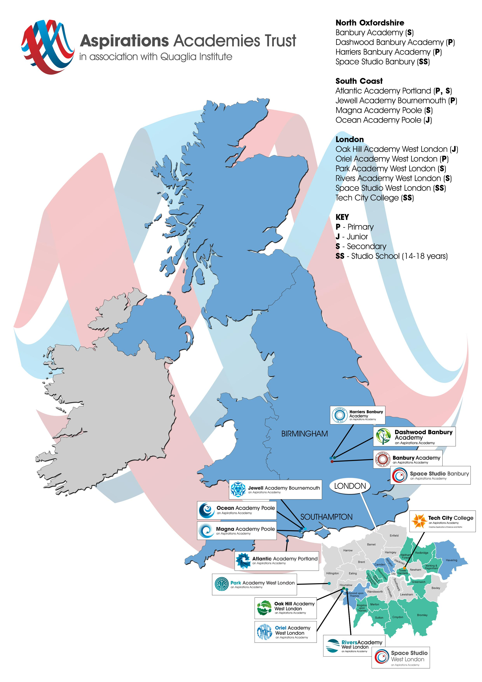
Our Academies

Continuous Professional Development

We offer unique and bespoke training for staff at all levels. This includes Senior Leadership Training, Aspirations Training – Level 1 & 2, Polishing Pedagogy, Coaching and Mentoring. Staff will be supported to develop a positive orientation to professional learning as reflective practitioners and will be empowered to take ownership and responsibility for their professional learning and development.

We strive to embed the voice of students (for example, through My Voice, iKnow My Class Surveys and student voice and leadership developments) and the active engagement of students in the process of CPD and staff professional learning.

Safe Recruitment Procedure
The AAT is committed to safeguarding and promoting the welfare of children and young people in its academies. In order to meet this responsibility, its academies follow a rigorous selection process to discourage and screen out unsuitable applicants. This process is outlined below, but can be provided in more detail if requested.

Disclosure

This post is classified as having substantial access to children, and appointment is subject to an enhanced police check of previous criminal convictions (DBS). Applicants are required, before appointment, to disclose any conviction, caution or binding over including ‘spent convictions’ under the Rehabilitation of Offenders Act 1974 (Exemptions) Order 1975. Non-disclosure may lead to termination of employment. However, disclosure of a criminal background will not necessarily debar individuals from employment – this will depend upon the nature of the offence(s) and when they occurred.

Shortlisting

Only those candidates meeting the right criteria will be taken forward from application.

Interview

1. Longlisted candidates will be subject to a screening interview. Those shortlisted will take part in an in-depth interview process including a lesson observation.
2. Candidates will be asked to address any discrepancies, anomalies or gaps in their application form.

Reference checking

References from the previous and current employer will be taken up for shortlisted candidates, and where necessary employers may be contacted to gather further information.

