RSA ACADEMY, TIPTON
TEACHING POSTS

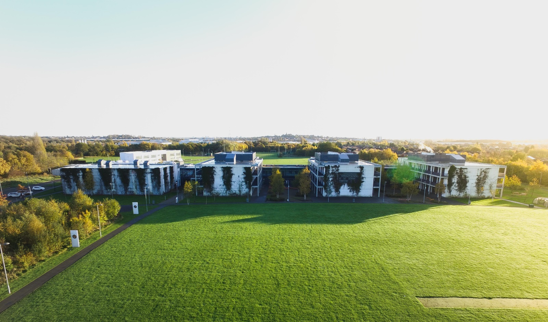

Eric Griffiths,
Chair of Central RSA Academies Trust Board

The RSA Academy, Tipton joined the Central RSA Academies Trust in October 2017. There are currently five schools within the Trust led by our Executive Principal/CEO, Guy Shears with children from the age of three up to sixth form.

By being part of the trust it allows The RSA Academy, Tipton to increase the prospects already offered to our students in terms of school life, aspirations and the unique opportunities presented by our association with the RSA.

As Chair of Central RSA Academies Trust Board, I am very proud to work with this group of schools and happy to receive your interest in our posts at the RSA Academy, Tipton. If successful, you will play a key role within our Trust, as well as the school itself. For more information about our Trust please visit our website: www.centralrsaacademies.co.uk

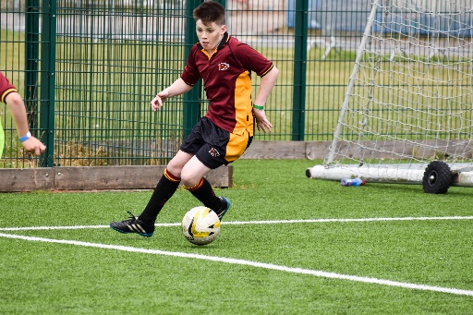

Guy Shears, Executive Principal (CEO), CRSAAT.

It is my privilege and pleasure to be Executive Principal (CEO) of the Trust, working with exceptional Trustees, Governors, Principals and staff teams in our five schools. I was previously Principal in two schools, most recently the RSA Academy, Arrow Vale, in Redditch, which co-leads the RSA Academies Teaching School Alliance.

We are a group of schools with a strong and powerful relationship with The Royal Society for the Encouragement of Arts, Manufactures and Commerce (The RSA). The RSA has a strong history of supporting educational innovation, thinking and approaches, going back as far as the Nineteenth Century (https://www.thersa.org/about-us/education-history). Today we work together as a group of schools, working closely with the RSA, to ensure the best possible educational outcomes for young people in our schools. We aim to ensure excellent test and examination results for our students, and ensure they are fully prepared for a happy and fulfilling life.

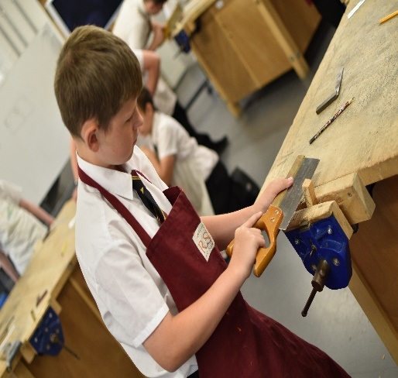

The aim of the Trust is to get the very best staff teams across our schools, and we invest time and energy in developing the very best teachers, leaders and staff. One of my key jobs as Executive Principal(CEO) is to maximise expertise and sharing so that our staff can be the best they can be. As we achieve this, we are then able to genuinely support the students in being the best they possibly can be. It is brilliant for the Trust that the expertise at The RSA Academy, Tipton is now part of the Trust, and of course the staff and students at Tipton can benefit through the expertise in the other schools too.

We thank you for your interest in our Teaching posts at the RSA Academy, Tipton. Please do come and have a look at the school, and the excellent opportunity these posts present.

RECRUITMENT PROCESS

For our teaching posts with leadership responsibility the format us usually as follows:

- Lesson observation
- Tour of the Academy
- Student panel
- Formal interviews with the Principal and Curriculum Lead
- Presentation
- Data exercise

APPLICATIONS

Thank you for your interest in this post.

In order to apply, please complete:

- Our application form
- A letter of application

These must be returned no later than midday on 23rd March 2018 and the interview process will be week commencing 26th March 2018.

